Shimizu, Shizuoka, Japan
On a clear morning, snow-capped Fuji towers above the bay as your ship ties up at Hinode Pier — and the city's legendary bluefin tuna is just a five-minute walk away.
⚓ Pier (Hinode Pier) · 🕒 Typical call: 8-10 hrs · 💴 Japanese Yen (JPY) · 🗣️ Japanese · 🗻 Mount Fuji views
✍️ MY DAY IN PORT (FILL IN)
Ship / Date
In port | arrive ______ · all aboard ______
Booked excursion
Notes / meeting point
GETTING ASHORE
- Docking: Pier — Hinode Pier, no tender required
- Walk to center: S-Pulse Dream Plaza 5 min; Shimizu Station 25-30 min
- Best For: Mt. Fuji views, fresh tuna, Japanese culture
- Don't Miss: Miho no Matsubara pine grove, Kunozan Toshogu Shrine
GETTING AROUND
- 🚕 Taxi: ¥1,400–¥1,800 — Taxis are available outside the pier and take about 2–5 minutes to JR Shimizu Station. Metered fares; the GO app can be
- 📱 Rideshare: ✅ Uber
TOP THINGS TO DO
- Nihondaira & Mt. Fuji Panorama — Ride to the Nihondaira plateau for 360° views of Fuji, Suruga Bay, and the Izu Peninsula from Kengo Kuma's sleek observation…
- Kunozan Toshogu Shrine — Japan's original shrine to Tokugawa Ieyasu, the shogun who unified the nation.
- Miho no Matsubara Pine Grove — A UNESCO World Heritage landscape: 7 km of ancient pine trees framing an iconic view of Mt.
- Kashi no Ichi Fish Market & Tuna Lunch — Shimizu lands more bluefin tuna than anywhere in Japan.
- Chibi Maruko-chan Land — The beloved manga character was born in Shimizu — her museum inside S-Pulse Dream Plaza celebrates the town's most famous export.
BEST WALKS
- Pier to S-Pulse Dream Plaza Boardwalk: 0.5 km · 5-10 min · Flat — A restored historic boardwalk along the waterfront passes preserved rail tracks, moored yachts, and…
- Boardwalk to Shimizu Station: 2 km · 25-30 min · Flat — Continue from S-Pulse toward JR Shimizu Station through the harbor district, passing local shops…
WEATHER · DAYLIGHT · MONEY
Month | High °F | Low °F | Rainy days
May | 73 | 59 | 12
Jul | 84 | 73 | 17
Sep | 81 | 70 | 18
Daylight: May 4:42AM–6:42PM · Jul 4:43AM–7:00PM · Sep 5:28AM–5:53PM
cruiseports.org/shimizu · Confirm terminal & all-aboard time with your ship

Shimizu, Shizuoka, Japan — Port Map
Red = walkable sights · Amber = excursions farther out · P = cruise terminal
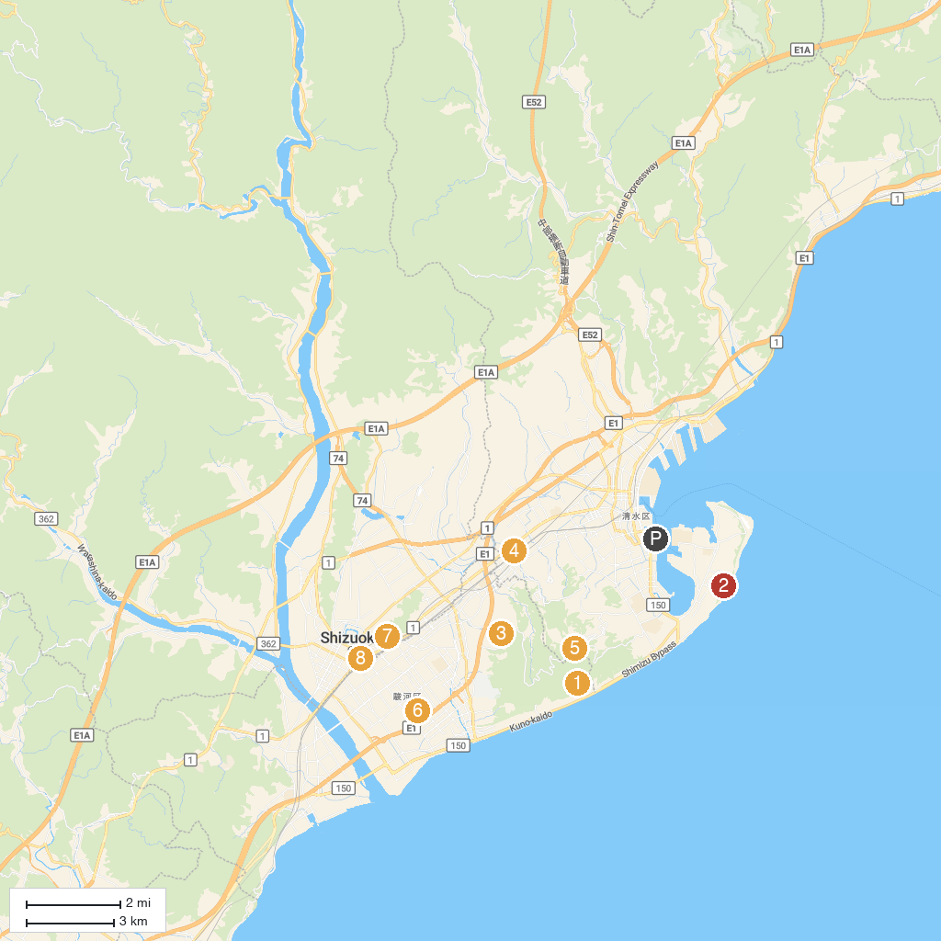
MAP KEY
1. Kunōzan Tōshōgū | 5. Nihondaira Prefectural Natural Park
2. Miho no Matsubara (Miho Pine Forest) | 6. Toro Archaeological Site
3. Nihondaira Zoo | 7. Kiyomizudera
4. Aoi Hot Spring Kusanagi no Yu | 8. Aoi Tower
P. Cruise port / terminal
Map © MapTiler © OpenStreetMap contributors · cruiseports.org

