Shingu, Wakayama, Japan
A portal to Japan's spiritual heartland, Shingu sits where the sacred Kumano River meets the Pacific — an off-the-beaten-path port of ancient shrines, pilgrim trails, and dramatic waterfalls.
⚓ Pier (docked) · 🕒 Typical call: 7-10 hrs · 💴 Cash yen essential · 🗣️ Japanese (little English) · 🏛️ UNESCO World Heritage
✍️ MY DAY IN PORT (FILL IN)
Ship / Date
In port | arrive ______ · all aboard ______
Booked excursion
Notes / meeting point
GETTING ASHORE
- Docking: Pier — ships dock at Miwasaki or Hyakken Wharf; no tendering
- Walk to center: Not walkable — 4–5 km industrial zone; free shuttle to JR Shingu Station (~10 min)
- Best For: Shinto pilgrimage, nature, history, fresh bluefin tuna
- Don't Miss: Kumano Hayatama Taisha Shrine & the 800-year-old sacred Nagi tree
GETTING AROUND
- 🚕 Taxi: ¥1,300–¥2,500 — Metered taxis are available at the port and near JR Shingu Station. Short city-center rides typically cost ¥1,300–¥2,500
TOP THINGS TO DO
- Kumano Hayatama Taisha Grand Shrine — One of the three Grand Shrines of Kumano and a UNESCO World Heritage site, this vermilion-painted shrine is home to the sacred…
- Kamikura-jinja Shrine & Gotobiki Rock — Climb 538 steep, hand-carved stone steps to a colossal sacred boulder worshipped as a natural deity.
- Nachi Falls & Seiganto-ji Temple — Japan's tallest waterfall (133 m) framed by the three-story pagoda of Seiganto-ji Temple — one of Japan's most photographed scenes.
- Kumano River Traditional Boat Tour — Drift down the pristine Kumano River on a flat-bottomed wooden boat, recreating the pilgrimage journey of ancient Japanese…
- Shingu City & Local Food Walk — Explore the streets near JR Shingu Station for local specialties: Mehari-zushi (giant rice balls in pickled mustard greens)…
BEST WALKS
- Shrine & River Walk: 2–3 km · 1–1.5 hrs · Easy — From JR Shingu Station, walk to Kumano Hayatama Taisha for the sacred Nagi tree and bright…
- Kamikura Shrine Climb: 1 km · 1 hr · Strenuous — A short walk from JR Shingu Station leads to the base of Kamikura-jinja Shrine.
WEATHER · DAYLIGHT · MONEY
Month | High °F | Low °F | Rainy days
May | 73 | 59 | 12
Jul | 84 | 74 | 18
Sep | 81 | 71 | 19
Daylight: May 4:55AM–6:49PM · Jul 4:56AM–7:07PM · Sep 5:39AM–6:02PM
cruiseports.org/shingu · Confirm terminal & all-aboard time with your ship

Shingu, Wakayama, Japan — Port Map
Red = walkable sights · Amber = excursions farther out · P = cruise terminal
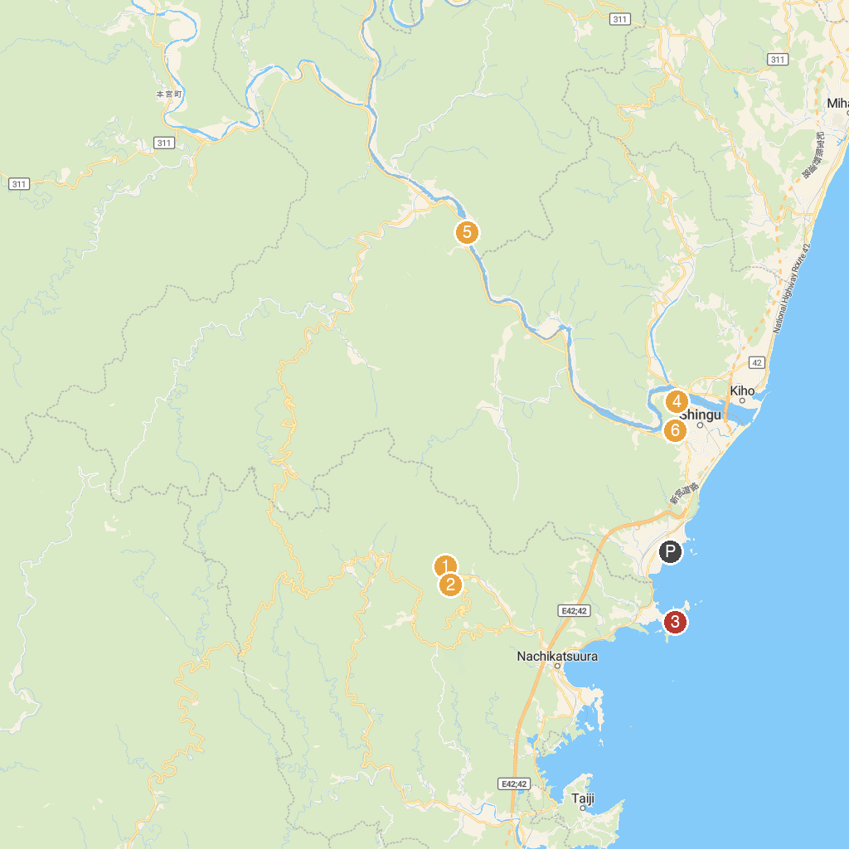
MAP KEY
1. Nachi Waterfall | 5. Kumano Boat River Cruise
2. Seiganto-ji | 6. Taiji Marinarium
3. Ugui Visitor Center | 7. Kamikura-jinja Shrine
4. Kumano Hayatama Taisha
P. Cruise port / terminal
Map © MapTiler © OpenStreetMap contributors · cruiseports.org

