Silistra, Silistra Province, Bulgaria
One of Bulgaria's oldest cities, Silistra sits on the Roman legionary fortress of Durostorum — where the Danube forms the border with Romania and pelicans still nest in a UNESCO lake nearby.
⚓ Docked (riverside quay) · 🕒 Typical call: 6-8 hrs · 💵 Bulgarian Lev (BGN) · 🗣️ Bulgarian (Cyrillic script)
✍️ MY DAY IN PORT (FILL IN)
Ship / Date
In port | arrive ______ · all aboard ______
Booked excursion
Notes / meeting point
GETTING ASHORE
- Docking: River quay directly alongside Danube Park — no tender
- Walk to center: 5–10 min (400 m) through the park to Freedom Square
- Best For: Roman history, birdwatching, authentic off-the-beaten-path Bulgaria
- Don't Miss: The 4th-century Roman Tomb murals & Medzhidi Tabia Ottoman fortress views
GETTING AROUND
- 🚕 Taxi: €2–5 in-city — Metered yellow taxis are readily available. Local companies include Evropa Taksi and Istar Taxi; fares start around €1 w
- 📱 Rideshare: ❌ not available
TOP THINGS TO DO
- Roman Durostorum — Fortress Walls & Tomb — Wander free through the excavated Roman fortress walls in Danube Park, then visit the 4th-century Roman Tomb with its startlingly…
- Archaeological Museum — The town-centre museum holds Roman armour, a detailed Durostorum fortress model, medieval artifacts, and finds from the Roman tomb.
- Medzhidi Tabia Ottoman Fortress — A hexagonal 19th-century Ottoman fort built 1841–1853, with 8-metre walls and a small military history museum inside.
- Srebarna Nature Reserve (UNESCO) — A freshwater lake 16–20 km west of Silistra, listed as a UNESCO World Heritage Site and Ramsar wetland.
- Danube Park & Ethnographic Museum Walk — Stroll Bulgaria's oldest public park (est.
BEST WALKS
- Danube Park to Freedom Square: 0.8 km · 15 min · Flat · Free — Step off the ship into Danube Park, pass the Roman fortress wall sections and early-Christian…
- Town Centre Loop — Museums & Market: 1.5 km · 25 min · Flat — From Freedom Square walk to the Archaeological Museum, continue past the Art Gallery (housed in a…
WEATHER · DAYLIGHT · MONEY
Month | High °F | Low °F | Rainy days
May | 72 | 54 | 11
Jul | 85 | 66 | 7
Sep | 78 | 59 | 4
Daylight: May 5:44AM–8:30PM · Jul 5:42AM–8:51PM · Sep 6:50AM–7:21PM
cruiseports.org/silistra · Confirm terminal & all-aboard time with your ship

Silistra, Silistra Province, Bulgaria — Port Map
Red = walkable sights · Amber = excursions farther out · P = cruise terminal
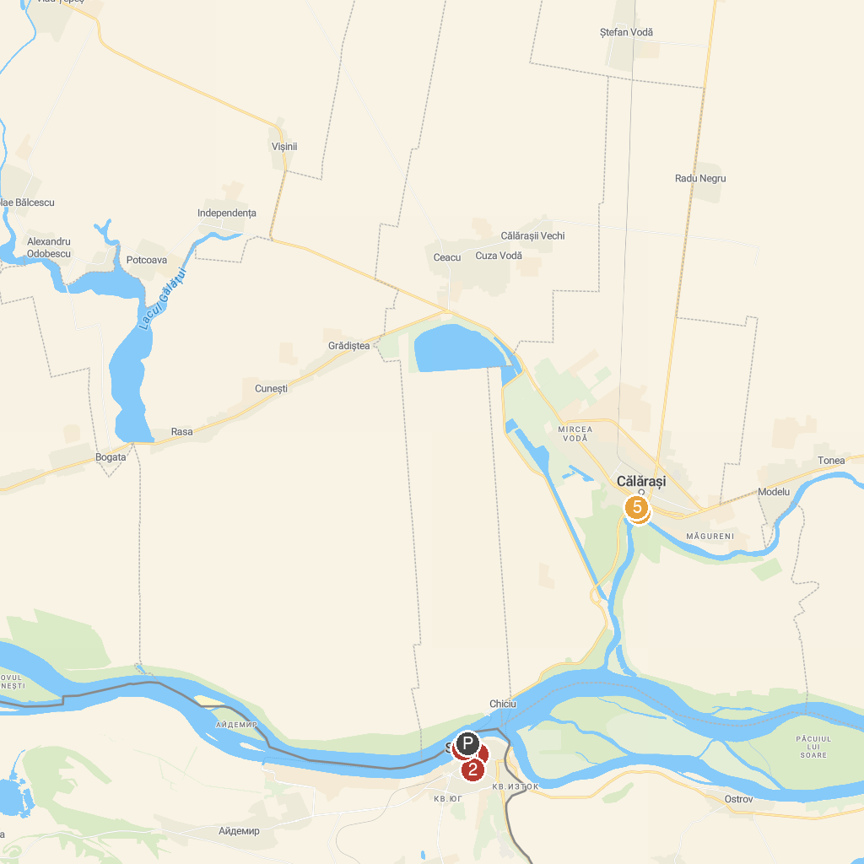
MAP KEY
1. Archaeological Museum | 4. Waterfront Park Central Calarasi
2. Ethnographic Museum | 5. Museum of The Lower Danube
3. Ancient city of Durostorum - Drastar
P. Cruise port / terminal
Map © MapTiler © OpenStreetMap contributors · cruiseports.org

