Singapore, Singapore
The city-state that does everything at full intensity — soaring Supertrees, a rooftop infinity pool, jungle conservatories, the world's first night zoo, and the planet's greatest street food, all linked by a gleaming, cashless metro.
⚓ Docked (MBCCS or HarbourFront) · 🕒 Typical call: 8–12 hrs (often overnight) · 💵 Singapore Dollar (SGD) — near-cashless city · 🗣️ English · Malay · Mandarin · Tamil
✍️ MY DAY IN PORT (FILL IN)
Ship / Date
In port | arrive ______ · all aboard ______
Booked excursion
Notes / meeting point
GETTING ASHORE
- Docking: Marina Bay Cruise Centre (MBCCS) or Singapore Cruise Centre (HarbourFront) — check your documents
- Walk to center: MBCCS: 600 m sheltered walk to MRT; HarbourFront: directly inside terminal
- Best For: Gardens · Hawker food · Multicultural districts · Night Safari
- Don't Miss: Gardens by the Bay Cloud Forest + Supertree Grove at night
GETTING AROUND
- 🚕 Taxi: S$6–10 (US$4–8) — From Marina Bay Cruise Centre, metered taxis reach City Hall in ~5 min for S$6–8. HarbourFront is ~S$10 to the city. Not
- 📱 Rideshare: ✅ Grab, Gojek, TADA
- 🚌 Hop-on hop-off: ✅ Big Bus Tours / FunVee
TOP THINGS TO DO
- Gardens by the Bay & Cloud Forest — Singapore's defining attraction: the alien Supertree Grove lights up nightly for the Garden Rhapsody show, while the Cloud Forest…
- Marina Bay Sands SkyPark & Merlion Walk — Ride the elevator to the SkyPark observation deck atop the three MBS towers for sweeping harbour views — you may even spot your…
- Chinatown, Little India & Kampong Glam — Three of Singapore's most vibrant heritage districts: Sri Mariamman Temple and hawker stalls in Chinatown, the riot of marigolds…
- Sentosa Island: Universal Studios & Beaches — Singapore's dedicated resort island — walk or cable car from HarbourFront.
- Singapore Zoo, River Wonders & Night Safari — One of the world's finest zoo complexes: open-concept enclosures, giant pandas at River Wonders, and the Night Safari — the…
BEST WALKS
- Marina Bay Waterfront Loop: ~4 km · 2 hrs · easy (mostly covered walkways) — Singapore's showpiece walk: Merlion Park, the Esplanade Theatres on the Bay, the ArtScience Museum…
- Chinatown to Kampong Glam Heritage Walk: ~3.5 km · 2 hrs · easy — From the colourful shophouses of Chinatown (Sri Mariamman Temple, Maxwell Food Centre) north…
- HarbourFront to Sentosa Boardwalk: ~1 km · 15 min · very easy (shaded, flat) — From the Singapore Cruise Centre at HarbourFront, walk the pedestrian boardwalk straight onto…
WEATHER · DAYLIGHT · MONEY
Month | High °F | Low °F | Rainy days
May | 85 | 79 | 29
Jul | 84 | 79 | 23
Sep | 84 | 78 | 22
Daylight: May 6:55AM–7:06PM · Jul 7:05AM–7:16PM · Sep 6:56AM–7:03PM
cruiseports.org/singapore · Confirm terminal & all-aboard time with your ship

Singapore, Singapore — Port Map
Red = walkable sights · Amber = excursions farther out · P = cruise terminal
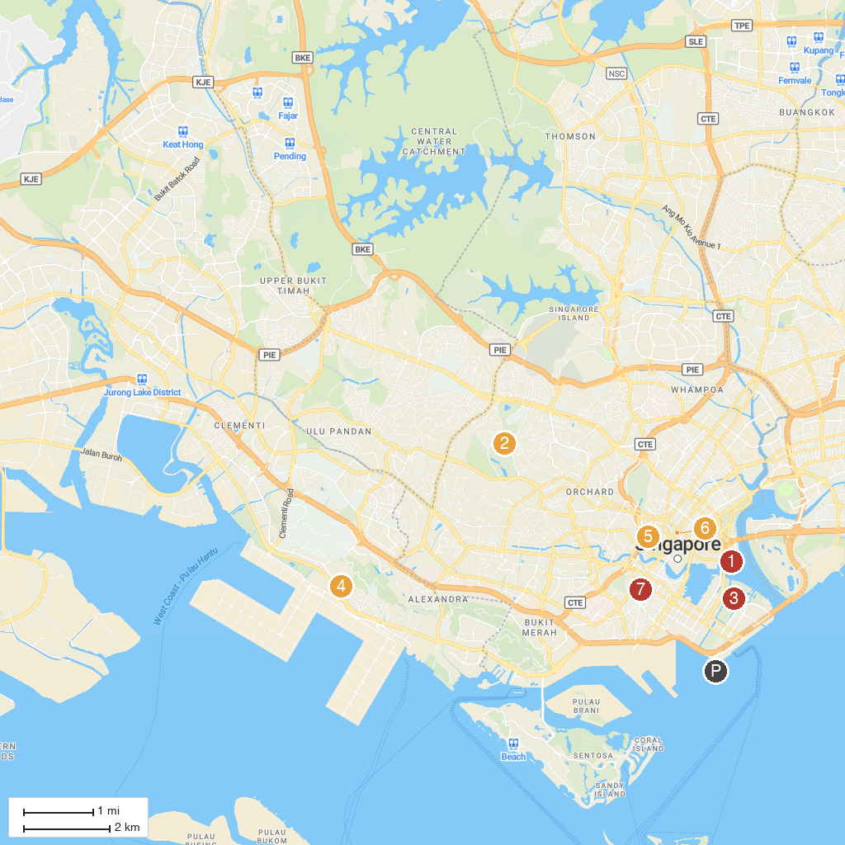
MAP KEY
1. Singapore Flyer | 5. Fort Canning Park
2. Singapore Botanic Gardens | 6. CHIJMES
3. Gardens by the Bay | 7. Science Centre Singapore
4. Haw Par Villa | 8. Chinatown Heritage Centre
P. Cruise port / terminal
Map © MapTiler © OpenStreetMap contributors · cruiseports.org

