Sitka, Alaska, USA
Alaska's most historic port sits on the outer coast of Baranof Island — Russian cathedrals, Tlingit totem poles, and bald eagles wheeling overhead, all within a short walk of the dock.
⚓ Docks at Sitka Sound Cruise Terminal / some ships tender downtown · 🕒 Typical call: 7–9 hrs · 💵 US Dollar (USD) · 🌧️ Rain gear essential
✍️ MY DAY IN PORT (FILL IN)
Ship / Date
In port | arrive ______ · all aboard ______
Booked excursion
Notes / meeting point
GETTING ASHORE
- Docking: Dock or tender (ship-dependent)
- To center: ~10–15 min shuttle (or tender to downtown)
- Best For: History · Wildlife · Totems
- Don't Miss: Sitka National Historical Park
GETTING AROUND
- 🚕 Taxi: $40–50 — Taxis are available but limited in Sitka. The ~5–6 mile ride to downtown costs roughly $40–50; pre-arranging is strongly
- 📱 Rideshare: ✅ Uber, Lyft
- 🚌 Hop-on hop-off: ✅ Sitka Rides (The Cool Bus!)
TOP THINGS TO DO
- Sitka National Historical Park — The oldest national park in Alaska.
- Alaska Raptor Center — A working rehabilitation center for injured bald eagles, owls, and hawks — some permanently resident because they can't be…
- Fortress of the Bear — A nonprofit bear sanctuary housing orphaned brown bears rescued from the wild.
- St. Michael's Cathedral & Russian Heritage — The onion-domed cathedral at the center of downtown is the oldest Russian Orthodox church in North America (rebuilt after a 1966…
- Sea Otter & Wildlife Quest — Sitka Sound is one of the best places in Alaska to see sea otters, Steller sea lions, humpback whales, and seabirds from a small…
BEST WALKS
- Downtown Heritage Loop: ~2 km · 1–1.5 hrs · easy — From the small boat harbor, walk Lincoln Street past St.
- Indian River Trail to Sitka National Historical Park: ~3.5 km one-way · 1.5–2 hrs · easy-moderate — Walk or cab to the park entrance, then follow the totem-lined forest trail along the Indian River…
WEATHER · DAYLIGHT · MONEY
Month | High °F | Low °F | Rainy days
May | 54 | 44 | 15
Jul | 62 | 54 | 18
Sep | 58 | 50 | 20
Daylight: May 4:41AM–9:14PM · Jul 4:30AM–9:43PM · Sep 6:33AM–7:17PM
cruiseports.org/sitka · Confirm terminal & all-aboard time with your ship

Sitka, Alaska, USA — Port Map
Red = walkable sights · Amber = excursions farther out · P = cruise terminal
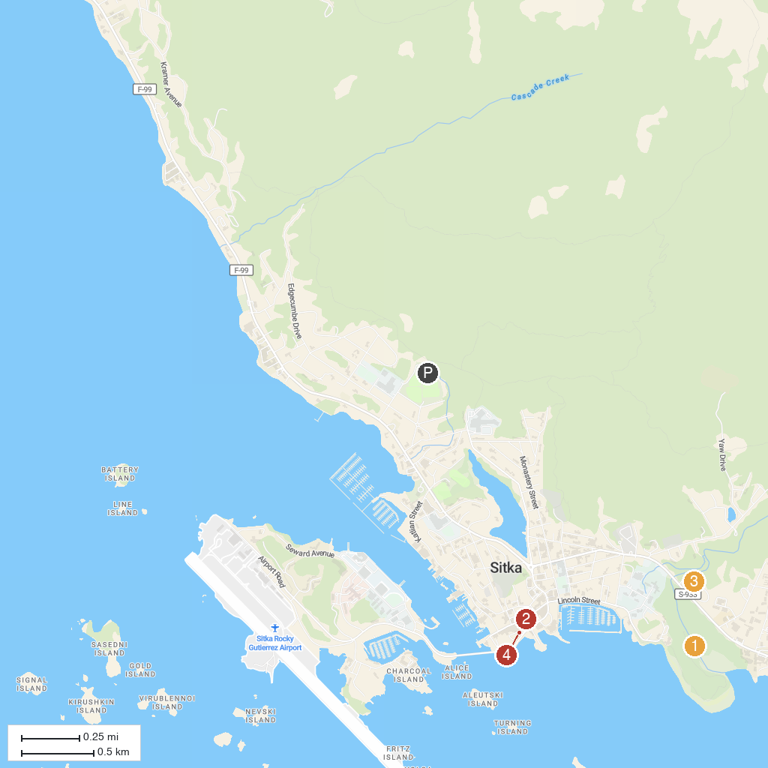
MAP KEY
1. Sitka National Historical Park | 3. Alaska Raptor Center
2. St. Michael's Cathedral | 4. Castle Hill
P. Cruise port / terminal
Map © MapTiler © OpenStreetMap contributors · cruiseports.org

