Skiathos Island, Sporades, Greece
Pine-clad and turquoise-fringed, Skiathos packs more beach beauty per square kilometre than almost anywhere in the Aegean — and you'll be swimming within an hour of the tender touching down.
⚓ Tender port · 🕒 Typical call: 7-9 hrs · 💶 Currency: Euro (€) · 🗣️ Language: Greek · 🏖️ Beach paradise
✍️ MY DAY IN PORT (FILL IN)
Ship / Date
In port | arrive ______ · all aboard ______
Booked excursion
Notes / meeting point
GETTING ASHORE
- Docking: Tender to Old Port, Skiathos Town
- Walk to center: 0 min — tender drops you on the promenade
- Best For: Beaches, Greek island vibes, plane-spotting
- Don't Miss: Lalaria sea arch & Koukounaries golden sand
GETTING AROUND
- 🚕 Taxi: €7–€10 — The taxi rank is about 50m from the new port exit near the ring road. Fares are metered and regulated; the short ride to
- 📱 Rideshare: ✅ Uber
TOP THINGS TO DO
- Koukounaries Beach Day — Consistently ranked among Greece's best beaches, Koukounaries offers fine golden sand, shallow crystal-clear water, and a…
- Lalaria Beach Boat Trip — Accessible only by sea, Lalaria stuns with smooth white pebbles, towering cliffs, and the iconic Tripia Petra natural stone arch…
- Airport Plane-Spotting (Xanemos Beach) — Skiathos Airport is the 'St Maarten of Europe' — jets land just metres above a public road and beach.
- Evangelistria Monastery — Set in pine-forested hills 5 km from town, this late 18th-century monastery is where the first modern Greek flag was blessed in…
- Skiathos Town & Papadiamantis House — Stroll Papadiamantis Street, visit the writer's preserved 19th-century home (€2–3), then climb to Agios Nikolaos Church and its…
BEST WALKS
- Old Port to Bourtzi Peninsula: 15–20 min | Easy | Free — From the tender landing walk west along the waterfront to the pine-wooded Bourtzi islet, which…
- Town Stroll to Megali Ammos Beach: 15–20 min | Easy | Sandy beach — Head south along the waterfront promenade from the Old Port to reach Megali Ammos, a long sandy…
- Climb to Agios Nikolaos Church: 20–30 min | Moderate uphill | Best views — From Papadiamantis Street take the stepped lanes uphill to the Agios Nikolaos Church and clock tower.
WEATHER · DAYLIGHT · MONEY
Month | High °F | Low °F | Rainy days
May | 67 | 63 | 5
Jul | 80 | 76 | 2
Sep | 76 | 73 | 6
Daylight: May 6:13AM–8:32PM · Jul 6:12AM–8:51PM · Sep 7:07AM–7:34PM
cruiseports.org/skiathos-island · Confirm terminal & all-aboard time with your ship

Skiathos Island, Sporades, Greece — Port Map
Red = walkable sights · Amber = excursions farther out · P = cruise terminal
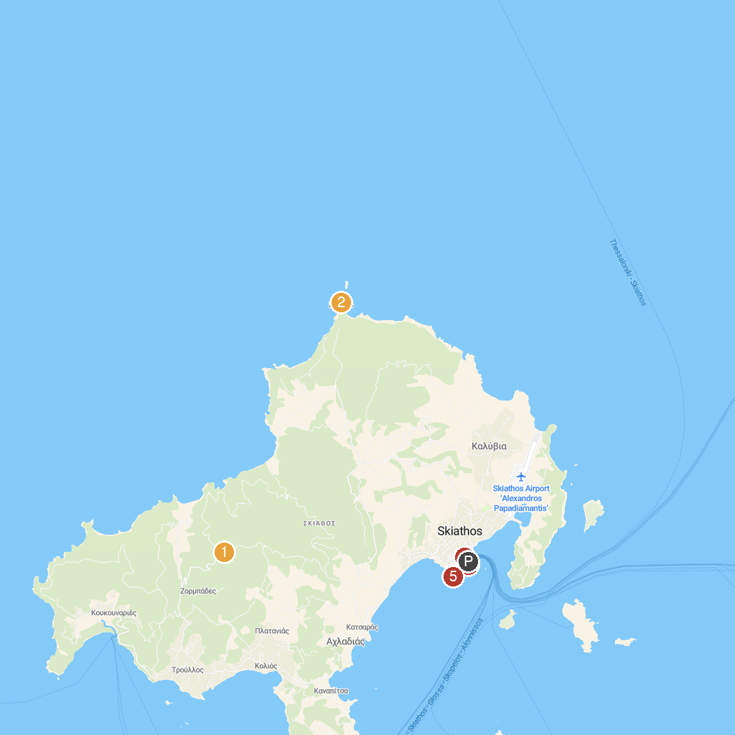
MAP KEY
1. Εκκλησία Παναγία Εικονίστρια | 4. Panormoscar
2. Byzantine Castle of Skiathos | 5. Belvedere Skiathos Old Port
3. House- Museum of Alexandros Papadiamantis | 6. Viewpoint near Plakes Beach
P. Cruise port / terminal
Map © MapTiler © OpenStreetMap contributors · cruiseports.org

