Skjolden, Sogn og Fjordane, Norway
Perched at the very end of the world's longest fjord, Skjolden is as quiet as Norway gets — turquoise glacial water, soaring peaks, and three national parks within reach of the pier.
⚓ Pier (dedicated cruise quay) · 🕒 Typical call: 7-9 hrs · 💵 Norwegian Krone (NOK) — nearly cashless, cards everywhere · 🗣️ Norwegian (English widely spoken)
✍️ MY DAY IN PORT (FILL IN)
Ship / Date
In port | arrive ______ · all aboard ______
Booked excursion
Notes / meeting point
GETTING ASHORE
- Docking: Dedicated 127.5 m cruise pier; anchorage/tender also available for larger ships or busy days
- Walk to centre: ~1 km (10–15 min flat) from pier to village
- Best For: Fjord scenery, glacier excursions, hiking, cycling the Romantic Road
- Don't Miss: Urnes Stave Church (UNESCO) and Nigardsbreen Glacier
GETTING AROUND
- 🚕 Taxi: Varies (expensive) — Skjolden has very few local taxis; none are regularly stationed at the pier. If needed, book well in advance through you
- 📱 Rideshare: ❌ not available
TOP THINGS TO DO
- Urnes Stave Church (UNESCO) — Norway's oldest stave church (c.
- Nigardsbreen Glacier Hike — An arm of Jostedalsbreen — the largest glacier in mainland Europe — Nigardsbreen glows electric blue up close.
- Sognefjellet Scenic Drive — Northern Europe's highest mountain pass climbs to 1,434 m through Jotunheimen, offering jaw-dropping views of glaciers and…
- RIB Fjord Safari — High-speed rigid inflatable boats launch from near the pier and thunder down the Lustrafjord, past Feigefossen waterfall (218 m…
- Wittgenstein's Cabin Walk — Philosopher Ludwig Wittgenstein retreated to a remote cabin above Lake Eidsvatnet to write some of his most important work.
BEST WALKS
- Pier to Village & Lake Eidsvatnet: 2–3 km round trip · Flat · 30–45 min — Walk the paved waterfront path from the cruise pier into the village, then continue to…
- Romantic Road (Sørsidevegen) Cycle/Walk: 4–8 km one way · Flat · Best by e-bike — The quiet south-side road along the Lustrafjord offers gorgeous views of the fjord and village.
WEATHER · DAYLIGHT · MONEY
Month | High °F | Low °F | Rainy days
May | 55 | 42 | 16
Jul | 69 | 57 | 20
Sep | 60 | 50 | 18
Daylight: May 4:40AM–10:13PM · Jul 4:19AM–10:50PM · Sep 6:56AM–7:51PM
cruiseports.org/skjolden · Confirm terminal & all-aboard time with your ship

Skjolden, Sogn og Fjordane, Norway — Port Map
Red = walkable sights · Amber = excursions farther out · P = cruise terminal
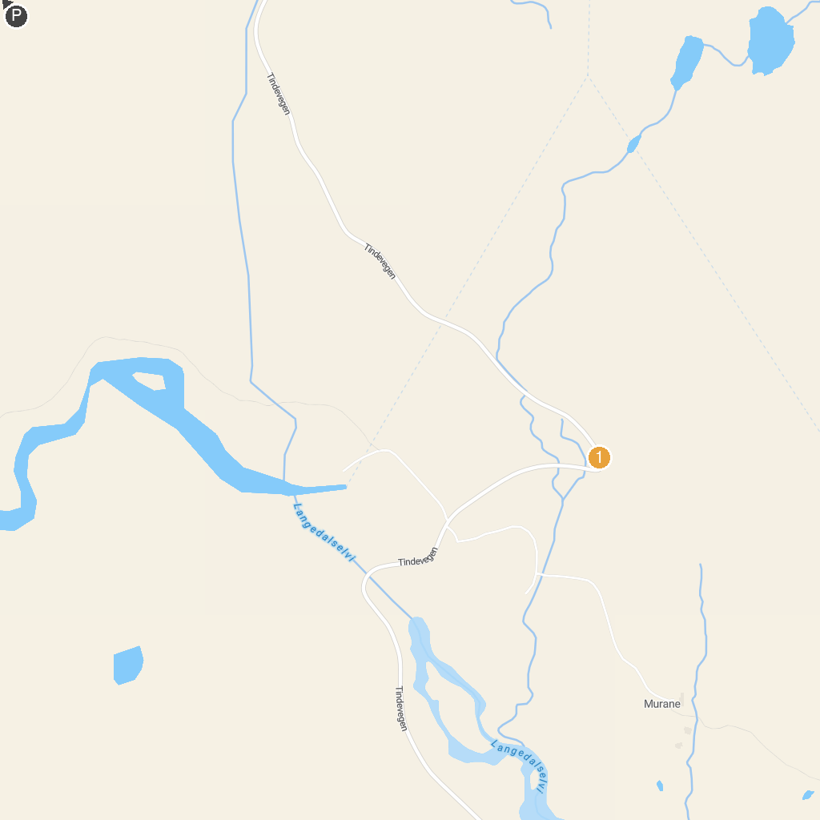
MAP KEY
1. Feigumfossen Waterfall, Luster | 2. Tindevegen
P. Cruise port / terminal
Map © MapTiler © OpenStreetMap contributors · cruiseports.org

