Sokcho, Gangwon-do, South Korea
Wedged between the jagged granite peaks of Seoraksan and the East Sea, Sokcho is one of Korea's most rewarding one-day destinations — ancient temples, a hand-pulled cable ferry, squid sausage, and mountain views that hit differently than any other Korean port.
⚓ Pier — Sokcho International Cruise Terminal · 🕒 Typical call: 8–10 hrs · 💵 Korean Won (KRW) — cards widely accepted · 🗣️ Korean (English at tourist sites; Papago app recommended)
✍️ MY DAY IN PORT (FILL IN)
Ship / Date
In port | arrive ______ · all aboard ______
Booked excursion
Notes / meeting point
GETTING ASHORE
- Docking: Pier — Sokcho International Cruise Terminal (opened 2017)
- Walk to center: Abai Village ~15 min (1.2 km); Jungang Market ~25 min (2 km)
- Best For: Nature, hiking, Korean food culture, mountain scenery
- Don't Miss: Seoraksan cable car + Sinheungsa Temple; Abai Village hand-pulled ferry; Dakgangjeong at Jungang Market
GETTING AROUND
- 🚕 Taxi: ₩8,500–₩11,000 to city center (~$6–8 USD) — Metered taxis are plentiful at the cruise terminal. Base fare is ₩4,500; expect 8–10 min to Sokcho Tourist Market or Aba
- 📱 Rideshare: ✅ Kakao T, Uber, k.ride
TOP THINGS TO DO
- Seoraksan National Park — Korea's most dramatic national park — granite spires, pine forests, Buddhist temples, and the iconic Gwongeumseong cable car with…
- Abai Village & the Gaetbae Ferry — A historic village founded by North Korean refugees who fled during the Korean War.
- Sokcho Jungang Market — A sensory-packed traditional market with a live seafood basement and ground floor of street snacks.
- Sinheungsa Temple & Great Unification Buddha — Inside Seoraksan park, this Zen Buddhist temple features the 14.6-meter Tongil Daebul bronze statue representing hope for Korean…
- Sokcho Beach & the Sokcho Eye — A clean white-sand beach backed by pine forest, just 10 minutes by taxi from the pier.
BEST WALKS
- Pier to Abai Village & Yeonggeumjeong Pavilion: 2–3 km · ~45 min · Flat · Free — Head south from the terminal along the waterfront to Abai Village (1.2 km).
- Market Loop: ~2 km · ~25 min walk · Flat — Walk straight from the pier to Sokcho Jungang Market for dakgangjeong, live seafood, and street…
WEATHER · DAYLIGHT · MONEY
Month | High °F | Low °F | Rainy days
May | 70 | 56 | 8
Jul | 80 | 71 | 15
Sep | 74 | 64 | 11
Daylight: May 5:15AM–7:29PM · Jul 5:14AM–7:48PM · Sep 6:07AM–6:33PM
cruiseports.org/sokcho · Confirm terminal & all-aboard time with your ship

Sokcho, Gangwon-do, South Korea — Port Map
Red = walkable sights · Amber = excursions farther out · P = cruise terminal
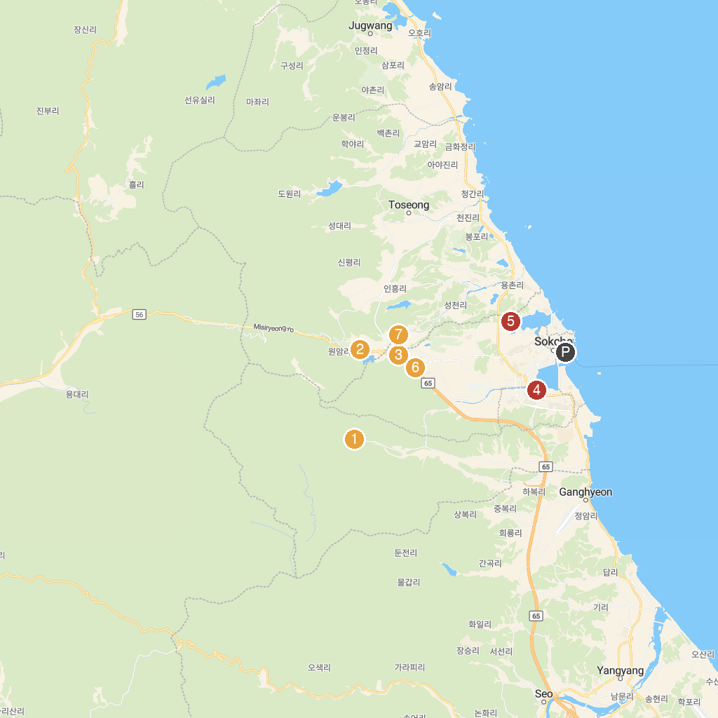
MAP KEY
1. 설악산국립공원 설악동지구 | 5. Yeongnangho Lake Hwarangdo Experience Tourism Complex
2. 울산바위 촬영휴게소 | 6. Happy Owl House
3. 테디베어팜 | 7. Bauzium Sculpture Museum
4. Expo Tower
P. Cruise port / terminal
Map © MapTiler © OpenStreetMap contributors · cruiseports.org

