Sóller, Mallorca, Spain
Tucked into a sheltered bay at the foot of the Serra de Tramuntana, Port de Sóller trades on orange groves, a vintage tramway, and one of Mallorca's prettiest mountain towns — all within easy reach of the pier.
⚓ Tender (anchor in bay) · 🕒 Typical call: 7-9 hrs · 💶 Euro (€) · 🗣️ Catalan / Spanish
✍️ MY DAY IN PORT (FILL IN)
Ship / Date
In port | arrive ______ · all aboard ______
Booked excursion
Notes / meeting point
GETTING ASHORE
- Docking: Cruise ships anchor in Port de Sóller bay and tender passengers ashore to the marina
- Walk to centre: Port de Sóller seafront is steps from the tender landing; vintage tram to Sóller town (~15 min)
- Best For: History, mountain scenery, beaches, and local cuisine
- Don't Miss: The 1913 electric tram ride up to Sóller's market square
GETTING AROUND
- 🚕 Taxi: €10–14 — Taxis are readily available at the port and take about 5–7 minutes to Sóller town center. Fixed regulated fares apply ac
- 📱 Rideshare: ✅ Uber, Bolt
TOP THINGS TO DO
- Vintage Train Palma–Sóller Round Trip — The wood-panelled 1912 train climbs through orange groves and mountain tunnels from Palma to Sóller station — one of the classic…
- Cap de Formentor & Lighthouse — A guided full-day tour or taxi excursion to Mallorca's dramatic northern headland, roughly 80 km (about 1¼ hours' drive each…
- Sóller Market & Orange Grove Walk — Sóller's weekly market (Saturdays) fills Plaça de la Constitució with local oranges, olive oil, and crafts.
- Serra de Tramuntana Hiking — The UNESCO-listed mountain range rises steeply behind the port.
- Fornalutx & Biniaraix Villages — Often ranked among Spain's most beautiful villages, Fornalutx is a 15-minute taxi ride from Sóller.
BEST WALKS
- Port de Sóller Seafront Loop: 2 km · 30–40 min · flat · no shade midday — Walk the promenade from the cruise pier along the bay to the beach, past cafés and the naval museum…
- Sóller Town Centre Walk: 1.5 km · 20–30 min · gentle slopes · historic centre — From Sóller tram station, stroll to Plaça de la Constitució to see the modernista church of Sant…
WEATHER · DAYLIGHT · MONEY
Month | High °F | Low °F | Rainy days
May | 74 | 61 | 6
Jul | 88 | 75 | 2
Sep | 81 | 71 | 10
Daylight: May 6:34AM–8:57PM · Jul 6:33AM–9:16PM · Sep 7:30AM–7:57PM
cruiseports.org/soller-mallorca · Confirm terminal & all-aboard time with your ship

Sóller, Mallorca, Spain — Port Map
Red = walkable sights · Amber = excursions farther out · P = cruise terminal
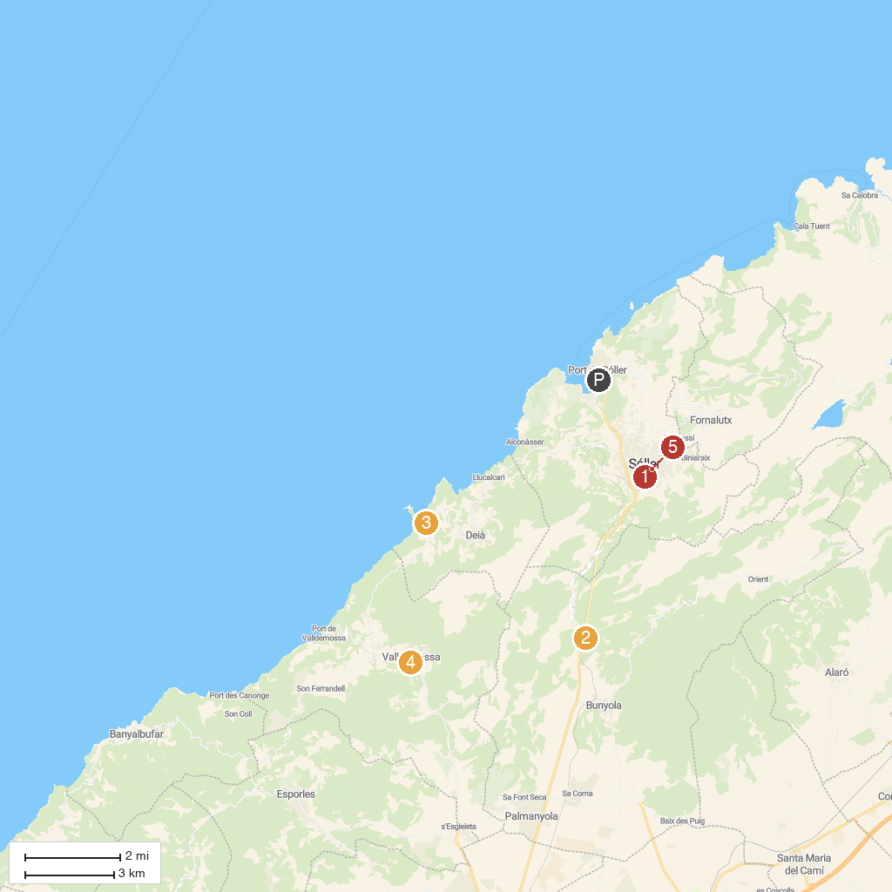
MAP KEY
1. Ferrocarril de Sóller (Sóller Railway) | 4. Real Cartuja de Valldemossa
2. Jardins d'Alfàbia | 5. Can Prunera Modernist Museum
3. Son Marroig
P. Cruise port / terminal
Map © MapTiler © OpenStreetMap contributors · cruiseports.org

