Souda (Chania), Crete, Greece
Your ship calls at Souda Bay, a deep-water NATO and commercial port on Crete's north coast — a quick bus or taxi ride from Chania, one of Greece's most beautiful old towns, with a sweeping Venetian harbor, labyrinthine alleys, and world-class Cretan food.
⚓ Docked (pier) · 🕒 Typical call: 7-9 hrs · 💶 Currency: Euro (€) · 🗣️ Language: Greek · 🏺 Venetian & Ottoman heritage
✍️ MY DAY IN PORT (FILL IN)
Ship / Date
In port | arrive ______ · all aboard ______
Booked excursion
Notes / meeting point
GETTING ASHORE
- Docking: Pier at Souda Bay — no tendering
- Port to Chania center: 6.5 km; ~15 min by taxi or bus
- Best For: History, Venetian architecture, beaches, Cretan cuisine
- Don't Miss: Walk the breakwater to the Venetian Lighthouse
GETTING AROUND
- 🚕 Taxi: €25–€30 — Taxis wait at the port exit for the 15–20 min ride to Chania Old Town. Confirm the fare before departure; metered or fix
- 📱 Rideshare: ❌ not available
TOP THINGS TO DO
- Chania Old Town & Venetian Harbor Walk — Stroll the horseshoe harbor front past Venetian arsenals and the Küçük Hasan Mosque, then walk the breakwater jetty all the way…
- Balos Lagoon & Gramvousa Island Boat Trip — A full-day boat excursion from Kissamos (1 hr west of Chania) to Balos, a dreamy lagoon with shallow turquoise water and…
- Samaria Gorge Hike — Europe's longest gorge — 16 km through the White Mountains from Xyloskalo plateau to the Libyan Sea at Agia Roumeli.
- Maritime Museum & Firka Fortress — Inside the Venetian Firka Fortress at the harbor mouth, this museum covers Cretan naval history from ancient times through WWII…
- Nea Chora Beach Day — A long sandy city beach a 15-minute walk west of the Venetian Harbor.
BEST WALKS
- Venetian Harbor Loop & Lighthouse: 2 km · 30-45 min · Easy · Free — Start at the bus/taxi drop-off near the Municipal Market.
- Old Town Alleys: Evraiki & Splantzia: 1.5 km · 30-45 min · Easy · Free — From the harbor front, duck into the Evraiki (Jewish Quarter) for its flower-filled passages and…
WEATHER · DAYLIGHT · MONEY
Month | High °F | Low °F | Rainy days
May | 72 | 63 | 5
Jul | 84 | 74 | 2
Sep | 80 | 71 | 6
Daylight: May 6:19AM–8:21PM · Jul 6:20AM–8:38PM · Sep 7:06AM–7:30PM
cruiseports.org/souda-chania · Confirm terminal & all-aboard time with your ship

Souda (Chania), Crete, Greece — Port Map
Red = walkable sights · Amber = excursions farther out · P = cruise terminal
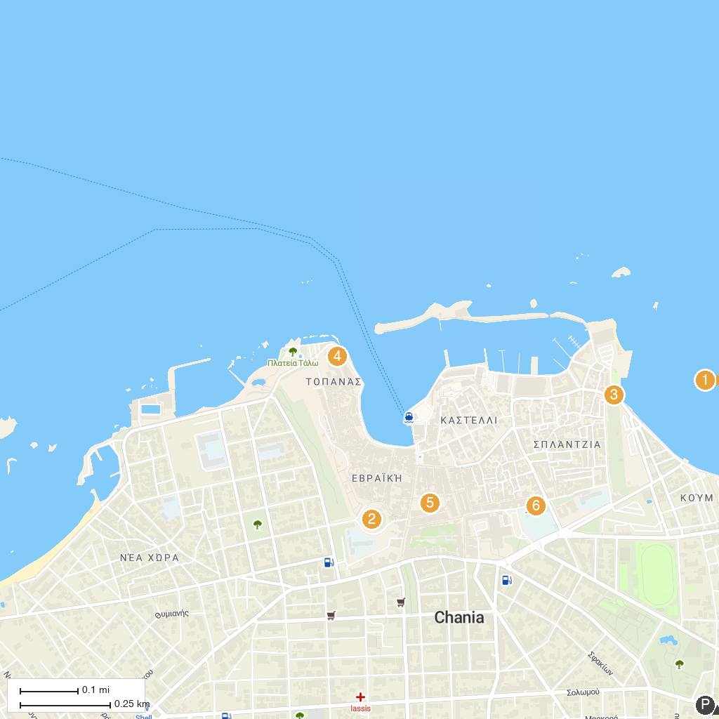
MAP KEY
1. Eleftherios Venizelos House | 5. Ενετικό φρούριο Φιρκά | Firka Venetian Fortress
2. Land bastion | 6. Folklore Museum of Gavalochori
3. Monastery Katholiko | 7. Holy Metropolitan Church of the Presentation of the Virgin Mary (Trimartiri)
4. Porta Sabbionara | 8. Greek National Football Team Museum
P. Cruise port / terminal
Map © MapTiler © OpenStreetMap contributors · cruiseports.org

