Speightstown, St. Peter, Barbados
Known as 'Little Bristol' for its 17th-century trade links with England, Speightstown skipped the tourist-resort makeover and kept its soul — colonial jetty-houses, a brilliant interactive museum, and calm platinum-coast beaches all within a short stroll of the tender jetty.
⚓ Tender port (small/luxury ships only) · 🕒 Typical call: 6-8 hrs · 💵 Barbados Dollar (BDS 2:1 USD; US$ widely accepted) · 🗣️ English · 🏖️ Uncrowded beaches
✍️ MY DAY IN PORT (FILL IN)
Ship / Date
In port | arrive ______ · all aboard ______
Booked excursion
Notes / meeting point
GETTING ASHORE
- Docking: Tender to Speightstown Jetty (small luxury & expedition ships only; most Barbados calls dock in Bridgetown, 12 mi south)
- Walk to center: 0 min — tender lands directly on Queen Street
- Best For: History, authentic Bajan culture, uncrowded beaches
- Don't Miss: Arlington House Museum & flying fish lunch at Fisherman's Pub
GETTING AROUND
- 🚕 Taxi: ~$40–50 USD to Bridgetown — Licensed taxis are available at the pier and in town. The fare to Bridgetown is approximately BDS $80–100 (~$40–50 USD);
- 📱 Rideshare: ✅ Uber
TOP THINGS TO DO
- Arlington House Museum — Three floors of immersive exhibits inside a restored 18th-century merchant's home trace Speightstown's days as a major…
- Barbados Wildlife Reserve — Walk freely among free-roaming green monkeys, red-footed tortoises, pelicans, and deer in a mahogany forest.
- St. Nicholas Abbey & Steam Train — One of the Western Hemisphere's oldest plantation houses — a stunning 350-year-old Jacobean manor with a working rum distillery.
- Mullins Beach — Active and lively platinum-coast beach with calm turquoise water, lounge chair rentals, watersports, and the Mullins Beach Bar.
- Bajan Lunch & Street Food Walk — Speightstown is a foodie's secret — flying fish & cou-cou at Fisherman's Pub, gourmet pizza at The Orange Street Grocer, fresh…
BEST WALKS
- Town History Walk: 0.5 mi · 30-45 min · Easy — From the jetty, stroll Queen Street past the overhanging 'jetty-house' balconies and St.
- Esplanade to Heywoods Beach: 1 mi · 20-30 min · Easy — Walk north along the esplanade boardwalk, past the fish market and Port St.
WEATHER · DAYLIGHT · MONEY
Month | High °F | Low °F | Rainy days
May | 84 | 78 | 11
Jul | 84 | 78 | 22
Sep | 85 | 79 | 20
Daylight: May 5:32AM–6:17PM · Jul 5:39AM–6:29PM · Sep 5:47AM–5:59PM
cruiseports.org/speightstown · Confirm terminal & all-aboard time with your ship

Speightstown, St. Peter, Barbados — Port Map
Red = walkable sights · Amber = excursions farther out · P = cruise terminal
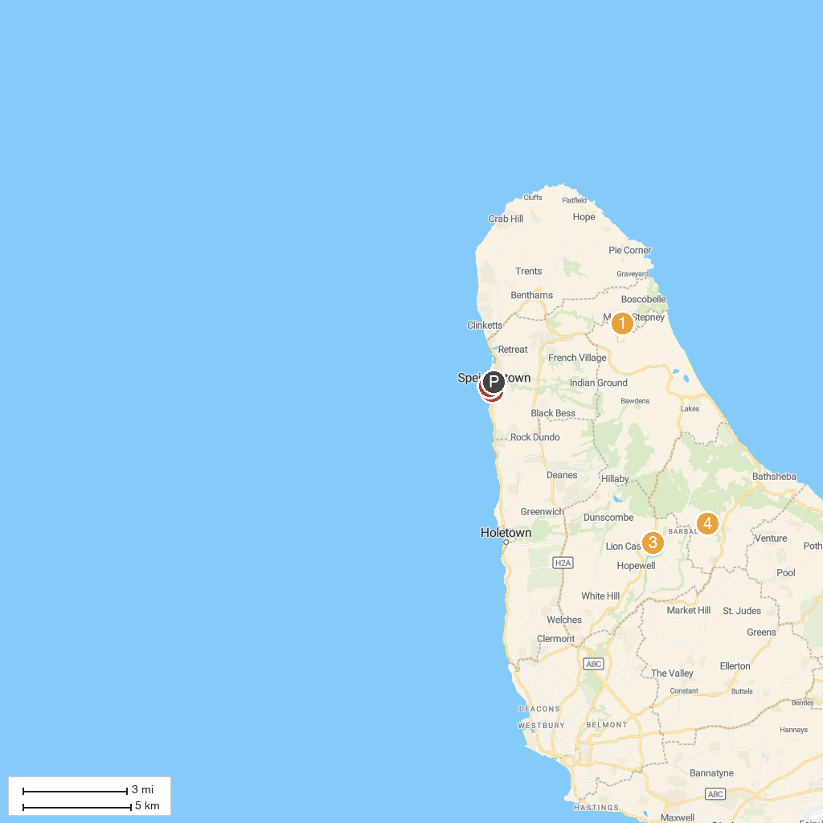
MAP KEY
1. St. Nicholas Abbey and Steam Railway | 4. Hunte's Gardens
2. Gallery Of Caribbean Art | 5. Tyrol Cot Heritage Village
3. Harrison's Cave Eco-Adventure Park | 6. Speightstown Pier
P. Cruise port / terminal
Map © MapTiler © OpenStreetMap contributors · cruiseports.org

