Speyer, Rhineland-Palatinate, Germany
One of the Rhine's most rewarding stops: a 2,000-year-old imperial city where a Romanesque UNESCO cathedral, the oldest Jewish ritual bath in Europe, and a Soviet space shuttle all sit within easy walking distance of the dock.
⚓ Docked (riverside pier) · 🕒 Typical call: 7-9 hrs · 💶 Euro (€) — carry cash · 🗣️ German (English widely spoken) · 🚶 Extremely walkable from dock
✍️ MY DAY IN PORT (FILL IN)
Ship / Date
In port | arrive ______ · all aboard ______
Booked excursion
Notes / meeting point
GETTING ASHORE
- Docking: Riverside pier on the Leinpfad promenade, ~500 m from the Cathedral
- Walk to center: 5–8 min flat walk to Cathedral; 15 min to Altpörtel gate
- Best For: Medieval history, Romanesque architecture, Jewish heritage, tech museum
- Don't Miss: Cathedral crypt with 8 Holy Roman Emperors; the 1,100-year-old Mikveh
GETTING AROUND
- 🚕 Taxi: €7–€15 — Taxis are available near the dock and at the main train station. Short intra-city rides are inexpensive; useful for reac
- 📱 Rideshare: ✅ Uber
TOP THINGS TO DO
- Speyer Cathedral & Imperial Crypt — The largest preserved Romanesque church in the world, a UNESCO World Heritage site since 1981.
- Judenhof & Medieval Mikveh — A UNESCO-listed Jewish heritage site behind the Cathedral.
- Technik Museum Speyer — A sprawling aviation, space, and technology museum housing a genuine Soviet Buran space shuttle, a Boeing 747 you can walk…
- Historical Museum of the Palatinate — Beside the Cathedral, this museum holds Roman treasures, medieval artefacts, and the extraordinary Wine Museum — home to the…
- Maximilianstraße Stroll & Altpörtel — Speyer's grand pedestrian boulevard runs from the Cathedral west to the Altpörtel, one of the best-preserved medieval city gates…
BEST WALKS
- Dock to Cathedral to Judenhof Loop: ~1.5 km | 30–45 min | Flat | Free (nav fee for Mikveh) — The essential Speyer walk.
- Maximilianstraße to Altpörtel & Back: ~2.5 km round trip | 45–60 min | Flat | Free (tower ~€2) — From the Cathedral, turn onto Maximilianstraße and walk the full length of Speyer's main pedestrian…
WEATHER · DAYLIGHT · MONEY
Month | High °F | Low °F | Rainy days
May | 67 | 50 | 11
Jul | 80 | 62 | 10
Sep | 71 | 55 | 9
Daylight: May 5:43AM–9:03PM · Jul 5:37AM–9:26PM · Sep 7:03AM–7:38PM
cruiseports.org/speyer · Confirm terminal & all-aboard time with your ship

Speyer, Rhineland-Palatinate, Germany — Port Map
Red = walkable sights · Amber = excursions farther out · P = cruise terminal
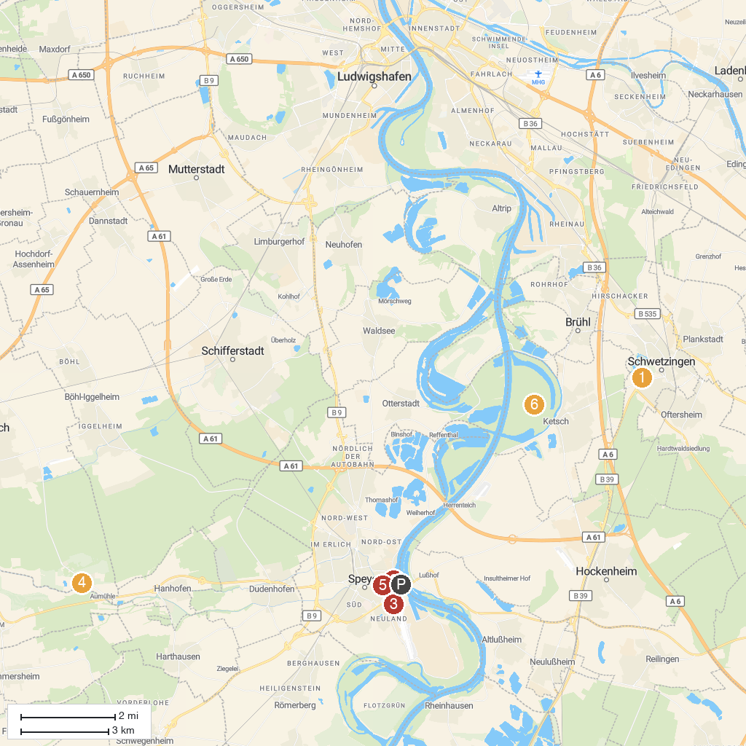
MAP KEY
1. Mosque in The Palace Garden | 5. Speyerer Dom
2. SEA LIFE Speyer | 6. Schwetzingen Palace
3. Technik Museum Speyer | 7. WBL - Wild Park Rheingönheim
4. Plopsaland Germany | 8. Ketscher Rheininsel
P. Cruise port / terminal
Map © MapTiler © OpenStreetMap contributors · cruiseports.org

