St. Anthony, Newfoundland, Canada
At the northern tip of Newfoundland, St. Anthony is the gateway to the only authenticated Viking settlement in North America — and on the right day, drifting icebergs and breaching humpbacks come free of charge.
⚓ Docked or Tendered (small wharf) · 🕒 Typical call: 6–8 hrs · 💵 Canadian Dollar (CAD) · 🗣️ English
✍️ MY DAY IN PORT (FILL IN)
Ship / Date
In port | arrive ______ · all aboard ______
Booked excursion
Notes / meeting point
GETTING ASHORE
- Docking: Town wharf (small; some ships tender)
- Walk to center: 5–10 min on foot
- Best For: Vikings · Icebergs · Wildlife
- Don't Miss: L'Anse aux Meadows UNESCO site
GETTING AROUND
- 🚕 Taxi: Varies (can be pricey) — Town Taxi is the main local provider. Supply is limited when a large ship is in port — arrange pickup in advance and exp
- 🚌 Hop-on hop-off: ✅ SABRI (St. Anthony Basin Resources Inc.)
TOP THINGS TO DO
- L'Anse aux Meadows — The only confirmed Viking/Norse settlement in North America, dating to around 1000 CE.
- Iceberg & Whale Watching — St.
- Grenfell Historic Properties — Sir Wilfred Grenfell came to this remote coast in the 1890s as a medical missionary and built hospitals, schools, and cooperatives.
- Fishing Point Park & Lighthouse Trail — A short walk from town leads to Fishing Point Park, where a coastal trail winds past the lighthouse with panoramic views of the…
BEST WALKS
- Fishing Point Lighthouse Trail: ~3 km return · 1–1.5 hrs · easy — Walk out along the rocky headland to the Fishing Point lighthouse for sweeping views of the harbor…
- Town & Grenfell Walk: ~1.5 km · 45 min · easy — From the wharf, stroll through the compact town center to the Grenfell Interpretation Centre and…
WEATHER · DAYLIGHT · MONEY
Month | High °F | Low °F | Rainy days
May | 43 | 33 | 13
Jul | 63 | 51 | 13
Sep | 57 | 47 | 15
Daylight: May 5:20AM–8:57PM · Jul 5:14AM–9:21PM · Sep 6:48AM–7:25PM
cruiseports.org/st-anthony · Confirm terminal & all-aboard time with your ship

St. Anthony, Newfoundland, Canada — Port Map
Red = walkable sights · Amber = excursions farther out · P = cruise terminal
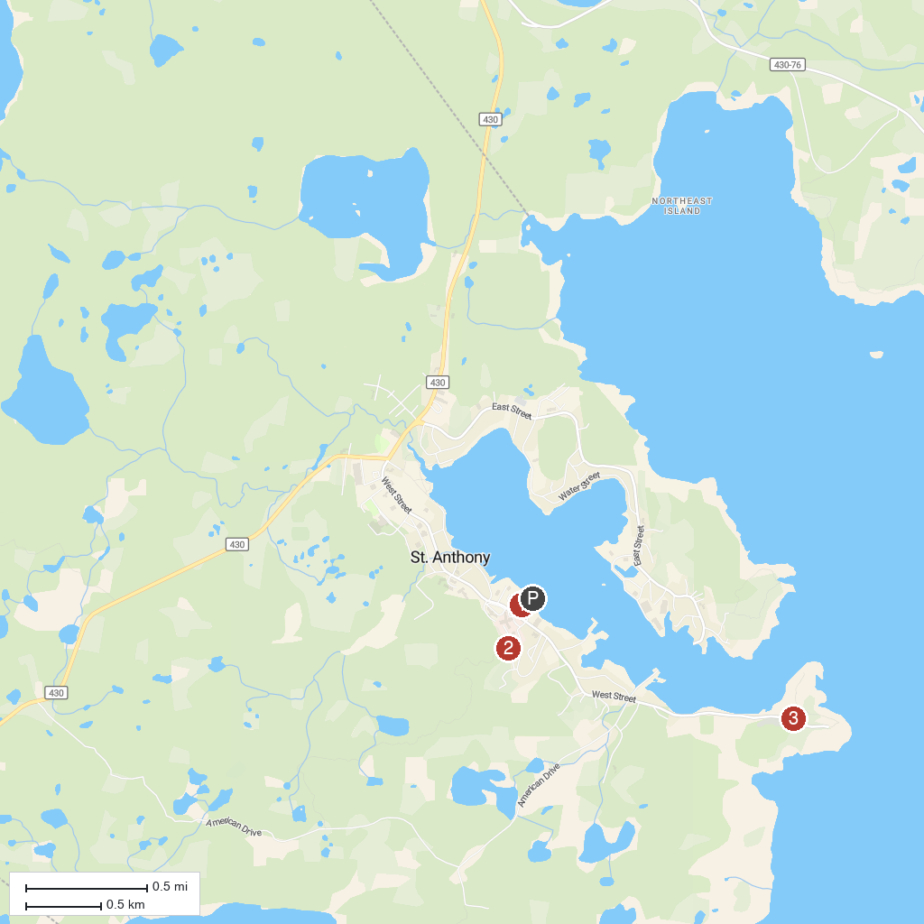
MAP KEY
1. Grenfell Historical Society | 3. Fishing Point Municipal Park
2. Grenfell House Museum
P. Cruise port / terminal
Map © MapTiler © OpenStreetMap contributors · cruiseports.org

