St. Francisville, Louisiana, USA
Perched on bluffs above the Mississippi, St. Francisville is Louisiana's antebellum jewel — grand plantation houses, moss-draped oaks, and the landscape that inspired John James Audubon's greatest works.
⚓ River docking (pier or shore tie) · 🕒 Typical call: 6–8 hrs · 💵 US Dollar · 🗣️ English / Louisiana Creole · 🏛️ Plantation & history focus
✍️ MY DAY IN PORT (FILL IN)
Ship / Date
In port | arrive ______ · all aboard ______
Booked excursion
Notes / meeting point
GETTING ASHORE
- Docking: River pier tie-up or shore landing; most ships walk off directly
- Walk to center: 5–10 min from typical landing to Royal Street historic district
- Best For: Antebellum plantation tours, birdwatching, Southern food, ghost stories
- Don't Miss: Rosedown Plantation gardens and Audubon State Historic Site (Oakley House)
GETTING AROUND
- 🚕 Taxi: ~$15–25 — A handful of local taxi services serve the area. Fares to nearby plantations like Rosedown or The Myrtles typically run
- 📱 Rideshare: ✅ Uber, Lyft
TOP THINGS TO DO
- Rosedown Plantation State Historic Site — An 1835 cotton plantation with an 8,000-sq-ft mansion and 28 acres of formal European-inspired gardens — a National Historic…
- Audubon State Historic Site (Oakley House) — John James Audubon lived here in 1821 and painted 32 of his Birds of America works.
- The Myrtles Plantation — Billed as one of America's most haunted homes, the Myrtles offers daytime and evening tours of its antebellum house, grounds, and…
- St. Francisville Historic District Walk — Stroll Royal Street and the surrounding blocks: beautifully preserved 19th-century homes, independent boutiques, galleries, and…
- Afton Villa Gardens — Dramatic 'ruins gardens' on the site of a Gothic mansion destroyed by fire — a hauntingly beautiful formal garden with an…
BEST WALKS
- Royal Street Historic Stroll: 1.5 miles · Easy · 1–2 hrs — Walk up from the riverfront through the historic district along Royal Street, past 19th-century…
cruiseports.org/st-francisville-la · Confirm terminal & all-aboard time with your ship

St. Francisville, Louisiana, USA — Port Map
Red = walkable sights · Amber = excursions farther out · P = cruise terminal
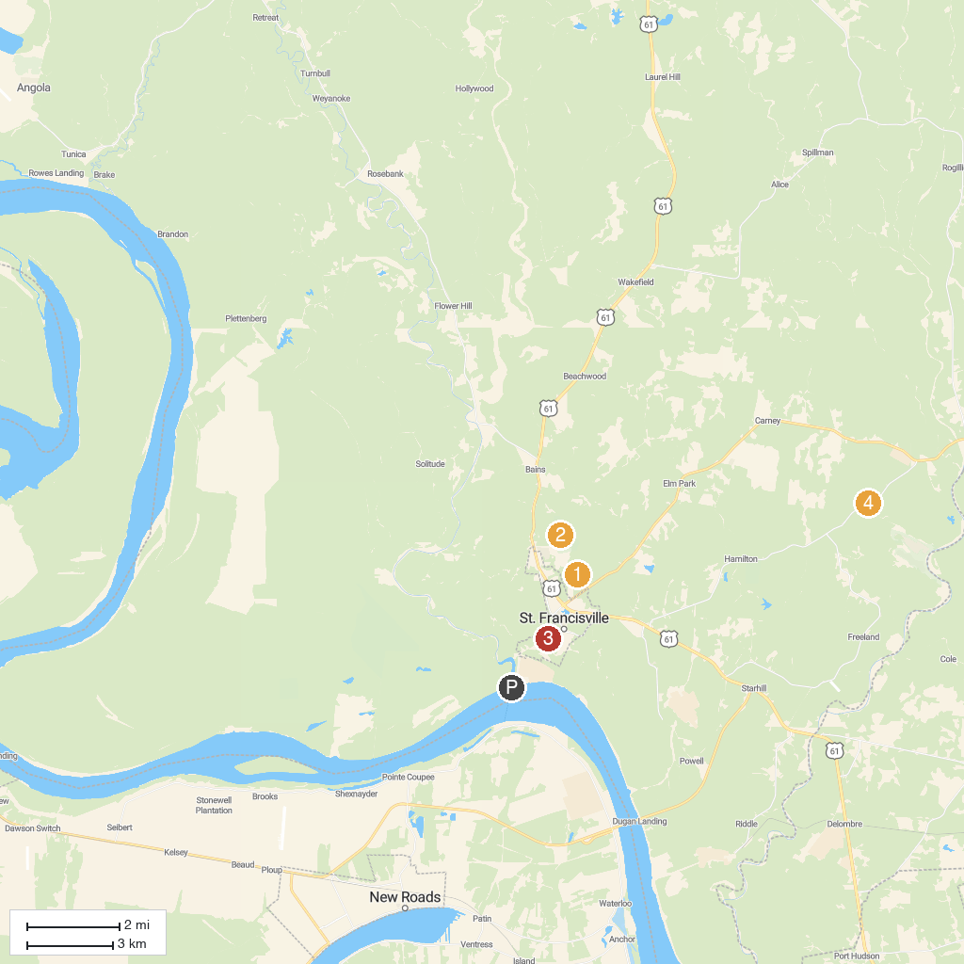
MAP KEY
1. Port Hudson State Historic Site | 4. West Feliciana Historical Society and Museum
2. Rosedown Plantation State Historic Site | 5. Mary Ann Brown Nature Preserve
3. West Feliciana Parish Parks
P. Cruise port / terminal
Map © MapTiler © OpenStreetMap contributors · cruiseports.org

