St John, U.S. Virgin Islands
The smallest and most pristine of the U.S. Virgin Islands, St John is 60% national park — a rare Caribbean island of world-class beaches, sea turtles, and zero traffic lights.
⚓ Tender (small ships direct; most visit via ferry from St Thomas) · 🕒 Typical call: 6-8 hrs · 💵 USD (no exchange needed) · 🗣️ English · 🏝️ 60% Virgin Islands National Park
✍️ MY DAY IN PORT (FILL IN)
Ship / Date
In port | arrive ______ · all aboard ______
Booked excursion
Notes / meeting point
GETTING ASHORE
- Docking: Tender only — small/luxury ships anchor in Cruz Bay; most cruise passengers ferry from St Thomas via Red Hook (~20 min, $8 each way)
- Walk to town: Immediate — Cruz Bay ferry dock drops you into the heart of town
- Best For: Snorkeling (Trunk Bay trail), sea turtle watching at Maho Bay, unspoiled Caribbean beaches
- Don't Miss: Trunk Bay's 650-ft underwater snorkeling trail; Maho Bay sea turtles; Annaberg Sugar Plantation ruins
GETTING AROUND
- 🚕 Taxi: $8-20 per person — The main local transport. Shared open-air safari buses run fixed per-person rates to beaches and attractions. Within Cru
- 📱 Rideshare: ❌ not available
TOP THINGS TO DO
- Trunk Bay Beach & Snorkel Trail — Consistently ranked one of the world's top beaches, Trunk Bay features a self-guided 650-ft underwater snorkel trail with plaques…
- Maho Bay Sea Turtle Watch — Maho Bay is famous for green sea turtles grazing in its shallow seagrass beds — sightings are nearly guaranteed.
- Annaberg Sugar Plantation — One of the best-preserved 18th-century Danish sugar plantations in the Caribbean.
- Reef Bay Hike with Petroglyphs — A National Park-guided strenuous hike through tropical forest to ancient Taino petroglyphs and sugar mill ruins, ending with a…
- Private Boat Charter — Charter a catamaran or speedboat for a full or half day to visit secluded cays, snorkel offshore reefs, and reach beaches…
BEST WALKS
- Cruz Bay Town Stroll: 30 min · Flat · Free — From the ferry dock, explore the colorful waterfront town — the National Park Visitor Center…
- Lind Point Trail to Honeymoon Beach: 1 mile each way · Moderate · Free — Begin at the NPS Visitor Center behind the dock, follow Lind Point Trail through forest to…
WEATHER · DAYLIGHT · MONEY
Month | High °F | Low °F | Rainy days
May | 80 | 78 | 11
Jul | 82 | 80 | 14
Sep | 83 | 80 | 16
Daylight: May 5:45AM–6:45PM · Jul 5:51AM–6:58PM · Sep 6:07AM–6:21PM
cruiseports.org/st-john-island-usvi · Confirm terminal & all-aboard time with your ship

St John, U.S. Virgin Islands — Port Map
Red = walkable sights · Amber = excursions farther out · P = cruise terminal
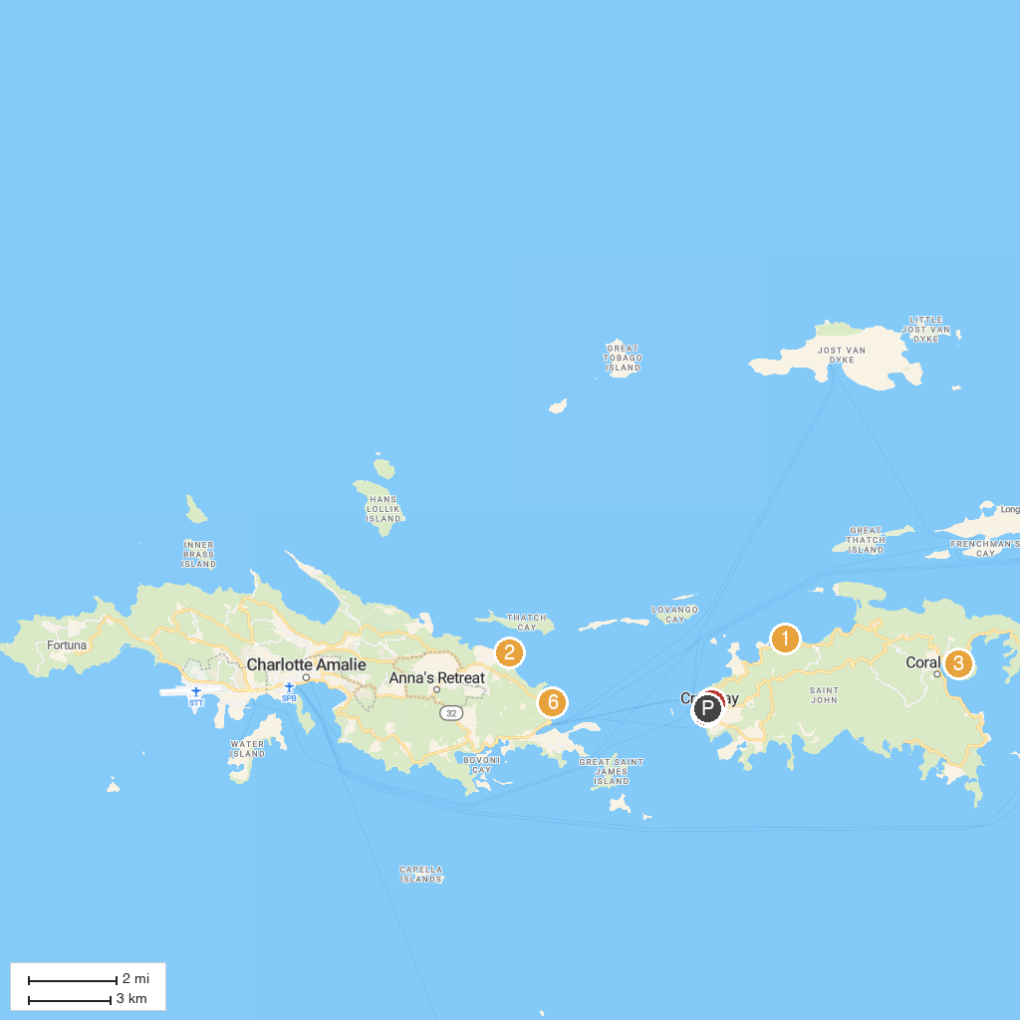
MAP KEY
1. Drake's Seat | 5. Carolina Corral
2. Skyride to Paradise Point | 6. Cruz Bay Visitor Center
3. Coral Reef Underwater Park Trail | 7. Our Lady Of Mt. Carmel
4. Coral World Ocean Park | 8. Parasail Virgin Islands
P. Cruise port / terminal
Map © MapTiler © OpenStreetMap contributors · cruiseports.org

