St. John's, Antigua, Caribbean
Antigua's capital greets ships with two walk-off piers right in the heart of town — making it one of the Caribbean's most convenient ports. Beyond the duty-free quays, 365 beaches and a UNESCO World Heritage naval dockyard await.
⚓ Docked — Heritage Quay or Deep Water Harbour · 🕒 Typical call: 7-9 hrs · 💵 Eastern Caribbean Dollar (USD widely accepted) · 🗣️ English
✍️ MY DAY IN PORT (FILL IN)
Ship / Date
In port | arrive ______ · all aboard ______
Booked excursion
Notes / meeting point
GETTING ASHORE
- Docking: Heritage Quay (walk-off to town) or Deep Water Harbour (~1 km from center)
- Walk to center: 0 min from Heritage Quay; 10-15 min from Deep Water Harbour
- Best For: Beaches, snorkeling, history (Nelson's Dockyard), and stingray encounters
- Don't Miss: Nelson's Dockyard National Park & Shirley Heights Lookout
GETTING AROUND
- 🚕 Taxi: $12-15 USD — Government-regulated fixed-rate taxis queue at the pier. Fares to nearby beaches like Dickenson Bay or Fort James run ro
- 📱 Rideshare: ❌ not available
TOP THINGS TO DO
- Nelson's Dockyard & Shirley Heights — UNESCO-listed English Harbour holds the only continuously operating Georgian-era naval dockyard in the world.
- Stingray City Antigua — Take a short boat ride out to a shallow offshore sandbar near Seaton's Village to wade in waist-deep water and hand-feed Southern…
- Beach Day — Dickenson Bay or Fort James — Fort James Beach is the closest to the port (10-min taxi), with calm water and vendors.
- Catamaran Sail & Snorkel — Sail along Antigua's south coast to snorkel Cades Reef, one of the Caribbean's longest fringing reefs.
- Rainforest Zipline Safari — Fly through Antigua's interior forest canopy on a multi-line zipline course, then explore the island's rugged landscape on an…
BEST WALKS
- Heritage Quay to St. John's Cathedral: 1.5 km · 20 min · Easy — Leave Heritage Quay heading east on Thames Street, passing Redcliffe Quay's colonial storefronts.
- Pier to Public Market: 0.8 km · 10 min · Easy — From Heritage Quay, head south on High Street into the heart of the local market district.
WEATHER · DAYLIGHT · MONEY
Month | High °F | Low °F | Rainy days
May | 84 | 77 | 16
Jul | 85 | 79 | 20
Sep | 86 | 79 | 21
Daylight: May 5:35AM–6:31PM · Jul 5:42AM–6:44PM · Sep 5:55AM–6:08PM
cruiseports.org/st-johns-antigua · Confirm terminal & all-aboard time with your ship

St. John's, Antigua, Caribbean — Port Map
Red = walkable sights · Amber = excursions farther out · P = cruise terminal
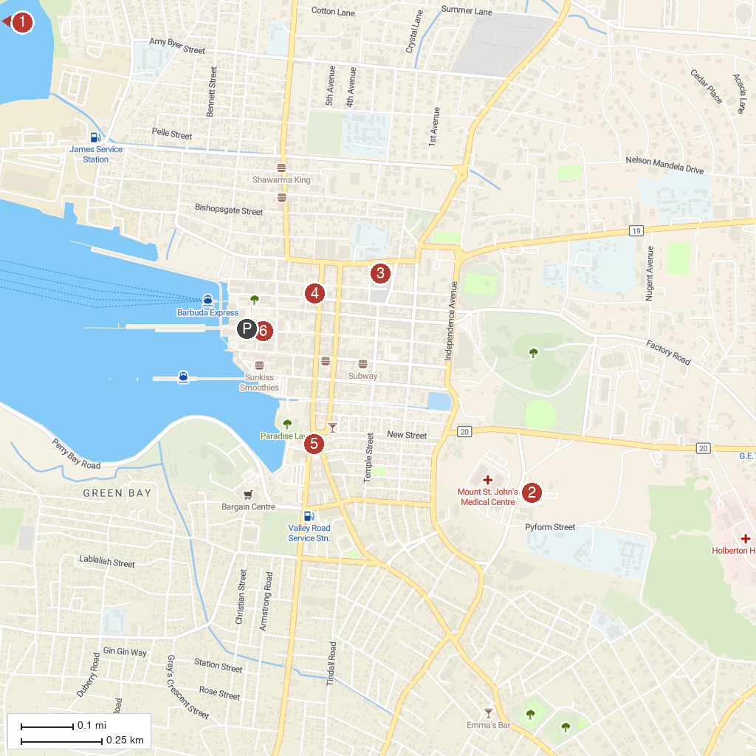
MAP KEY
1. Fort James | 5. Museum Of Antigua & Barbuda
2. Holy Family Catholic Cathedral | 6. VC Bird Monument
3. Antigua's Donkey Sanctuary Humane Society | 7. Antigua Cruise Port
4. Saint John's Cathedral
P. Cruise port / terminal
Map © MapTiler © OpenStreetMap contributors · cruiseports.org

