St. Louis, Missouri, USA
Where the Mississippi River bends beneath a shining 630-foot arch, St. Louis delivers a full day of free world-class museums, legendary BBQ, and big American city energy—all steps from the cobblestone levee.
⚓ Docked (cobblestone levee) · 🕒 Typical call: 8–10 hrs or home port · 💵 USD · 🗣️ English · 🌡️ Hot humid summers; mild spring/fall
✍️ MY DAY IN PORT (FILL IN)
Ship / Date
In port | arrive ______ · all aboard ______
Booked excursion
Notes / meeting point
GETTING ASHORE
- Docking: Riverboat dock at cobblestone levee below Gateway Arch, 50 S. Leonor K. Sullivan Blvd
- Walk to Arch: Steps from the dock — Gateway Arch National Park is immediately adjacent
- Best For: History, architecture, free museums, BBQ & blues
- Don't Miss: Tram ride to the top of the Gateway Arch and a frozen custard at Ted Drewes
GETTING AROUND
- 🚕 Taxi: $6–$15 for downtown trips — Metered taxis are available near the levee on Leonor K. Sullivan Blvd. Base fare ~$3.50–$4.50 plus ~$2–$3 per mile; avai
- 📱 Rideshare: ✅ Uber, Lyft
TOP THINGS TO DO
- Gateway Arch Tram Ride — Ride a pod-shaped tram to the observation deck of the world's tallest arch for panoramic views of St.
- Forest Park & Free Museums — One of the largest urban parks in the US — home to the free St.
- Old Courthouse & Museum of Westward Expansion — The domed Old Courthouse was the site of early Dred Scott hearings.
- Laclede's Landing & Blues Bars — The cobblestone district just north of the Arch is St.
- St. Louis Food Tour: Toasted Ravioli, BBQ & Custard — Sample the city's three food obsessions: toasted (deep-fried) ravioli on The Hill, St.
BEST WALKS
- Riverfront to Old Courthouse Walk: 0.6 miles · 15 min · Flat cobblestones and paved paths — Walk off the gangway onto the cobblestone levee, stroll through Gateway Arch National Park, and…
- Arch to Laclede's Landing: 0.5 miles · 12 min · Flat riverfront — Head north along the riverfront from the dock to Laclede's Landing, St.
WEATHER · DAYLIGHT · MONEY
Month | High °F | Low °F | Rainy days
May | 76 | 57 | 14
Jul | 88 | 70 | 13
Sep | 81 | 63 | 8
Daylight: May 5:48AM–8:05PM · Jul 5:49AM–8:24PM · Sep 6:42AM–7:08PM
cruiseports.org/st-louis-mo · Confirm terminal & all-aboard time with your ship

St. Louis, Missouri, USA — Port Map
Red = walkable sights · Amber = excursions farther out · P = cruise terminal
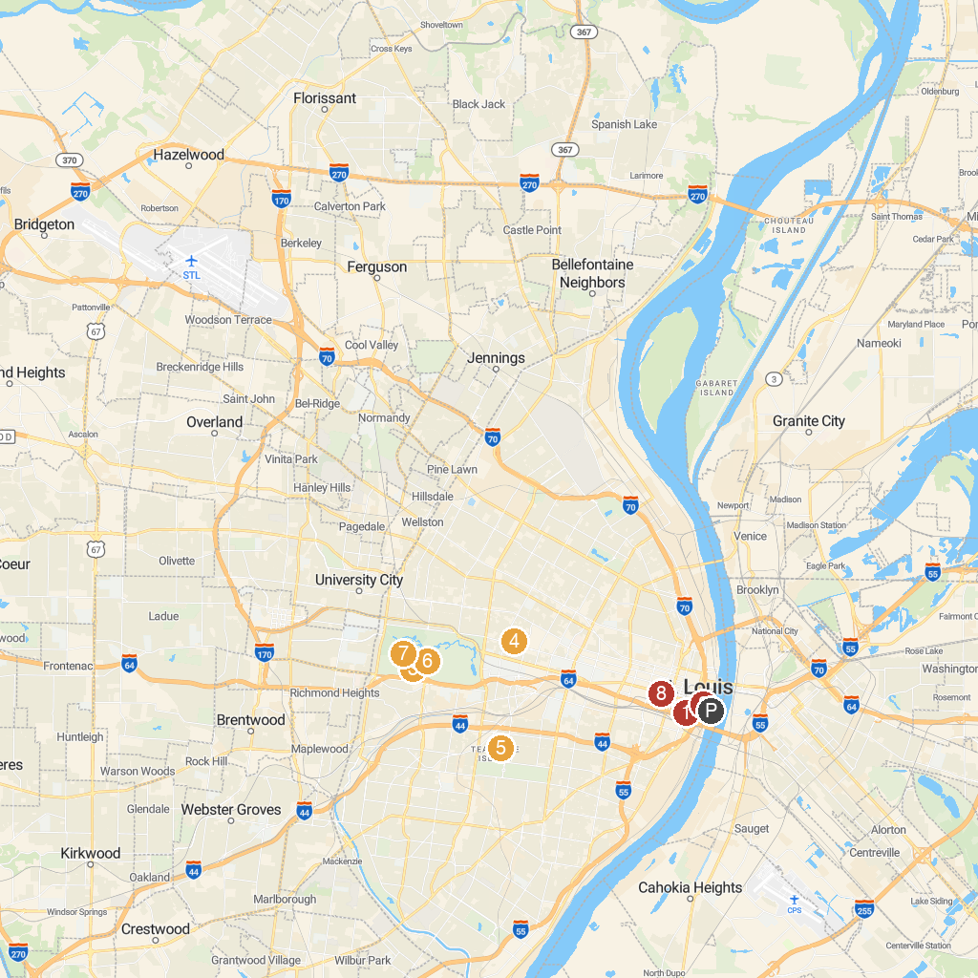
MAP KEY
1. Busch Stadium | 5. Missouri Botanical Garden
2. The Gateway Arch | 6. Forest Park
3. Saint Louis Zoo | 7. Saint Louis Art Museum
4. The Cathedral Basilica of St. Louis | 8. Stifel Theatre
P. Cruise port / terminal
Map © MapTiler © OpenStreetMap contributors · cruiseports.org

