St Michaels, Maryland, USA
A preserved 19th-century maritime village on Maryland's Eastern Shore, St. Michaels delivers fresh blue crab, an 18-acre waterfront museum, and storied War of 1812 lore — all steps from the dock.
⚓ Pier (docked at CBMM marina) · 🕒 Typical call: 6-8 hrs · 💵 USD · 🗣️ English · 🦀 Small-ship port only
✍️ MY DAY IN PORT (FILL IN)
Ship / Date
In port | arrive ______ · all aboard ______
Booked excursion
Notes / meeting point
GETTING ASHORE
- Docking: Pier — ships dock directly at Chesapeake Bay Maritime Museum
- Walk to center: 0.2 mi to Talbot Street (3-5 min flat walk)
- Best For: Maritime history, Maryland seafood, boutique shopping, boat tours
- Don't Miss: Hooper Strait Lighthouse climb + steamed blue crabs at The Crab Claw
GETTING AROUND
- 🚕 Taxi: $4–$5 per person each way — The St. Michaels Harbor Shuttle is the primary link between anchored vessels and the town. Hail on VHF Channel 71 or cal
- 📱 Rideshare: ✅ Uber, Lyft
TOP THINGS TO DO
- Chesapeake Bay Maritime Museum — Eighteen waterfront acres covering Chesapeake oystering, crabbing, and boatbuilding heritage.
- Patriot River Cruise — A 75-minute narrated cruise on the Miles River aboard a steamboat-style vessel, departing from the CBMM dock.
- Skipjack Sail on Rebecca Ruark — Sail a National Historic Landmark — an 1886 wooden oyster-dredging skipjack, one of the oldest still sailing on the Bay.
- Maryland Blue Crab Experience — Steamed crabs piled high with Old Bay seasoning — eaten with a wooden mallet at The Crab Claw's outdoor waterfront deck.
- Historic Downtown Walking Tour — Wander Talbot Street and side streets (Green Street, Mulberry Street) past Federal, Colonial, and Victorian homes many dating to…
BEST WALKS
- Dock to Downtown Loop: 1.2 miles | ~25 min | Easy | Flat brick sidewalks — From the CBMM marina, walk up Mill Street to Talbot Street (the main drag), past shops and…
- Waterfront Nature Trail: 1.5 miles | ~30 min | Easy | Waterside path — St.
WEATHER · DAYLIGHT · MONEY
Month | High °F | Low °F | Rainy days
May | 71 | 59 | 12
Jul | 85 | 75 | 14
Sep | 78 | 68 | 10
Daylight: May 5:52AM–8:10PM · Jul 5:52AM–8:28PM · Sep 6:46AM–7:12PM
cruiseports.org/st-michaels-md · Confirm terminal & all-aboard time with your ship

St Michaels, Maryland, USA — Port Map
Red = walkable sights · Amber = excursions farther out · P = cruise terminal
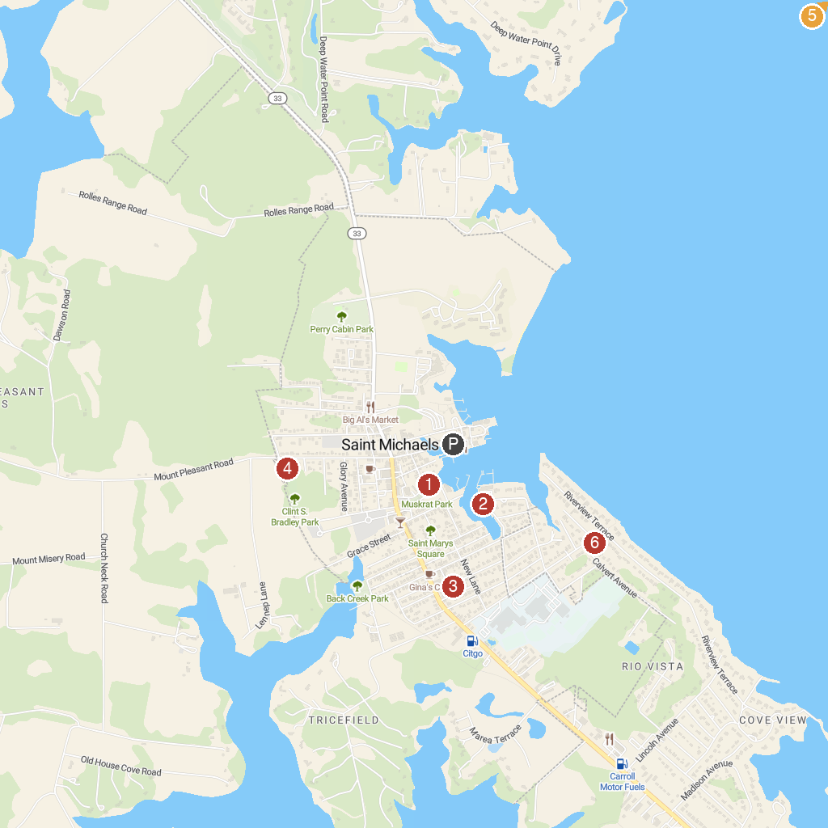
MAP KEY
1. Muskrat Park | 5. Wye Island NRMA
2. Sail Selina II | 6. Pickering Creek Audubon Center
3. Classic Motor Museum of St. Michaels | 7. Academy Art Museum
4. Bradley Park | 8. Waterfront Park on Miles River
P. Cruise port / terminal
Map © MapTiler © OpenStreetMap contributors · cruiseports.org

