St. Petersburg, Florida, USA
A walkable, arts-rich waterfront city on Tampa Bay — home to the world's largest Dalí collection outside Europe, a spectacular new pier, and easy access to some of Florida's best Gulf beaches.
⚓ Docked (downtown marina/quay) · 🕒 Typical call: 7-10 hrs · 💵 USD · 🗣️ English
✍️ MY DAY IN PORT (FILL IN)
Ship / Date
In port | arrive ______ · all aboard ______
Booked excursion
Notes / meeting point
GETTING ASHORE
- Docking: Small ships dock at the Port of St. Petersburg quay near downtown Bayboro Harbor; within walking distance of the city core.
- Walk to center: 5-15 min on foot to Beach Drive and St. Pete Pier from the Harborage/Municipal Marina area.
- Best For: Art lovers (Dalí, Chihuly), waterfront strolls, Gulf beach day trips.
- Don't Miss: The Salvador Dalí Museum — the largest Dalí collection outside of Europe, with stunning architecture.
GETTING AROUND
- 🚕 Taxi: $10–$20 — Taxis queue at the port and can take you downtown in about 5–10 minutes. Starting fare ~$3.37, then ~$2.38/mile.
- 📱 Rideshare: ✅ Uber, Lyft
TOP THINGS TO DO
- Salvador Dalí Museum — The largest collection of Dalí's work outside Europe — over 2,000 pieces including major oil paintings — housed in a striking…
- St. Pete Pier — The reimagined 26-acre pier stretches into Tampa Bay with restaurants, a splash pad, Spa Beach, sweeping bay views, and public art.
- Clearwater Beach Day Trip — One of the US's top-rated beaches is just 40 minutes away.
- Egmont Key Catamaran Cruise — A 4-hour catamaran excursion to Egmont Key — snorkel, explore the historic Fort Dade ruins and lighthouse, and watch for dolphins…
- Museum of Fine Arts & Waterfront Museum District — Beach Drive clusters the Museum of Fine Arts (Monet, O'Keeffe, Wyeth), the Chihuly Collection, and the Morean Arts Center within…
BEST WALKS
- Waterfront Museum District Loop: 2.5 miles · Easy · 60-90 min — From the pier area, walk south along Beach Drive past the Museum of Fine Arts, Vinoy Park, and the…
- Central Avenue Mural & Brewery Walk: 1 mile · Easy · 45-60 min — Stroll Central Avenue from 1st Street to 9th Street through the Central Arts District.
WEATHER · DAYLIGHT · MONEY
Month | High °F | Low °F | Rainy days
May | 84 | 72 | 11
Jul | 87 | 78 | 25
Sep | 86 | 76 | 20
Daylight: May 6:41AM–8:13PM · Jul 6:45AM–8:28PM · Sep 7:16AM–7:34PM
cruiseports.org/st-petersburg-fl · Confirm terminal & all-aboard time with your ship

St. Petersburg, Florida, USA — Port Map
Red = walkable sights · Amber = excursions farther out · P = cruise terminal
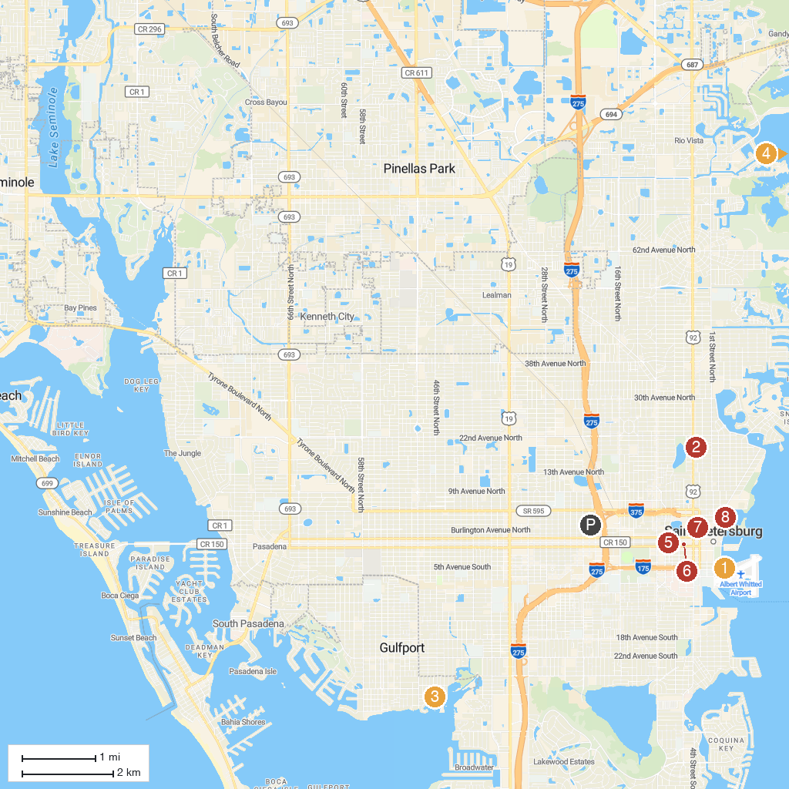
MAP KEY
1. The Dalí Museum | 5. Chihuly Collection
2. Sunken Gardens | 6. The Florida Holocaust Museum
3. Island Boat Adventures | 7. St. Petersburg Saturday Morning Market
4. Weedon Island Preserve | 8. North Straub Park
P. Cruise port / terminal
Map © MapTiler © OpenStreetMap contributors · cruiseports.org

