St. Thomas, U.S. Virgin Islands
One of the Caribbean's busiest cruise ports — turquoise bays, a legendary duty-free strip, aerial tramways above the harbor, and a sailing-dependent ferry trip to the national park beaches of St. John.
⚓ Docked (Havensight or Crown Bay) · 🕒 Typical call: 8–10 hrs · 💵 US Dollar (USD) · 🗣️ English
✍️ MY DAY IN PORT (FILL IN)
Ship / Date
In port | arrive ______ · all aboard ______
Booked excursion
Notes / meeting point
GETTING ASHORE
- Docking: Havensight Pier (WICO) or Crown Bay Marina (VIPA)
- Walk to center: 15–20 min from Havensight; taxi from Crown Bay
- Best For: Beach · Shopping · Snorkeling · Day trip to St. John
- Don't Miss: Magens Bay, Paradise Point Skyride, or Trunk Bay on St. John
GETTING AROUND
- 🚕 Taxi: $5–$9/person — Open-air safari taxis queue at both Havensight and Crown Bay terminals. Rates are government-regulated per person: ~$5–6
- 📱 Rideshare: ❌ not available
TOP THINGS TO DO
- Magens Bay Beach — Consistently ranked among the world's most beautiful beaches — a sheltered, mile-long arc of calm turquoise water backed by lush…
- Day Trip to St. John & Trunk Bay — Use Red Hook–Cruz Bay; confirm current sailings, journey time, total fare and return connection before visiting Trunk Bay.
- Paradise Point Skyride & Mountain Top — An aerial tramway carries you 700 feet above Charlotte Amalie harbor for panoramic views of the bay and surrounding islands — try…
- Charlotte Amalie Historic Walk — Explore 17th-century Danish colonial architecture along the waterfront, climb the famous 99 Steps (actually 103 — the Danes…
- Snorkeling at Coki Beach & Coral World — Coki Beach, on the island's east end near Coral World Ocean Park, offers some of St.
BEST WALKS
- Havensight to Charlotte Amalie Waterfront: ~2.5 km · 1–2 hrs · easy — Walk the harbor road west from Havensight Pier past the ferry docks to Charlotte Amalie's…
- 99 Steps & Government Hill: ~1.5 km · 1 hr · moderate (steep steps) — From Main Street, climb the famous 99 Steps — ballast stones brought by Danish ships, actually 103…
- Havensight Mall & Paradise Point Loop: ~0.5 km · 30 min · easy — From Havensight Pier, browse Havensight Mall's duty-free stores, then board the Paradise Point…
WEATHER · DAYLIGHT · MONEY
Month | High °F | Low °F | Rainy days
May | 80 | 78 | 11
Jul | 82 | 80 | 14
Sep | 83 | 80 | 17
Daylight: May 5:46AM–6:46PM · Jul 5:52AM–6:59PM · Sep 6:07AM–6:21PM
ESSENTIAL TRAVEL QUALIFICATIONS
Red Hook–Cruz Bay: adult one-way BASE $8.15 nonresident / $6.00 VI resident (checked 3 October 2026); $4 bag fee and fuel surcharge extra—confirm total. Confirm sailings, journey time and return. Charlotte Amalie service listed suspended until 31 October 2026; no automatic resumption assumed. Recheck: www.varlack-ventures.com/ferryservices
cruiseports.org/st-thomas-island-usvi · Confirm terminal & all-aboard time with your ship

St. Thomas, U.S. Virgin Islands — Port Map
Red = walkable sights · Amber = excursions farther out · P = cruise terminal
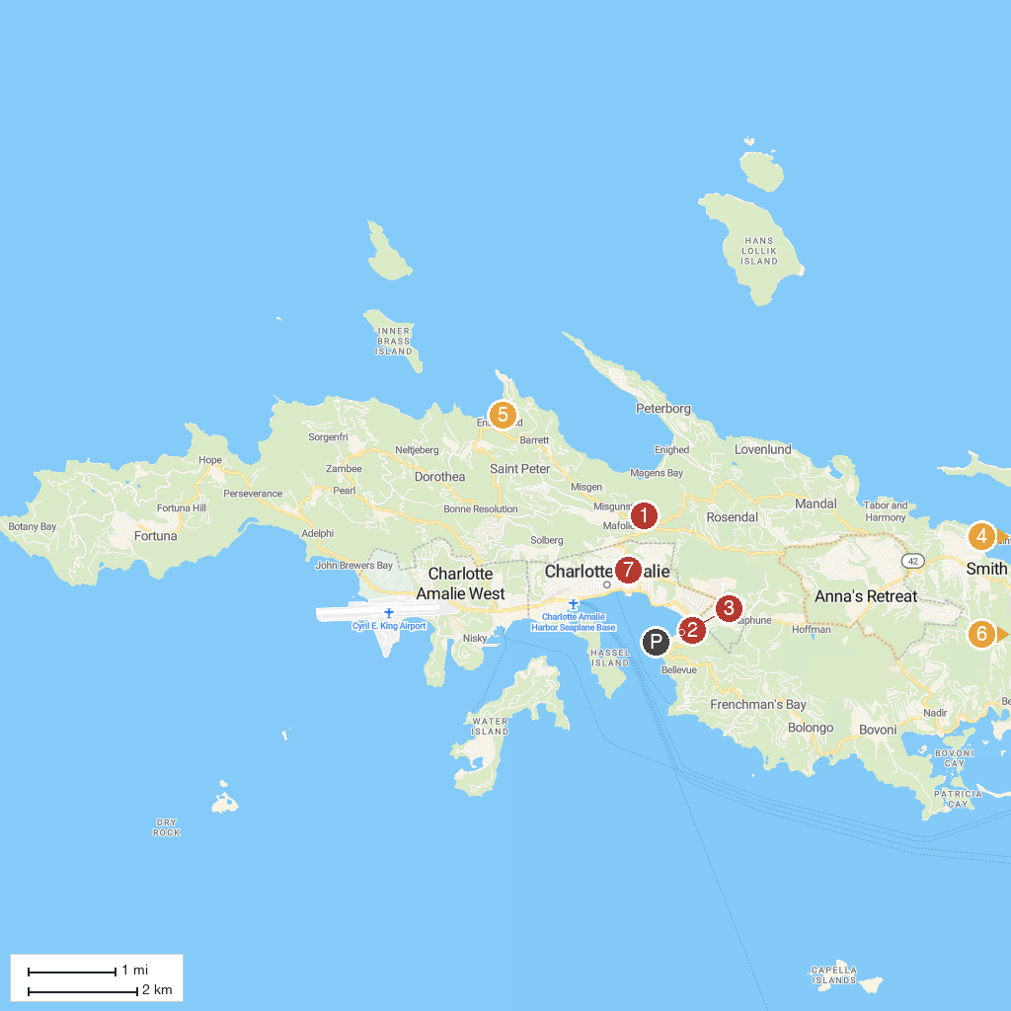
MAP KEY
1. Drake's Seat | 5. St Thomas Adventures
2. Skyride to Paradise Point | 6. Parasail Virgin Islands
3. West Indian Company Dock | 7. Blackbeard's Castle
4. Coral World Ocean Park
P. Cruise port / terminal
Map © MapTiler © OpenStreetMap contributors · cruiseports.org

