Stanley, Falkland Islands
A remote outpost of British charm and wildlife
🚢 Port of Call · 🐧 Penguin Haven · 🐑 Sheep Farming · 🇬🇧 British Outpost
✍️ MY DAY IN PORT (FILL IN)
Ship / Date
In port | arrive ______ · all aboard ______
Booked excursion
Notes / meeting point
GETTING ASHORE
- Docking: Tender
- Currency: Falkland Islands Pound (FKP)
- Language: English
- Climate: Windy, cool, and unpredictable
GETTING AROUND
- 🚕 Taxi: Negotiate before boarding (no meters) — Three local companies operate near the jetty: Stanley Cabs, Town Taxis, and Simon's Taxis. Primarily useful for out-of-t
- 📱 Rideshare: ❌ not available
TOP THINGS TO DO
- Penguin Colony Visit — A guided trip to the outskirts of town to see King and Gentoo penguins.
- Historic Site Tour — A guided tour visiting the Argentine Memorial and the 1982 conflict sites.
- Countryside Walk — A self-guided walk through the wind-swey pastures and colorful houses of Stanley.
- Local Craft Market — Boutselling local wool products and handcrafted jewelry.
BEST WALKS
- Waterfront Stroll: A gentle walk along the harbor, viewing the colorful houses and local boats. — Start at the tender pier, walk along the waterfront, and visit the local shops.
- Hilly Outskirts Walk: A more challenging walk to the higher ground for a panoramic view of the town. — Follow the path up the hill to overlook the Stanley settlement.
- Museum and Town Center Walk: A cultural exploration of the town's center, visiting the museum and local galleries. — C-walk from the pier to the Museum of the Falkland Islands and the local post office.
WEATHER · DAYLIGHT · MONEY
Month | High °F | Low °F | Rainy days
May | 45 | 38 | 10
Jul | 40 | 35 | 10
Sep | 44 | 36 | 11
Daylight: May 8:25AM–5:09PM · Jul 8:50AM–5:04PM · Sep 6:55AM–6:38PM
cruiseports.org/stanley · Confirm terminal & all-aboard time with your ship

Stanley, Falkland Islands — Port Map
Red = walkable sights · Amber = excursions farther out · P = cruise terminal
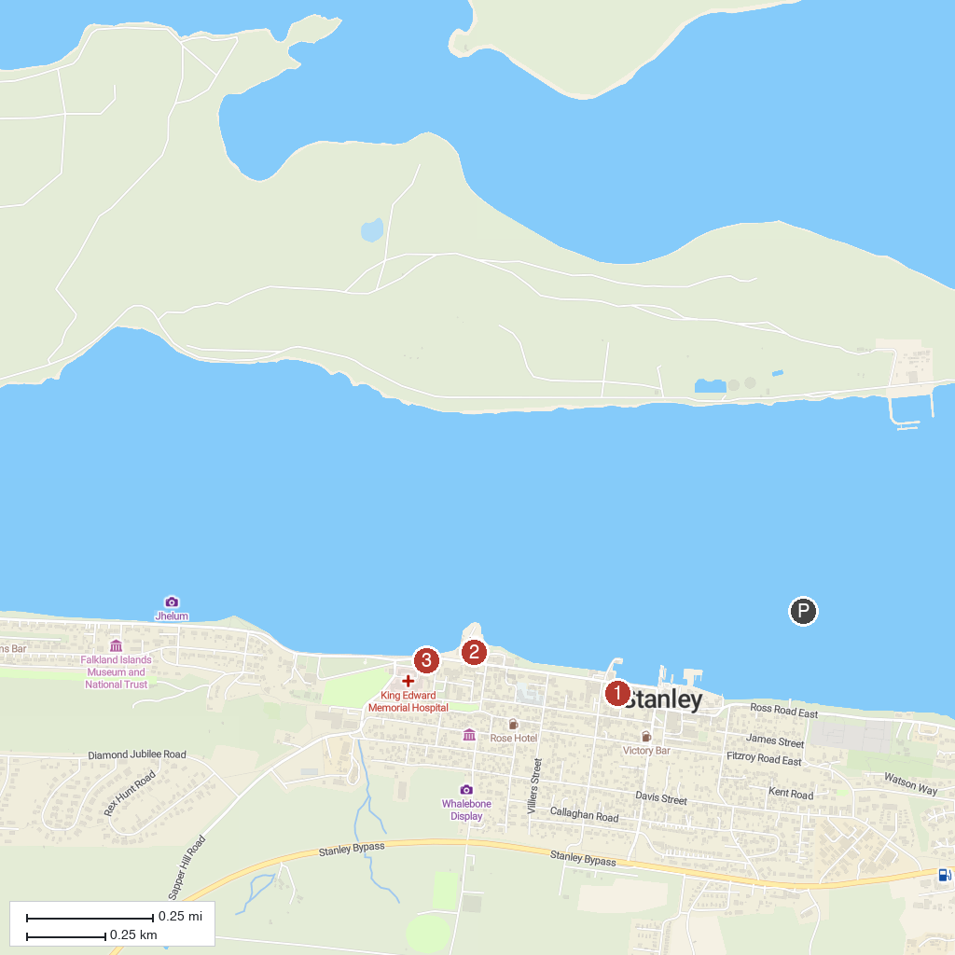
MAP KEY
1. Christ Church Cathedral | 3. 1982 Liberation Memorial
2. Falkland Islands Museum and National Trust
P. Cruise port / terminal
Map © MapTiler © OpenStreetMap contributors · cruiseports.org

