Stavanger, Rogaland, Norway
One of Europe's most convenient cruise ports — dock steps from 18th-century white wooden cottages, then venture out to the dramatic fjord cliffs that define the Norwegian southwest coast.
⚓ Pier — city center berths · 🕒 Typical call: 8–12 hrs · 💵 Norwegian Krone (NOK) — card everywhere · 🗣️ Norwegian (English widely spoken)
✍️ MY DAY IN PORT (FILL IN)
Ship / Date
In port | arrive ______ · all aboard ______
Booked excursion
Notes / meeting point
GETTING ASHORE
- Docking: Pier — Strandkaien, Skagenkaien, or Konserthuskaien in Vågen harbor
- Walk to center: 0–10 min — ships berth in the heart of the city
- Best For: Old Town strolling, Lysefjord cruises, Pulpit Rock hike (full-day)
- Don't Miss: Gamle Stavanger (Old Town) and the colorful Øvre Holmegate street
GETTING AROUND
- 🚕 Taxi: NOK 60–80 (~$6–8) short trip — Taxis are available near the port. Short rides within the city center cost NOK 60–80; longer trips (5 km) run around NOK
- 📱 Rideshare: ✅ Uber, Bolt
- 🚌 Hop-on hop-off: ✅ Gray Line / HopOn Norway
TOP THINGS TO DO
- Lysefjord Sightseeing Cruise — Board a catamaran directly from the cruise harbor and sail into Lysefjord — past sheer cliff walls, Hengjanefossen waterfall, and…
- Pulpit Rock (Preikestolen) Hike — Climb 604 m to the flat cliff plateau jutting over Lysefjord for one of Norway's great views.
- Gamle Stavanger (Old Town) Stroll — Wander 173 white-painted 18th-century wooden cottages — northern Europe's largest surviving collection — along cobblestone lanes…
- Norwegian Petroleum Museum — Interactive museum in a striking oil-platform-inspired building tracing how offshore oil transformed Norway from a fishing…
- RIB Safari on Lysefjord — Speed through the fjord on a rigid inflatable boat, close to cliff walls, waterfalls, and seabird colonies.
BEST WALKS
- Old Town & Color Street Loop: 2–3 km • 1–1.5 hrs • Easy — From Strandkaien pier, walk two minutes to Gamle Stavanger and wander the white wooden cottage lanes.
- Harbor to Petroleum Museum: 1.5 km • 30 min • Easy — Head north along the Vågen waterfront from your ship, past the GeoPark (public art made from…
WEATHER · DAYLIGHT · MONEY
Month | High °F | Low °F | Rainy days
May | 54 | 44 | 14
Jul | 63 | 54 | 18
Sep | 60 | 52 | 17
Daylight: May 5:06AM–10:01PM · Jul 4:50AM–10:34PM · Sep 7:06AM–7:56PM
cruiseports.org/stavanger · Confirm terminal & all-aboard time with your ship

Stavanger, Rogaland, Norway — Port Map
Red = walkable sights · Amber = excursions farther out · P = cruise terminal
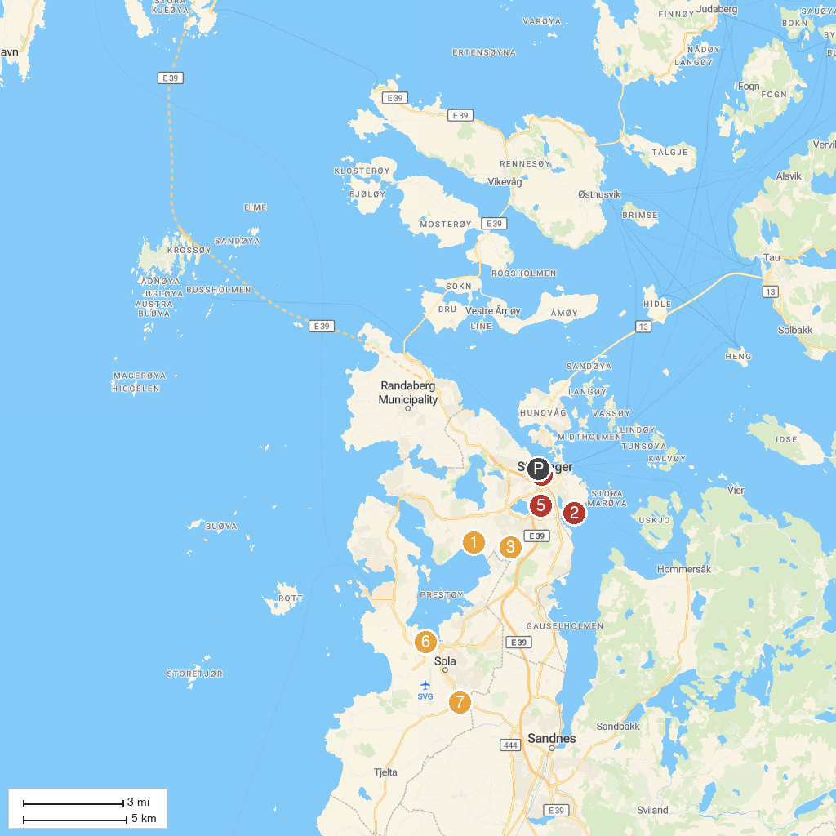
MAP KEY
1. Sverd i fjell | 5. Vålandstårnet
2. Godalen Strand | 6. Sola flytekniske museum
3. Stavanger Botanical Garden | 7. Sandnes Church
4. FjordEvents | 8. Rogaland War Historical Museum
P. Cruise port / terminal
Map © MapTiler © OpenStreetMap contributors · cruiseports.org

