Strait of Magellan, Magallanes, Chile
Magellan's 350-mile passage linking two oceans carves through one of Earth's last great wildernesses — towering fjords, penguin colonies, and migrating whales visible from the rail. This is scenic cruising at its most dramatic.
⚓ Scenic passage (no port stop) · 🕒 Transit: 20–36 hrs · 🌊 Expedition tender stops possible · 🐧 Wildlife: penguins, whales, sea lions · 🗣️ Spanish (Chile)
✍️ MY DAY IN PORT (FILL IN)
Ship / Date
In port | arrive ______ · all aboard ______
Booked excursion
Notes / meeting point
GETTING ASHORE
- Docking: Scenic cruising — no pier. Some expedition ships tender to Magdalena Island or Fort Bulnes.
- Best Season: Oct–Mar (austral summer); penguin colonies active, calmer seas
- Best For: Wildlife spotting, photography, history, Patagonian landscapes
- Don't Miss: Magdalena Island penguin colony (120,000+ birds); Francisco Coloane Marine Park for humpback whales
GETTING AROUND
- 🚕 Taxi: ~$5–10 USD — Taxis are plentiful near the pier. Agree on a fare before you go; a ride to the city center or most attractions is short
- 📱 Rideshare: ✅ Uber
- 🚌 Hop-on hop-off: ✅ Amigos Patagonia
TOP THINGS TO DO
- Magdalena Island Penguin Colony — Over 120,000 Magellanic penguins nest on this small island mid-strait.
- Francisco Coloane Marine Park — Chile's first marine park sits at the western end of the strait and is a prime summer feeding ground for humpback whales.
- Fort Bulnes (Fuerte Bulnes) — Chile's first permanent settlement on the strait, founded 1843.
- Kayaking the Patagonian Channels — Expedition operators offer guided kayak paddles in sheltered side channels branching off the strait — silent water, close-up…
- Scenic Navigation: Cape Horn Approach — Some itineraries combine Magellan Strait transit with a Cape Horn rounding — the world's most famous maritime passage.
BEST WALKS
- Magdalena Island Penguin Boardwalk: Easy · 45 min · Oct–Mar only — A circular path through the penguin colony leads to the historic Magdalena Island Lighthouse at the…
- Fort Bulnes Heritage Trail: Easy · 1 hr · Year-round — Wander reconstructed colonial-era buildings inside the fort walls, then follow the shoreline path…
WEATHER · DAYLIGHT · MONEY
Month | High °F | Low °F | Rainy days
May | 45 | 35 | 0
Jul | 40 | 31 | 0
Sep | 47 | 35 | 0
Daylight: May 9:23AM–5:56PM · Jul 9:49AM–5:50PM · Sep 7:48AM–7:29PM
cruiseports.org/strait-of-magellan · Confirm terminal & all-aboard time with your ship

Strait of Magellan, Magallanes, Chile — Port Map
Red = walkable sights · Amber = excursions farther out · P = cruise terminal
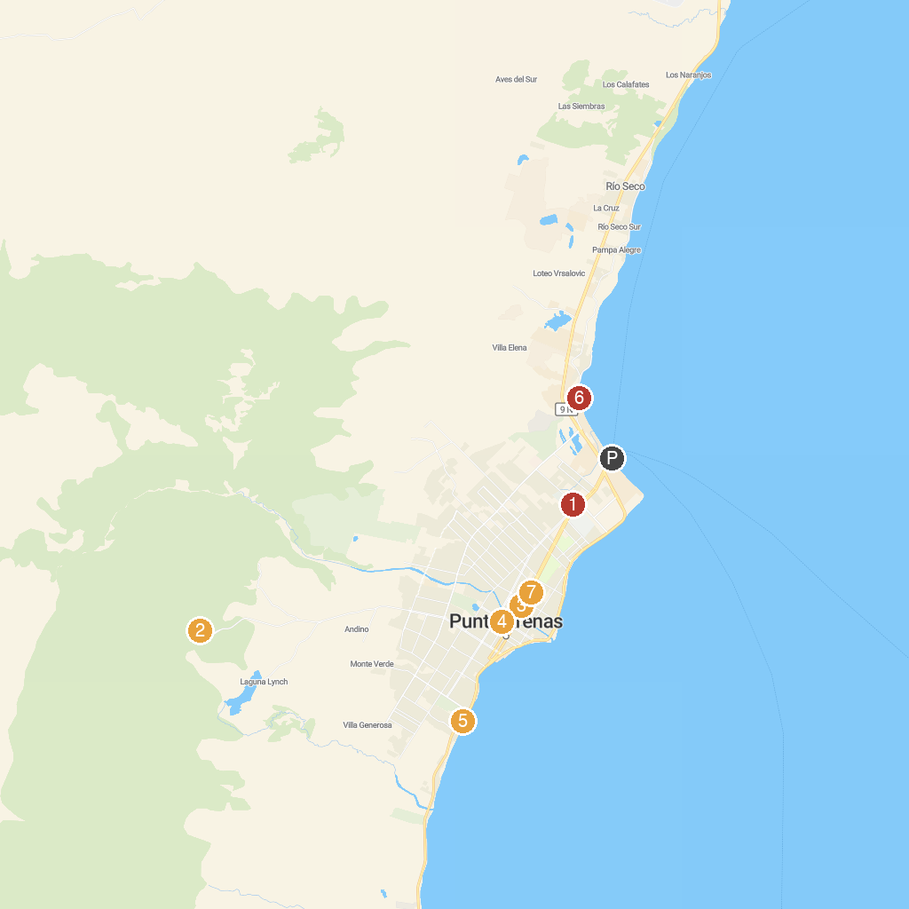
MAP KEY
1. Remembrance Museum | 5. Lord Lonsdale
2. Club Andino punta arenas | 6. Museo Nao Victoria
3. Museo Maggiorino Borgatello | 7. Cemetery of Punta Arenas
4. La Galería, tienda de arte y diseño
P. Cruise port / terminal
Map © MapTiler © OpenStreetMap contributors · cruiseports.org

