Stralsund, Mecklenburg-Vorpommern, Germany
A medieval Hanseatic gem on the Baltic, Stralsund's brick-Gothic skyline and UNESCO-listed Old Town reward cruise passengers who can walk straight off the pier into history.
⚓ Pier (Stadthafen) · 🕒 Typical call: 6-8 hrs · 💶 Euro (€) · 🗣️ German (English widely understood) · 🏛️ UNESCO World Heritage
✍️ MY DAY IN PORT (FILL IN)
Ship / Date
In port | arrive ______ · all aboard ______
Booked excursion
Notes / meeting point
GETTING ASHORE
- Docking: Pier — Stadthafen (City Harbor), right in the Old Town
- Walk to center: 5-8 min to Alter Markt; Ozeaneum is 2-3 min from the pier
- Best For: Medieval architecture, marine science, fresh Baltic seafood
- Don't Miss: Fischbrötchen (fish rolls) from harbour cutter boats
GETTING AROUND
- 🚕 Taxi: €7–€12 — Metered taxis are available at the port and city taxi ranks (try Hansa Funk-Taxi). The short 2–3 km ride to the city cen
TOP THINGS TO DO
- UNESCO Old Town Walking Tour — Explore Stralsund's remarkably preserved 13th-century street grid: the Alter Markt, the Gothic Rathaus arcade, St.
- Ozeaneum Aquarium — One of Germany's best aquariums, housed in a stunning modern building right on the harbor.
- Rügen Island Day Trip — Take the train from Stralsund Hauptbahnhof to Binz or Sellin on Rügen — Germany's largest island, famous for white-sand beaches…
- Gorch Fock I Tall Ship — Board the legendary 1933 steel barque moored right in the Stadthafen beside your ship.
- Fischbrötchen & Harbor Food Trail — Stralsund claims the birthplace of the original Bismarck Herring recipe.
BEST WALKS
- Stadthafen to Alter Markt: 0.5 km · 8 min · Flat — Walk from the pier past the Ozeaneum, through the harbor promenade, and into the heart of the…
- Old Town to St. Mary's Church Tower: 1 km · 15 min · Easy — From the Alter Markt, walk south through the medieval grid to St.
WEATHER · DAYLIGHT · MONEY
Month | High °F | Low °F | Rainy days
May | 64 | 44 | 0
Jul | 74 | 54 | 1
Sep | 68 | 49 | 1
Daylight: May 5:03AM–9:05PM · Jul 4:53AM–9:32PM · Sep 6:41AM–7:23PM
cruiseports.org/stralsund · Confirm terminal & all-aboard time with your ship

Stralsund, Mecklenburg-Vorpommern, Germany — Port Map
Red = walkable sights · Amber = excursions farther out · P = cruise terminal
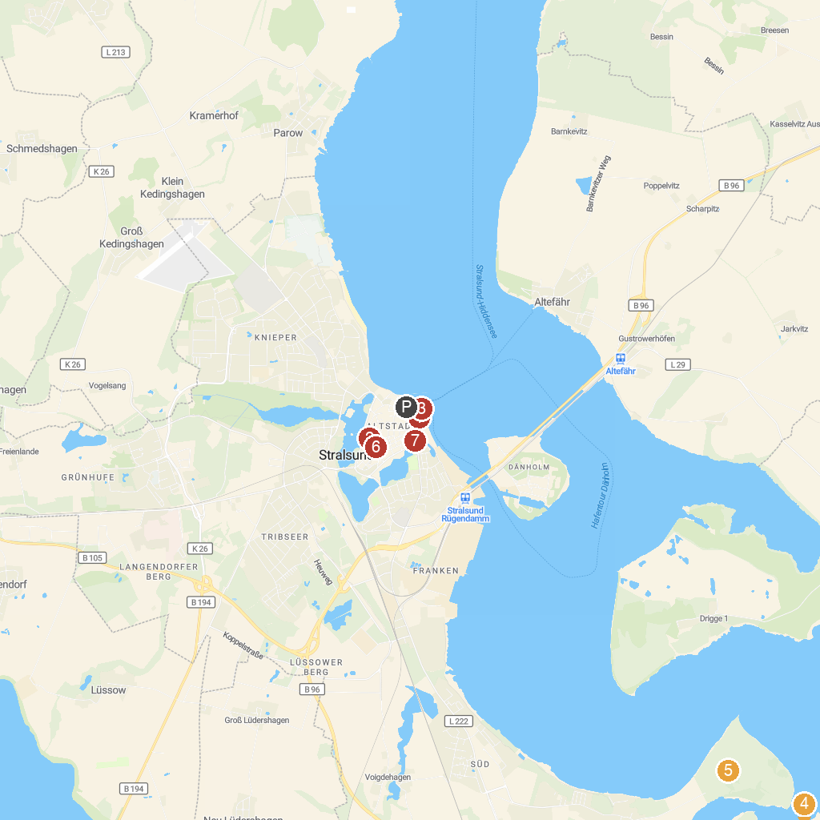
MAP KEY
1. OZEANEUM Stralsund GmbH | 5. Halbinsel Devin
2. German Oceanographic Museum | 6. Museumshaus
3. Gorch Fock I | 7. Heilgeist Kirche
4. Marina Neuhof GmbH
P. Cruise port / terminal
Map © MapTiler © OpenStreetMap contributors · cruiseports.org

