Stykkishólmur, Snæfellsnes, Iceland
A compact fishing town ringed by basalt islands and fjord views, Stykkishólmur punches well above its size — freshest scallops in Iceland, an eerie art installation made of glacier water, and day trips to one of the country's most dramatic peninsulas.
⚓ Pier (small/expedition ships) or Tender (larger vessels) · 🕒 Typical call: 6–8 hrs · 💵 Icelandic Króna (ISK) — virtually cashless; card accepted everywhere · 🗣️ Icelandic; English widely spoken · 🧊 Gateway to Snæfellsnes Peninsula
✍️ MY DAY IN PORT (FILL IN)
Ship / Date
In port | arrive ______ · all aboard ______
Booked excursion
Notes / meeting point
GETTING ASHORE
- Docking: Pier for small/expedition ships; larger vessels tender to harbour pontoon
- Walk to centre: 1–3 min from harbour — town wraps directly around the quay
- Best For: Viking Sushi boat tours, scenic coastal walks, Snæfellsnes Peninsula excursions
- Don't Miss: Viking Sushi Adventure (Seatours) — fresh scallops dredged and eaten on deck
GETTING AROUND
- 🚕 Taxi: ~2,500–5,000 ISK (short local trip) — Taxis in Stykkishólmur are very limited and must be pre-booked by phone; there is no taxi rank at the pier. Icelandic ta
- 📱 Rideshare: ❌ not available
TOP THINGS TO DO
- Viking Sushi Adventure (Seatours) — Board a boat into Breiðafjörður Bay, where a dredge hauls up live scallops and sea urchins from the seabed.
- Snæfellsnes Peninsula Highlights — A half-day bus tour hits Kirkjufell (the Game of Thrones arrowhead mountain), Kirkjufellsfoss waterfall, Djúpalónssandur…
- Library of Water (Vatnasafn) — American artist Roni Horn filled 24 floor-to-ceiling glass columns with meltwater from Iceland's major glaciers.
- Norska Húsið — The Norwegian House — Built in 1832, this is the oldest two-story wooden house in Iceland.
- Breiðafjörður Bay Kayaking & Island Hopping — Paddle or boat among the thousands of small basalt islands in Breiðafjörður Bay, spotting eider ducks, puffins (in season)…
BEST WALKS
- Harbour to Súgandisey Lighthouse: 1 km round-trip | 20–30 min | Easy paved path with stairs — Walk out along the causeway to Súgandisey Island, a basalt outcrop that shelters the harbour.
- Old Town Stroll: 1.5 km loop | 30–45 min | Flat, easy — Wander the preserved 19th-century streets — Aðalgata and Frúarstígur — lined with brightly painted…
WEATHER · DAYLIGHT · MONEY
Month | High °F | Low °F | Rainy days
May | 48 | 38 | 1
Jul | 57 | 47 | 0
Sep | 52 | 43 | 1
Daylight: Sep 6:53AM–7:56PM
cruiseports.org/stykkisholmur · Confirm terminal & all-aboard time with your ship

Stykkishólmur, Snæfellsnes, Iceland — Port Map
Red = walkable sights · Amber = excursions farther out · P = cruise terminal
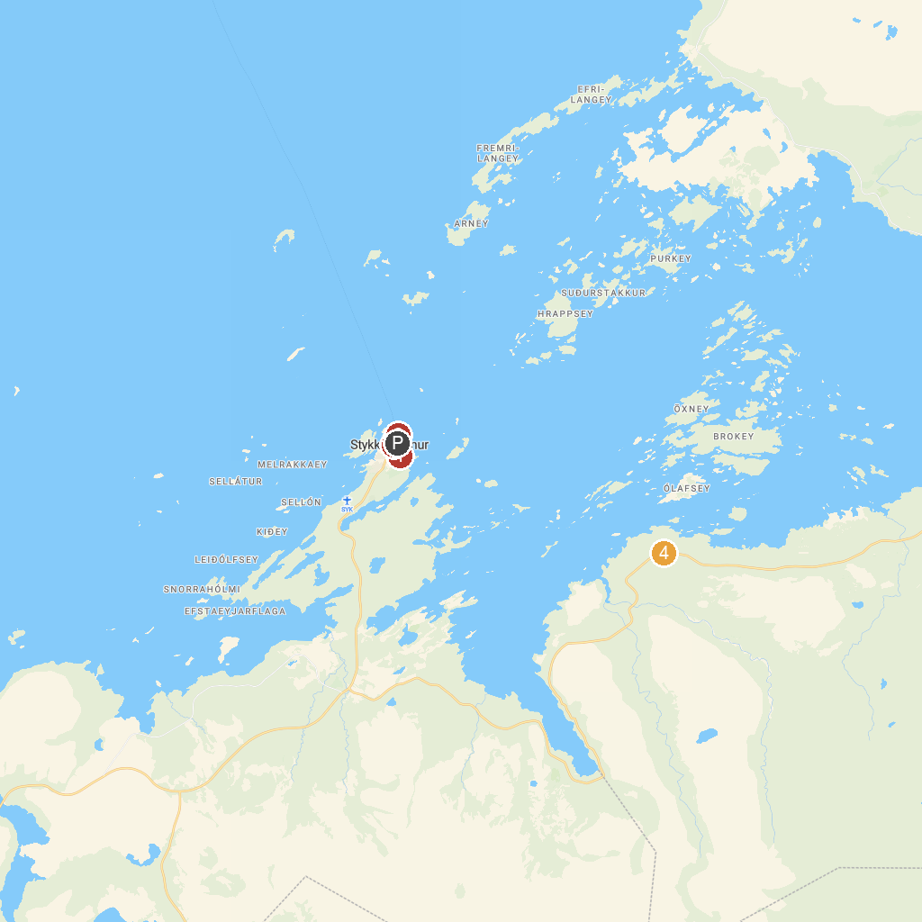
MAP KEY
1. Stykkishólmskirkja Church | 4. Súgandisey Island Light Beacon
2. Bjarnarhöfn Shark Museum | 5. Good view
3. Norwegian House
P. Cruise port / terminal
Map © MapTiler © OpenStreetMap contributors · cruiseports.org

