Svalbard Islands, Spitsbergen, Norway
Halfway between mainland Norway and the North Pole, Svalbard is where polar bears outnumber people and glaciers tumble into fjords of impossible blue. This is expedition cruising at its most raw.
⚓ Pier (Longyearbyen) or tender — varies by ship size · 🕒 Typical call: 6–10 hrs · 💵 Norwegian Krone (NOK) — nearly cashless; cards everywhere · 🗣️ Norwegian / English fluent · 🐻‍❄️ Polar bear country — guided hikes only outside town
✍️ MY DAY IN PORT (FILL IN)
Ship / Date
In port | arrive ______ · all aboard ______
Booked excursion
Notes / meeting point
GETTING ASHORE
- Docking: Larger ships dock at Bykaia pier (~1.5 km from town); smaller expedition vessels tender to central pontoon or anchor at remote bays
- Walk to Center: ~20 min flat walk from Bykaia pier; shuttle buses often provided. Tender passengers land near the Tourist Info building
- Best For: Polar bear & wildlife spotting, glacier excursions, Arctic history, duty-free shopping
- Don't Miss: Svalbard Museum, the North Pole Expedition Museum, and a boat tour to Pyramiden or a glacier front
GETTING AROUND
- 🚕 Taxi: NOK 150–250 (~$15–26 USD) — Local taxis (Longyearbyen Taxi AS, Svalbard Buss og Taxi) cover the short port-to-town run. Supply is limited — pre-book
- 📱 Rideshare: ❌ not available
TOP THINGS TO DO
- Polar Bear & Wildlife Safari by Boat — Board a small expedition vessel or RIB to patrol fjords and coastline for polar bears, walruses, reindeer, and Arctic foxes.
- Glacier Boat Tour — Nordenskiöldbreen or Esmarkbreen — Cruise deep into Billefjorden or Ymerbukta to drift in front of towering tidewater glacier walls.
- Pyramiden — Soviet Ghost Town — Boat trip to the abandoned Soviet coal-mining settlement, abruptly evacuated in 1998 and left frozen in time.
- Guided Arctic Hike — Platåfjellet or Sarkofagen — All wilderness hikes require an armed guide.
- Svalbard Museum & North Pole Expedition Museum — Two excellent museums walkable from the pier.
BEST WALKS
- Bykaia Pier to Longyearbyen Town Center: 1.5 km · 20–25 min · Flat & paved — Walk from the cruise pier along the fjord road into town.
- Town Centre Loop — Museums & Church: ~2 km loop · 30–45 min · Easy — From Gågata, walk up to the Svalbard Science Centre (housing the Svalbard Museum), continue to the…
WEATHER · DAYLIGHT · MONEY
Month | High °F | Low °F | Rainy days
May | 32 | 23 | 2
Jul | 45 | 37 | 2
Sep | 36 | 28 | 2
Daylight: Sep 5:39AM–8:01PM
cruiseports.org/svalbard-islands · Confirm terminal & all-aboard time with your ship

Svalbard Islands, Spitsbergen, Norway — Port Map
Red = walkable sights · Amber = excursions farther out · P = cruise terminal
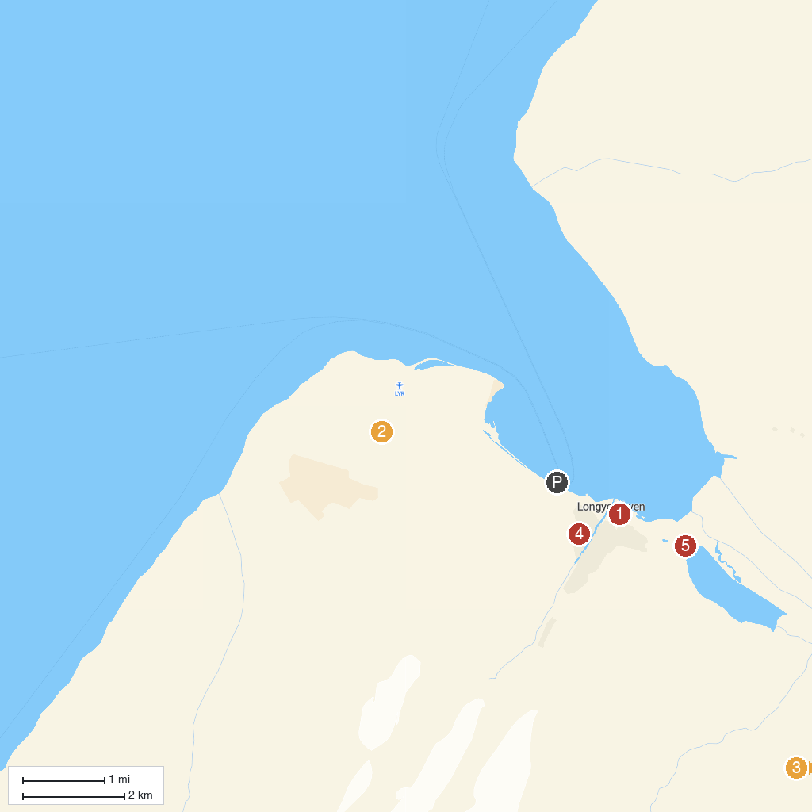
MAP KEY
1. North Pole Expedition Museum | 4. Svalbard Kirke
2. Gruve 3 | 5. Polar Bear Sign
3. Svalbard Husky AS
P. Cruise port / terminal
Map © MapTiler © OpenStreetMap contributors · cruiseports.org

