Sydney, New South Wales, Australia
Australia's harbour city delivers one of cruising's great arrivals — the Opera House and Harbour Bridge framing the skyline as your ship sails through Sydney Heads at dawn. Whether you step off at Circular Quay or transfer from White Bay, one of the world's great urban harbours is waiting.
⚓ Docked (two terminals — see below) · 🕒 Typical call: 8–12 hrs · 💵 Australian Dollar (AUD) — city is nearly cashless · 🗣️ English
✍️ MY DAY IN PORT (FILL IN)
Ship / Date
In port | arrive ______ · all aboard ______
Booked excursion
Notes / meeting point
GETTING ASHORE
- Docking: Overseas Passenger Terminal (Circular Quay) or White Bay Cruise Terminal (Rozelle)
- Walk to center: Immediate (OPT) or 20-min taxi/ferry (White Bay)
- Best For: Opera House · Harbour Bridge · Beaches · Day trips
- Don't Miss: BridgeClimb or the dawn sail-in through Sydney Heads
GETTING AROUND
- 🚕 Taxi: AU$15–20 (OPT to CBD); AU$20–40 (White Bay to CBD) — Taxis are readily available at both terminals. The OPT is already in the city center; White Bay is a 10–15 minute ride t
- 📱 Rideshare: ✅ Uber, DiDi
- 🚌 Hop-on hop-off: ✅ Big Bus Sydney
TOP THINGS TO DO
- Sydney Opera House & The Rocks — Walk off the ship at Circular Quay and you're already there.
- BridgeClimb Sydney Harbour Bridge — Walk to the 134 m summit of the Harbour Bridge for a 360-degree panorama of harbour, city, and ocean.
- Bondi Beach & Coastal Walk — Train from Circular Quay to Bondi Junction, then bus to Bondi Beach (45 min total).
- Taronga Zoo by Ferry — A 12-minute ferry from Circular Quay Wharf 2 lands at the foot of Taronga Zoo, home to koalas, wombats, platypus, and giraffes…
- Manly Beach by Ferry — The 30-minute Manly Ferry from Circular Quay is one of the world’s great harbour rides.
BEST WALKS
- Circular Quay to The Rocks & Harbour Bridge Pylon: ~3 km · 2 hrs · easy — Walk from the Opera House along the waterfront to the Museum of Contemporary Art Australia, into…
- Royal Botanic Garden & Mrs Macquaries Chair: ~4 km · 1.5 hrs · easy — Walk east from Circular Quay through the Royal Botanic Garden along the harbour foreshore to Mrs…
- Bondi to Coogee Coastal Walk: ~6 km · 2–2.5 hrs · moderate — Sydney's best free coastal trail runs from Bondi Beach south along sandstone cliffs past Tamarama…
WEATHER · DAYLIGHT · MONEY
Month | High °F | Low °F | Rainy days
May | 67 | 52 | 6
Jul | 62 | 47 | 6
Sep | 68 | 51 | 8
Daylight: May 6:40AM–5:02PM · Jul 6:58AM–5:04PM · Sep 5:55AM–5:46PM
cruiseports.org/sydney · Confirm terminal & all-aboard time with your ship

Sydney, New South Wales, Australia — Port Map
Red = walkable sights · Amber = excursions farther out · P = cruise terminal
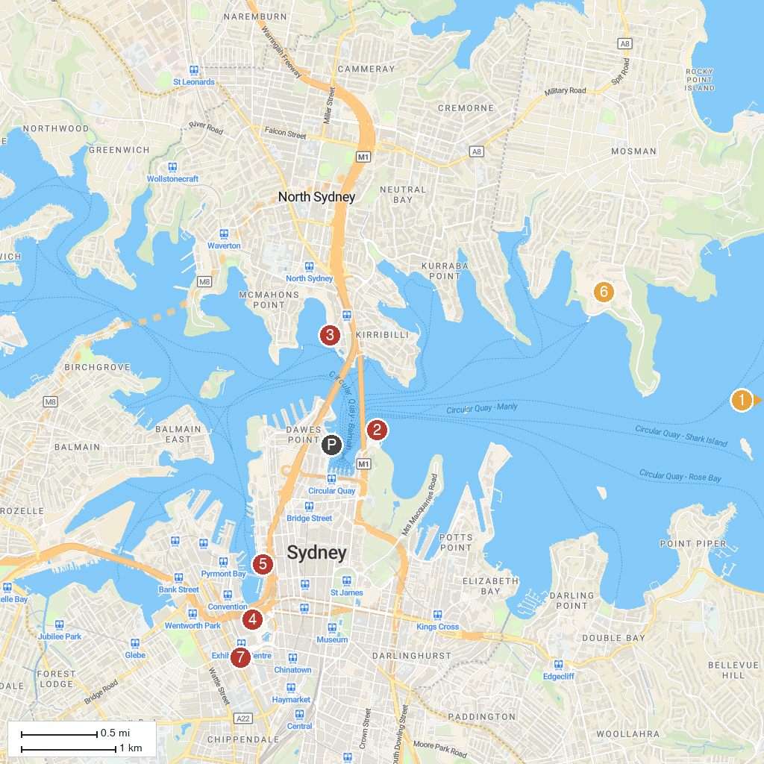
MAP KEY
1. Macquarie Lighthouse | 5. SEA LIFE Sydney Aquarium
2. Sydney Opera House | 6. Taronga Zoo Sydney
3. Luna Park Sydney | 7. Powerhouse Ultimo
4. Darling Harbour
P. Cruise port / terminal
Map © MapTiler © OpenStreetMap contributors · cruiseports.org

