Syros Island, Cyclades, Greece
Far from the whitewashed clichés of Mykonos, Syros is a living 19th-century city — neoclassical mansions, a marble main square, and a hilltop medieval quarter all walkable from the pier.
⚓ Pier (docked) · 🕒 Typical call: 6–9 hrs · 💶 Euro (EUR) · 🗣️ Greek
✍️ MY DAY IN PORT (FILL IN)
Ship / Date
In port | arrive ______ · all aboard ______
Booked excursion
Notes / meeting point
GETTING ASHORE
- Docking: Pier — walk straight into Ermoupoli (no tender)
- Walk to center: 5 min to Miaouli Square
- Best For: Architecture, history, local food & culture
- Don't Miss: Ano Syros medieval quarter & Apollo Theater
GETTING AROUND
- 🚕 Taxi: €12–20 — Taxis queue at the port and are generally affordable. A 15-minute ride to coastal villages like Azolimnos runs €12–20; f
- 📱 Rideshare: ❌ not available
TOP THINGS TO DO
- Miaouli Square & Neoclassical Ermoupoli — Stroll the marble-paved Miaouli Square, admire Ernst Ziller's grand Town Hall, and wander the Vaporia district — the clifftop…
- Ano Syros Medieval Quarter — Taxi to the top and wander the 13th-century Catholic hill town: labyrinthine alleys, arched passages, and panoramic views of…
- Apollo Theater — A miniature La Scala built in 1864, Ermoupoli's Apollo Theater is a jaw-dropper.
- Asteria Beach & Vaporia Swim — Not sand — but the Asteria concrete lido platform in the Vaporia district offers crystal-clear deep water, loungers, and the…
- Galissas or Kini Beach — Hop the KTEL bus (€2 each way, ~15–20 min) to Galissas — a sheltered sandy bay with calm water and tavernas — or Kini, a fishing…
BEST WALKS
- Harbour to Vaporia Loop: 3.5 km · 50 min · Easy — From the pier, walk to Miaouli Square, detour through the Apollo Theater, continue to St.
- Ano Syros Descent: 1.5 km downhill · 25 min · Easy down — Take a taxi to the top gate (Kamara) of Ano Syros, wander the medieval alleys at your own pace…
cruiseports.org/syros-island · Confirm terminal & all-aboard time with your ship

Syros Island, Cyclades, Greece — Port Map
Red = walkable sights · Amber = excursions farther out · P = cruise terminal
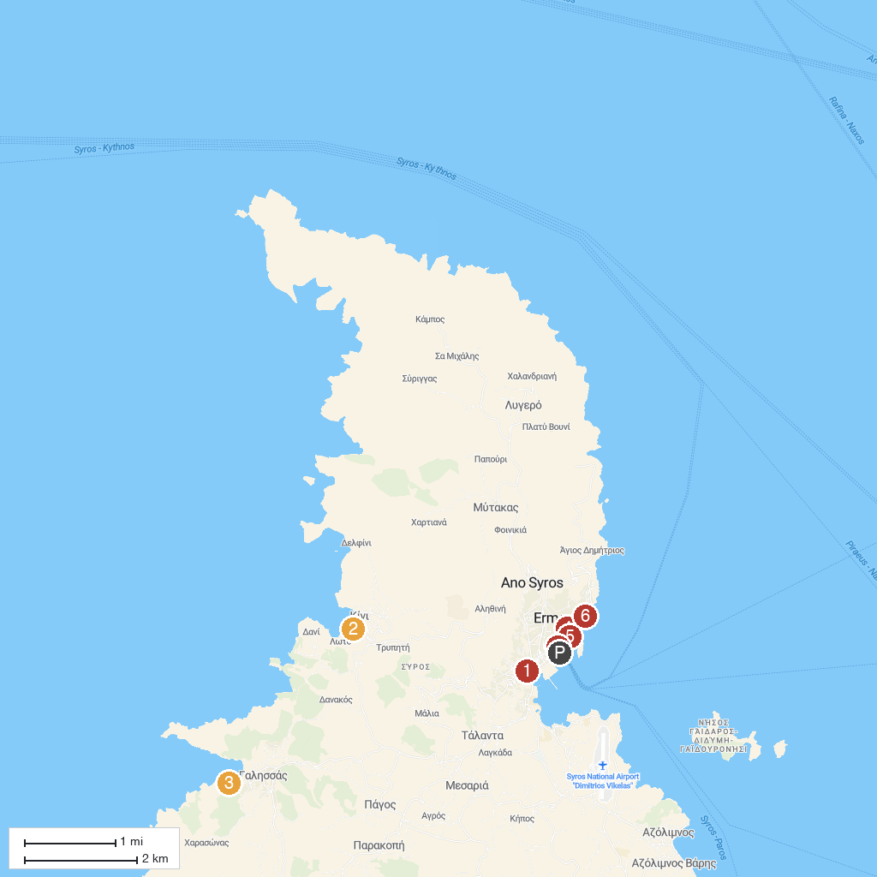
MAP KEY
1. Industrial museum of Ermoupolis | 5. National Resistance Monument
2. Kini Aquarium | 6. Vaporia Beach
3. Chapel of Santa Pakú (Obbedienza) | 7. Casino Syros
4. Miaouli Square
P. Cruise port / terminal
Map © MapTiler © OpenStreetMap contributors · cruiseports.org

