Szczecin, Pomerania, Poland
Once the German city of Stettin, Szczecin surprises cruisers with Prussian grandeur, Parisian boulevard layouts, a Renaissance ducal castle, and the unmissable pasztecik — a deep-fried street snack with EU heritage status.
⚓ Pier (Wały Chrobrego quay) · 🕒 Typical call: 8–10 hrs · 💵 Polish Złoty (PLN) — cards universal · 🗣️ Polish / English widely spoken · 🚢 Small–medium ships dock in city; large liners use Świnoujście
✍️ MY DAY IN PORT (FILL IN)
Ship / Date
In port | arrive ______ · all aboard ______
Booked excursion
Notes / meeting point
GETTING ASHORE
- Docking: Pier — Nabrzeże Pasażerskie below Chrobry Embankment (small/medium ships). Large ocean liners may dock at Świnoujście, 1.5 hrs away.
- Walk to centre: 1–2 min to Chrobry Embankment; 10–12 min to Dukes' Castle; 12–15 min to Old Town
- Best For: History, architecture, free self-guided walking, local street food
- Don't Miss: Pasztecik Szczeciński at the original 1969 bar on Wojska Polskiego
GETTING AROUND
- 🚕 Taxi: PLN 20–50 (~–13) — Multiple taxi companies operate in Szczecin with metered fares. Base fee ~PLN 8–10, then ~PLN 2.20–3.20/km. Short city r
- 📱 Rideshare: ✅ Uber, Bolt
TOP THINGS TO DO
- Pomeranian Dukes' Castle — The Renaissance castle of the Dukes of Pomerania dominates the Old Town skyline.
- WWII Underground Trails — Poland's largest civilian bomb shelter, built by Germans during WWII and repurposed as a Cold War nuclear shelter, sits beneath…
- Szczecin Philharmonic — Iceberg Building — The award-winning Szczecin Philharmonic won the Mies van der Rohe Prize for its extraordinary white angular facade that resembles…
- St James Cathedral Observation Deck — The 110-metre spire of Szczecin's Gothic brick cathedral offers the highest viewpoint in the city.
- Wyspa Grodzka City Beach — A sandy river beach on the island directly opposite the cruise quay, reached by footbridge from the Old Town.
BEST WALKS
- Red Route: Embankment to Dukes' Castle & Old Town: 2.5 km · 45–60 min · flat to gentle uphill — Follow the red-dashed line painted on the pavement from Wały Chrobrego up to the Pomeranian Dukes'…
- Boulevard to the Parisian Star Plazas: 2 km · 25 min · flat — Walk north along Aleja Wojska Polskiego past grand Prussian-era apartment blocks — pick up a…
WEATHER · DAYLIGHT · MONEY
Month | High °F | Low °F | Rainy days
May | 66 | 46 | 1
Jul | 76 | 57 | 1
Sep | 69 | 51 | 0
Daylight: May 5:01AM–8:55PM · Jul 4:52AM–9:22PM · Sep 6:35AM–7:16PM
cruiseports.org/szczecin · Confirm terminal & all-aboard time with your ship

Szczecin, Pomerania, Poland — Port Map
Red = walkable sights · Amber = excursions farther out · P = cruise terminal
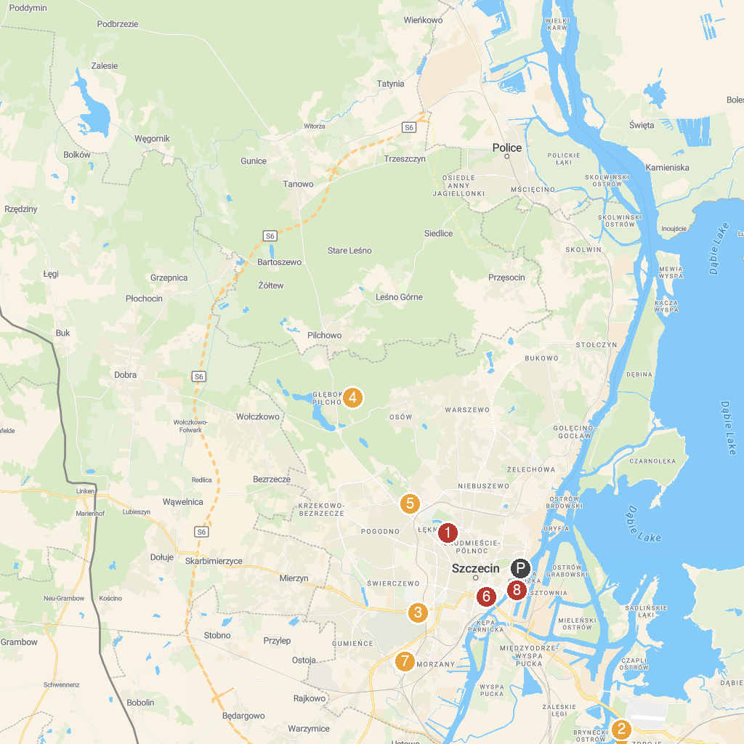
MAP KEY
1. Memorial of the Poles' Feat | 5. Botanical Garden in Szczecin
2. Zdroje Forest Park | 6. Archcathedral Basilica of St. James the Apostle
3. Central Cemetery in Szczecin | 7. Geko. climbing center
4. Valley of the Seven Mills | 8. Lastadia
P. Cruise port / terminal
Map © MapTiler © OpenStreetMap contributors · cruiseports.org

