Takamatsu, Kagawa, Japan
Gateway to Shikoku's finest garden and the Seto Inland Sea's art islands, Takamatsu is one of Japan's most rewarding and walkable cruise ports — and its udon is the stuff of legend.
⚓ Docked (pier) · 🕒 Typical call: 8-10 hrs · 💴 Japanese Yen (JPY) · 🗣️ Japanese
✍️ MY DAY IN PORT (FILL IN)
Ship / Date
In port | arrive ______ · all aboard ______
Booked excursion
Notes / meeting point
GETTING ASHORE
- Docking: Pier — Sunport Takamatsu (Tamamo District); a second berth at Asahishinmachi (~3.5 km east) requires taxi
- Walk to center: 3-5 min to JR Takamatsu Station and Symbol Tower; ~15 min to Ritsurin Garden by bicycle
- Best For: Japanese gardens, contemporary art (Naoshima), Sanuki udon, Seto Inland Sea island-hopping
- Don't Miss: Ritsurin Garden (3-star Michelin) and at least one bowl of fresh Sanuki udon
GETTING AROUND
- 🚕 Taxi: ¥1,200–¥3,000 (~$7–19 USD) — Taxis are metered and readily available outside the port. Ritsurin Garden (one of Japan's finest landscape gardens) cost
- 📱 Rideshare: ✅ Uber
TOP THINGS TO DO
- Ritsurin Garden — One of Japan's three finest gardens and the only one with a Michelin three-star rating, Ritsurin features six ponds, thirteen…
- Naoshima Art Island — A 30-50 min public ferry ride delivers you to Naoshima, where Tadao Ando-designed museums, Yayoi Kusama's pumpkin sculptures, and…
- Tamamo Park & Takamatsu Castle Ruins — A 5-minute walk from the pier, Tamamo Park contains the ruins of Takamatsu Castle — one of Japan's rare coastal castles with a…
- Sanuki Udon Crawl — Kagawa Prefecture is Japan's udon capital, and Takamatsu's covered arcades hide dozens of family-run udon shops serving thick…
- Yashima Plateau — A flat-topped mountain northeast of the city, Yashima was the site of a famous 12th-century Taira clan battle.
BEST WALKS
- Sunport to Tamamo Park & Shopping Arcade: 1.5 km · 20-25 min · Flat — From the Sunport pier, walk past the Symbol Tower to Tamamo Park and Takamatsu Castle Ruins (5 min).
- Pier to Ritsurin Garden (by bicycle): 3.5 km · 15 min by bike · Flat — Rent a bicycle (¥200/day) from the underground station beneath JR Takamatsu Station and follow the…
WEATHER · DAYLIGHT · MONEY
Month | High °F | Low °F | Rainy days
May | 78 | 60 | 1
Jul | 89 | 76 | 2
Sep | 84 | 71 | 2
Daylight: May 5:02AM–6:58PM · Jul 5:02AM–7:16PM · Sep 5:46AM–6:10PM
cruiseports.org/takamatsu · Confirm terminal & all-aboard time with your ship

Takamatsu, Kagawa, Japan — Port Map
Red = walkable sights · Amber = excursions farther out · P = cruise terminal
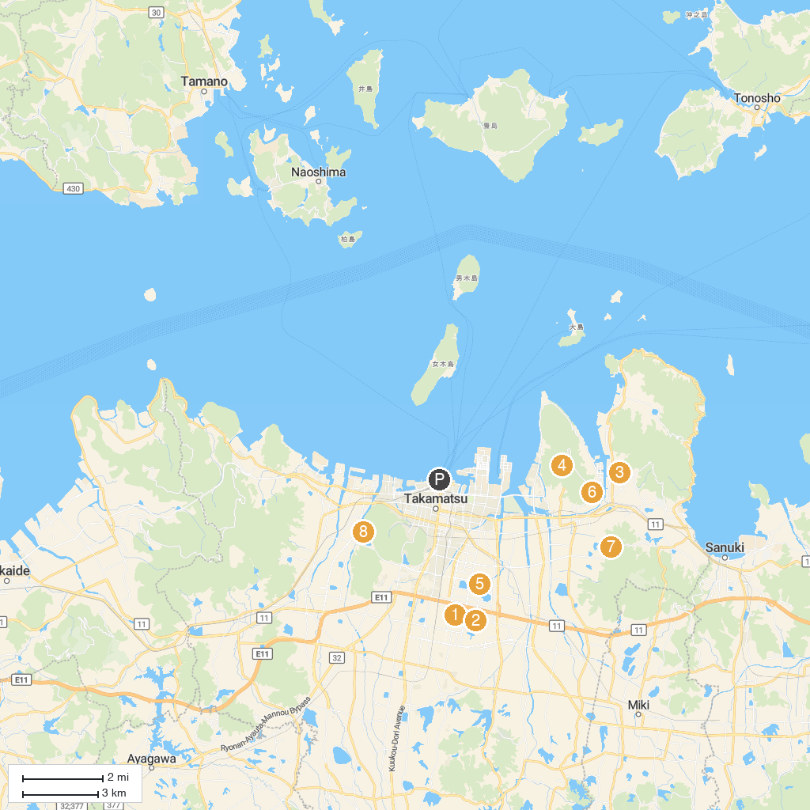
MAP KEY
1. Ota Central Park | 5. Kita Chuo Park
2. Nagaike Central Park | 6. Seidai Temple
3. Isamu Noguchi Garden Museum | 7. Takamatsushi Tobu Sports Park
4. Yashima Temple | 8. 高松市水道資料館旧御殿水源地
P. Cruise port / terminal
Map © MapTiler © OpenStreetMap contributors · cruiseports.org

