Tampa, Florida, USA
Medium-sized ships, big-city energy. Tampa's cruise terminals sit one block from Sparkman Wharf, a free historic streetcar, and the start of a 2.6-mile waterfront Riverwalk — all before you've even paid for parking.
⚓ Docked — no tendering · 🏠 Major homeport (turnaround days) · 💵 USD · 🗣️ English
✍️ MY DAY IN PORT (FILL IN)
Ship / Date
In port | arrive ______ · all aboard ______
Booked excursion
Notes / meeting point
GETTING ASHORE
- Docking: Terminals 2, 3 & 6 on Channelside Drive — all pier, no tendering
- Walk to Center: 5 min to Sparkman Wharf; 8 min to Riverwalk & Florida Aquarium
- Best For: Families, foodies, history lovers, beach seekers
- Don't Miss: Sailing under the Sunshine Skyway Bridge on departure evening
GETTING AROUND
- 🚕 Taxi: $25–$35 — Taxis are readily available at Port Tampa Bay. A flat-rate fare to downtown Tampa runs $25–$35 and takes about 13–15 min
- 📱 Rideshare: ✅ Uber, Lyft
- 🚌 Hop-on hop-off: ✅ Hop-on hop-off
TOP THINGS TO DO
- Ybor City — Tampa's Latin Quarter — Ride the free TECO streetcar to 7th Avenue, America's former cigar capital.
- Tampa Riverwalk & Waterfront — A 2.6-mile paved path links Sparkman Wharf, the Florida Aquarium, Tampa Bay History Center, Tampa Museum of Art, Glazer…
- The Florida Aquarium — Literally 2 minutes from Terminal 2, this 250,000 sq ft aquarium covers Florida wetlands, live reef ecosystems, sharks, sea…
- Busch Gardens Tampa Bay — Africa-themed mega-park 8 miles north with world-class coasters including Iron Gwazi and SheiKra, plus a 12,000-animal zoo, water…
- Clearwater Beach & Gulf Coast — Consistently ranked among America's best beaches.
BEST WALKS
- Channelside to Curtis Hixon Park via Riverwalk: 2.5 miles · Easy · ~1–1.5 hrs one way — Head out from the terminal, pass Sparkman Wharf and the Florida Aquarium, then pick up the Tampa…
- Streetcar to Ybor City: Streetcar + stroll · Easy · 2–4 hrs — Walk 5 minutes to the Channelside TECO Streetcar stop and ride the free yellow streetcar north to…
WEATHER · DAYLIGHT · MONEY
Month | High °F | Low °F | Rainy days
May | 86 | 70 | 11
Jul | 88 | 77 | 26
Sep | 86 | 75 | 20
Daylight: May 6:40AM–8:12PM · Jul 6:43AM–8:27PM · Sep 7:15AM–7:33PM
ESSENTIAL TRAVEL QUALIFICATIONS
Streetcar; verify current hours/service: Free (operator checked 3 Oct 2026).
cruiseports.org/tampa · Confirm terminal & all-aboard time with your ship

Tampa, Florida, USA — Port Map
Red = walkable sights · Amber = excursions farther out · P = cruise terminal
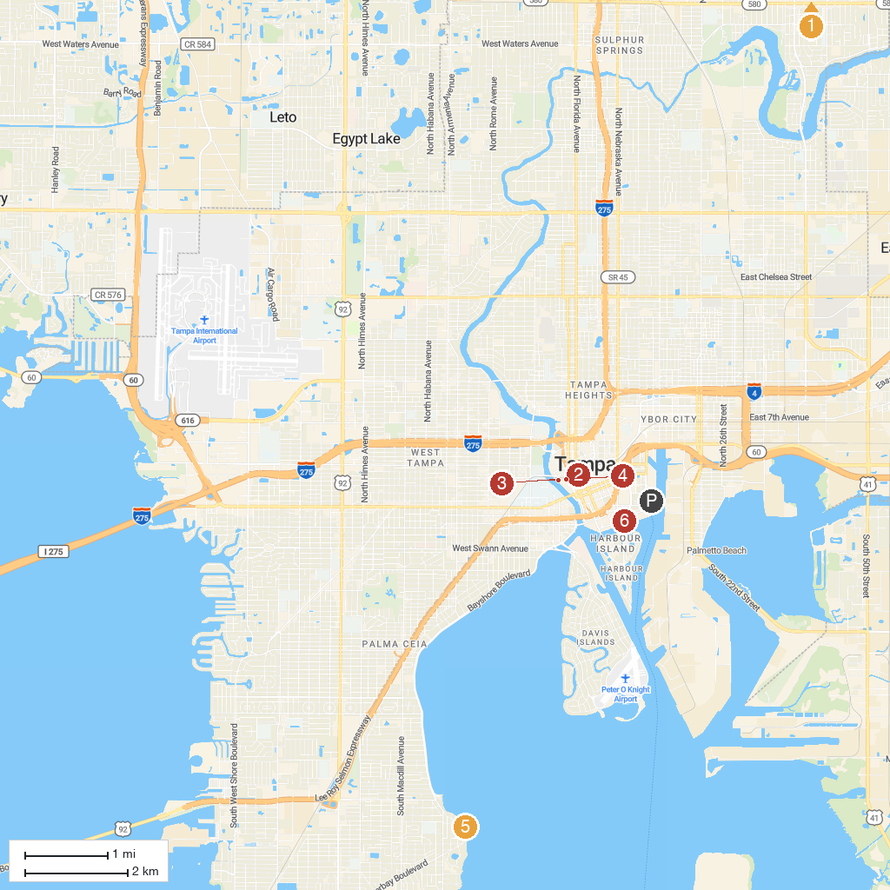
MAP KEY
1. Adventure Island | 5. Ballast Point Park
2. Tampa Theatre | 6. Hindu Temple of Florida
3. Tampa Museum of Art | 7. Tampa Bay History Center
4. Glazer Children's Museum
P. Cruise port / terminal
Map © MapTiler © OpenStreetMap contributors · cruiseports.org

