Taranto, Puglia, Italy
Founded by Spartan settlers in the 8th century BC, Taranto guards two seas with an atmospheric island old town, towering Aragonese castle, and one of the most dazzling Greek-era gold collections on earth.
⚓ Pier (Molo San Cataldo) · 🕒 Typical call: 7-9 hrs · 💶 Currency: Euro · 🗣️ Language: Italian · 🦪 Famous for mussels
✍️ MY DAY IN PORT (FILL IN)
Ship / Date
In port | arrive ______ · all aboard ______
Booked excursion
Notes / meeting point
GETTING ASHORE
- Docking: Pier — Molo San Cataldo cruise terminal; free shuttle to city gate
- Walk to center: ~5 min by free port shuttle to Piazza Castello; all sights then walkable
- Best For: Greek history, archaeology, authentic Puglia street food, day trips to Alberobello or Matera
- Don't Miss: MArTA museum's Ori di Taranto gold collection and fresh mussels alla tarantina
GETTING AROUND
- 🚕 Taxi: €9–€12 — Taxis wait outside the cruise terminal. The 4–5 minute ride to the city center costs roughly €9–€12; meter starts at €4.
- 📱 Rideshare: ❌ not available
TOP THINGS TO DO
- MArTA Museum & Gold of Taranto — The National Archaeological Museum of Taranto houses the world-renowned Ori di Taranto — breathtaking Hellenistic gold jewelry…
- Old Town Island & Castello Aragonese — Cross the swing bridge onto the island Borgo Antico, explore the 10th-century Cathedral of San Cataldo, and take a free guided…
- Doric Temple Columns & Ipogei Underground — Visit the 6th-century BC Doric columns of the Temple of Poseidon in Piazza Castello — the oldest Magna Graecia ruins in Puglia.
- Dolphin Watching in the Gulf of Taranto — The Gulf of Taranto hosts a large resident population of striped and Risso's dolphins.
- Day Trip to Alberobello Trulli — About an hour's drive north, Alberobello's UNESCO-listed Rione Monti district is packed with hundreds of conical-roofed trulli…
BEST WALKS
- Old Town to New Town Loop: 2.5 km | 45-60 min | Easy | Flat — Start at Piazza Castello, see the Doric columns and castle exterior, walk down Via Duomo to the…
- New Town Stroll to MArTA: 1.5 km | 20 min | Easy — From the swing bridge, follow Corso Umberto I through the 19th-century grid into the New Town to…
WEATHER · DAYLIGHT · MONEY
Month | High °F | Low °F | Rainy days
May | 76 | 57 | 0
Jul | 92 | 70 | 0
Sep | 84 | 65 | 0
Daylight: May 5:34AM–8:00PM · Jul 5:33AM–8:19PM · Sep 6:32AM–6:59PM
cruiseports.org/taranto · Confirm terminal & all-aboard time with your ship

Taranto, Puglia, Italy — Port Map
Red = walkable sights · Amber = excursions farther out · P = cruise terminal
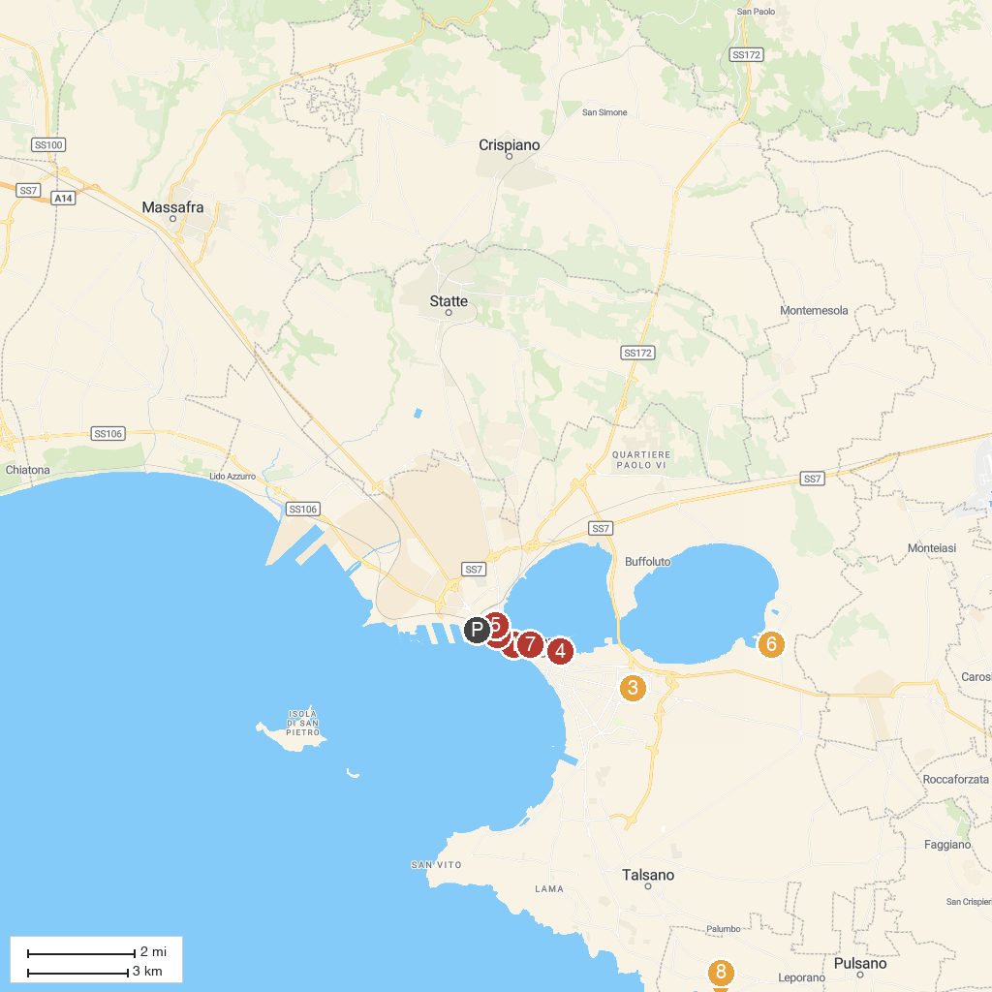
MAP KEY
1. Tempio Dorico | 5. Jonian Dolphin Conservation
2. Palazzo Amati | 6. Ecomuseo Palude La Vela e Mar Piccolo
3. Ancient Greek Walls Archaeological Park | 7. Archaeological Museum of Taranto
4. Ancient Athletes Tomb | 8. Saturo Archaeological Park
P. Cruise port / terminal
Map © MapTiler © OpenStreetMap contributors · cruiseports.org

