Tarragona, Catalonia, Spain
Ancient Rome meets the Costa Daurada — Tarragona packs a UNESCO-listed archaeological ensemble, a clifftop amphitheatre overlooking the sea, and a laid-back Catalan old town into one very walkable shore day.
⚓ Pier (Moll de Balears) · 🕒 Typical call: 8-10 hrs · 💶 Currency: Euro (€) · 🗣️ Language: Catalan / Spanish · 🏛️ UNESCO World Heritage
✍️ MY DAY IN PORT (FILL IN)
Ship / Date
In port | arrive ______ · all aboard ______
Booked excursion
Notes / meeting point
GETTING ASHORE
- Docking: Pier — Moll de Balears, ~2 km from city centre
- Walk to centre: Shuttle or taxi recommended (2 km); free escalators once in town
- Best For: Roman history, UNESCO ruins, beaches, Catalan cuisine
- Don't Miss: Roman Amphitheatre, Tarragona Cathedral, Rambla Nova
GETTING AROUND
- 🚕 Taxi: €10–15 — Official taxis queue outside the terminal. A cruise port supplement of ~€4.20 applies; expect €10–15 to the city center
- 📱 Rideshare: ✅ Uber
TOP THINGS TO DO
- Roman Amphitheatre & UNESCO Circuit — The clifftop Amphitheatre is Tarragona's headline sight — gladiatorial arena built into a bluff above the sea.
- Part Alta Old Town & Cathedral — Wander the medieval upper town to the striking Romanesque-Gothic Cathedral, built on the site of a Roman temple.
- Pont del Diable — Les Ferreres Aqueduct — A remarkably preserved two-tier Roman aqueduct sitting in a shaded valley park just 4 km outside the city.
- Playa de la Miracle & Costa Daurada Beaches — Tarragona's own city beach, Playa de la Miracle, sits right below the amphitheatre.
- PortAventura Theme Park — One of Europe's top theme parks sits just 12 km from Tarragona.
BEST WALKS
- Roman Tarragona Heritage Loop: ⏱ 2 hrs · 📏 ~3 km · 🚶 Moderate — hilly — The classic circuit of Tarragona's UNESCO highlights.
- El Serrallo Fishing Quarter Stroll: ⏱ 45 min · 📏 ~1.5 km · 🚶 Easy — flat — A flat walk along the port edge to the colourful fishing district.
WEATHER · DAYLIGHT · MONEY
Month | High °F | Low °F | Rainy days
May | 76 | 55 | 0
Jul | 89 | 69 | 0
Sep | 83 | 64 | 1
Daylight: May 6:37AM–9:06PM · Jul 6:35AM–9:25PM · Sep 7:35AM–8:03PM
cruiseports.org/tarragona · Confirm terminal & all-aboard time with your ship

Tarragona, Catalonia, Spain — Port Map
Red = walkable sights · Amber = excursions farther out · P = cruise terminal
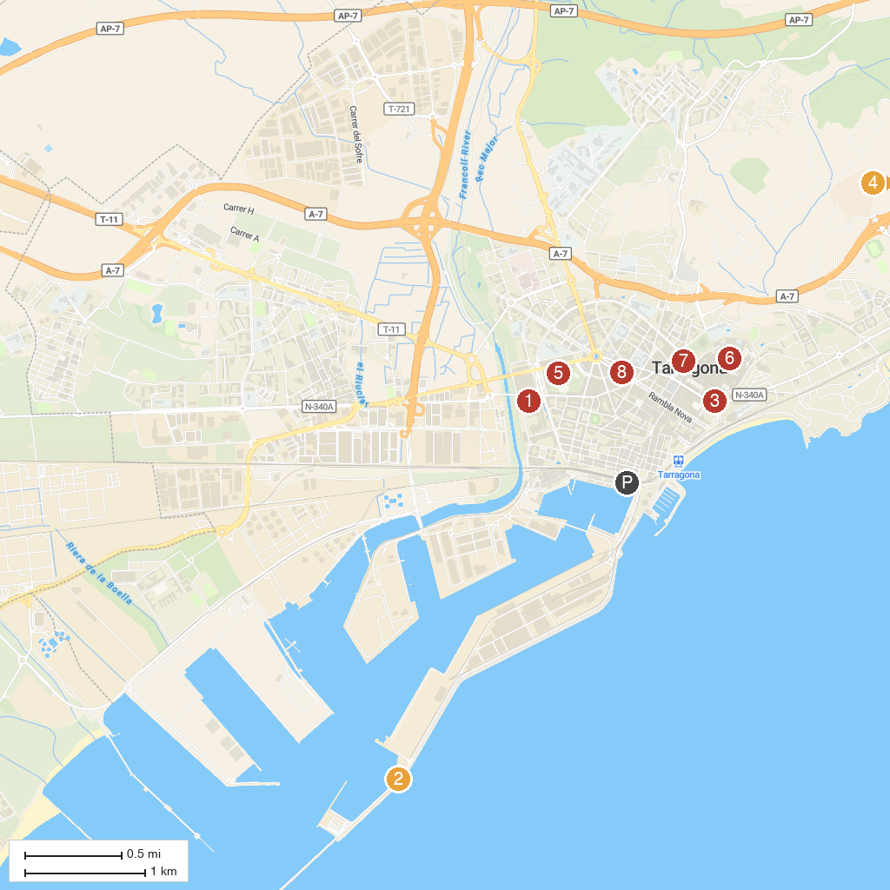
MAP KEY
1. Early Christian cemetery of Tàrraco | 5. Quinta de Sant Rafael
2. Far de la Banya - Museu de Fars | 6. Museu Bíblic Tarraconense
3. Torre de les Monges | 7. Parc de Saavedra
4. Scipio's Tower | 8. Castellers Monument
P. Cruise port / terminal
Map © MapTiler © OpenStreetMap contributors · cruiseports.org

