Taveuni Island, Fiji
Fiji's lushest island delivers soft-coral reefs ranked among the world's best, triple Tavoro waterfalls you can swim in, and a crack in the earth where today meets tomorrow — all on a single shore day.
⚓ Tender port · 🕒 Typical call: 6–8 hrs · 💵 Fijian Dollar (FJD) · 🗣️ Fijian & English
✍️ MY DAY IN PORT (FILL IN)
Ship / Date
In port | arrive ______ · all aboard ______
Booked excursion
Notes / meeting point
GETTING ASHORE
- Docking: Tender — ships anchor offshore; tenders land at Waiyevo Pier (government wharf)
- Walk to center: Waiyevo / Naqara village centre is a short walk from the pier; Somosomo ~3 km north
- Best For: Snorkelling, diving, waterfall hikes, nature & wildlife
- Don't Miss: Tavoro (Bouma) Waterfalls swim, Waitavala natural rock waterslide, International Date Line marker
GETTING AROUND
- 🚕 Taxi: FJ$2–FJ$50 depending on distance — Taxis wait at Waiyevo Pier but supply is limited on busy cruise days. Fares are negotiated — always agree on a price bef
- 📱 Rideshare: ❌ not available
TOP THINGS TO DO
- Tavoro (Bouma) Waterfalls Hike & Swim — Bouma National Heritage Park is the centrepiece of any Taveuni visit.
- Snorkel or Dive the Rainbow Reef — The Somosomo Strait between Taveuni and Vanua Levu is dubbed the Soft Coral Capital of the World.
- Waitavala Natural Rock Waterslide — Near Waiyevo (the trailhead is by the Taveuni Corrections Centre, a short walk from town), a stream has carved smooth channels…
- International Date Line Experience — The 180° meridian cuts directly through Taveuni.
- Lavena Coastal Walk — A 5-km trail on Taveuni's southeastern shore winds through coastal rainforest, remote beaches, and Fijian villages, ending at the…
BEST WALKS
- Waiyevo to Somosomo Village Stroll: 2 km one-way | Easy | 30–40 min — From the Waiyevo Pier, walk north along the main road through Naqara to Somosomo, Taveuni's main…
- Waitavala Waterslide Walk: Short walk from roadside | Easy | 15 min — From the road near Waiyevo (trailhead by the Taveuni Corrections Centre), a short trail leads to…
WEATHER · DAYLIGHT · MONEY
Month | High °F | Low °F | Rainy days
May | 80 | 76 | 20
Jul | 78 | 74 | 16
Sep | 78 | 74 | 18
Daylight: May 6:16AM–5:36PM · Jul 6:29AM–5:42PM · Sep 5:55AM–5:54PM
cruiseports.org/taveuni-island-fiji · Confirm terminal & all-aboard time with your ship

Taveuni Island, Fiji — Port Map
Red = walkable sights · Amber = excursions farther out · P = cruise terminal
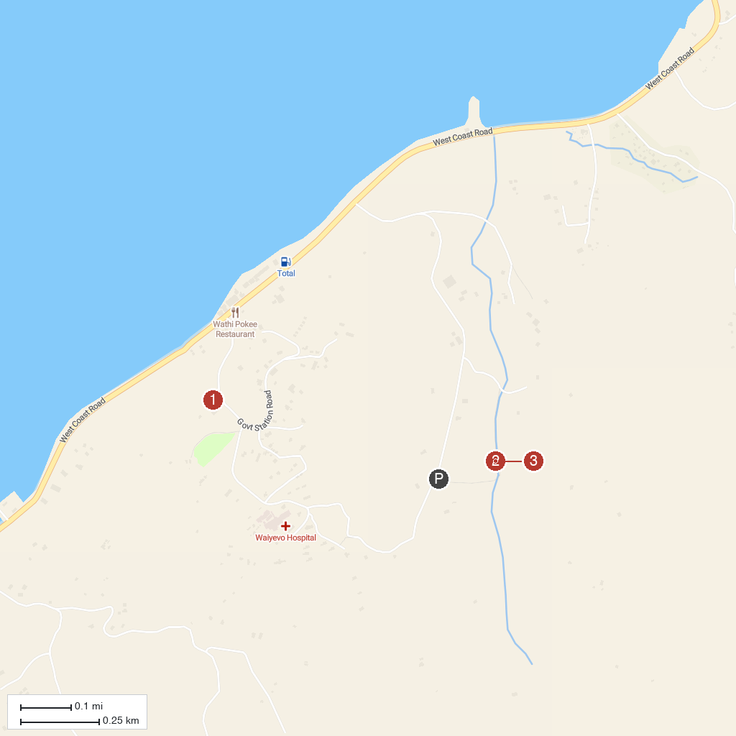
MAP KEY
1. Bouma National Heritage Park (Tavoro Waterfalls) | 4. Waitavala Water Slide
2. Lavena Coastal Walk | 5. Waiyevo Government Wharf
3. International Date Line Monument
P. Cruise port / terminal
Map © MapTiler © OpenStreetMap contributors · cruiseports.org

