The Hague, South Holland, Netherlands
The Netherlands' seat of government and royal residence pairs stately Golden Age grandeur with a vibrant North Sea beach resort — all from one compact harbor in Scheveningen.
⚓ Docked (Scheveningen pier) · 🕒 Typical call: 8-10 hrs · 💶 Currency: Euro (€) · 🗣️ Dutch (English everywhere)
✍️ MY DAY IN PORT (FILL IN)
Ship / Date
In port | arrive ______ · all aboard ______
Booked excursion
Notes / meeting point
GETTING ASHORE
- Docking: Pier at Scheveningen (Vissershaven or Adriaan Maaskade); smaller ships only — large ships may use Rotterdam
- Walk to center: Scheveningen beach is steps away; The Hague city center ~5 km by tram (15 min)
- Best For: Art lovers, history buffs, beach walks, Indonesian food
- Don't Miss: Mauritshuis (Girl with a Pearl Earring) and the Peace Palace exterior
GETTING AROUND
- 🚕 Taxi: €20–€30 — Taxis queue at the Scheveningen cruise terminal for the ~5–7 km ride to The Hague city centre. Journey takes about 10–15
- 📱 Rideshare: ✅ Uber, Bolt
- 🚌 Hop-on hop-off: ✅
TOP THINGS TO DO
- Mauritshuis — Girl with a Pearl Earring — One of the world's finest small museums, housed in a 17th-century city palace beside the Hofvijver lake.
- Peace Palace & Binnenhof Walk — Walk past the Peace Palace (Vredespaleis), seat of the International Court of Justice — the exterior alone impresses.
- Panorama Mesdag — A stunning 360° cylindrical panorama painting from 1881 — 14 m high, 120 m around — that puts you on a sand dune overlooking…
- Escher in The Palace — M.C.
- Scheveningen Beach & Pier — The widest beach in the Netherlands is steps from the ship.
BEST WALKS
- Scheveningen Beachfront Stroll: 2 km · Flat · 30-40 min — Walk from the harbor along the beach promenade past the historic Kurhaus hotel to the Scheveningen…
- Hague City Center Highlights: 2.5 km · Flat · 1-1.5 hrs — From Den Haag Centraal, stroll the Lange Voorhout (Europe's loveliest lime-tree avenue), past…
WEATHER · DAYLIGHT · MONEY
Month | High °F | Low °F | Rainy days
May | 63 | 49 | 1
Jul | 72 | 59 | 1
Sep | 67 | 55 | 1
Daylight: May 5:48AM–9:30PM · Jul 5:40AM–9:55PM · Sep 7:17AM–7:57PM
cruiseports.org/the-hague · Confirm terminal & all-aboard time with your ship

The Hague, South Holland, Netherlands — Port Map
Red = walkable sights · Amber = excursions farther out · P = cruise terminal
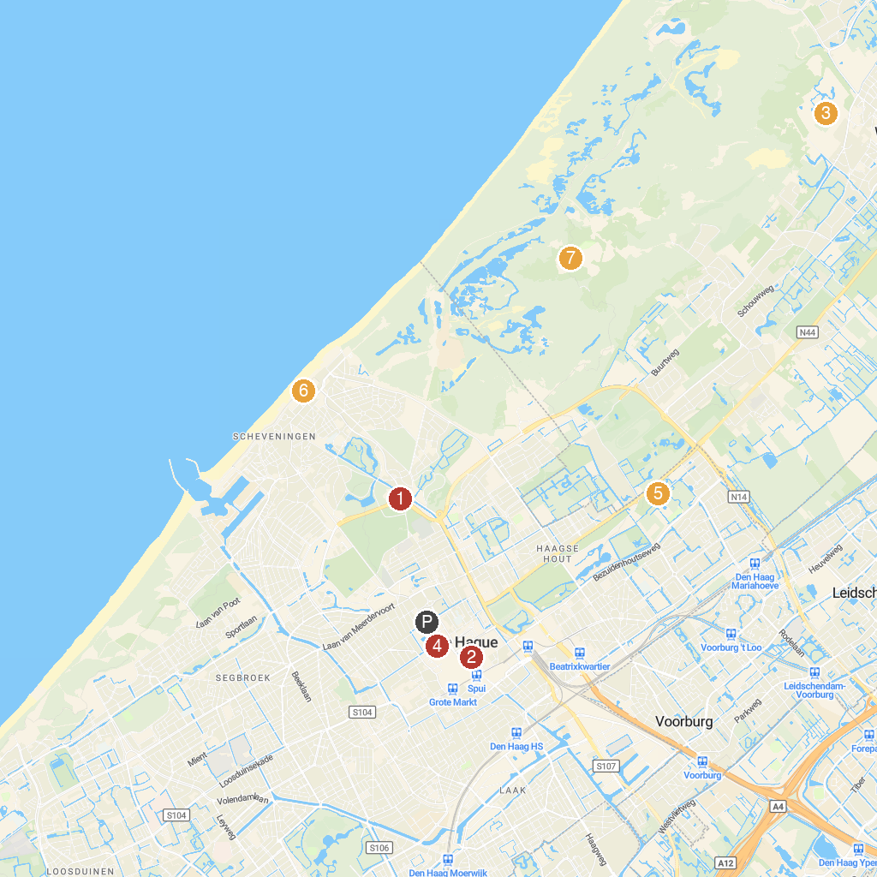
MAP KEY
1. Abtswoudse Bos | 5. Noordeinde Palace
2. Madurodam | 6. Louwman Museum
3. Binnenhof | 7. Sea Life Scheveningen
4. Duinrell | 8. Meijendel
P. Cruise port / terminal
Map © MapTiler © OpenStreetMap contributors · cruiseports.org

