Thursday Island, Queensland, Australia
Perched at the top of Australia in the Torres Strait, Thursday Island packs a remarkable history — pearling boom, WWII defenses, and one of the country's most distinct Indigenous cultures — into just 3.5 square kilometres.
⚓ Tender port · 🕒 Typical call: 6–8 hrs · 💵 Australian Dollar (AUD) · 🗣️ English / Torres Strait Creole · 🌡️ Tropical year-round
✍️ MY DAY IN PORT (FILL IN)
Ship / Date
In port | arrive ______ · all aboard ______
Booked excursion
Notes / meeting point
GETTING ASHORE
- Docking: Tender to Engineers Jetty
- Walk to center: 2 min from jetty to Douglas St
- Best For: Culture, history, pearling heritage
- Don't Miss: Gab Titui Cultural Centre & Green Hill Fort
GETTING AROUND
- 🚕 Taxi: Varies (metered) — Local taxis (Laifoo's, Silver Leaf, TI Taxi Association) available for trips to Green Hill Fort and other island sites.
- 📱 Rideshare: ❌ not available
TOP THINGS TO DO
- Gab Titui Cultural Centre — The Torres Strait's premier cultural showcase features wood carvings, linocut prints, elaborate dhari headdresses, and…
- Green Hill Fort & Museum — Built in the 1890s to guard against feared Russian invasion, the fort's massive 6-inch guns still point out to sea.
- Horn Island WWII Battlefield Tour — A short ferry hop to neighbouring Horn Island reveals Australia's most bombed airbase.
- Peddells Island Bus Tour — The go-to option for time-limited cruise passengers: a 1-hour air-conditioned circuit of TI's key sights — fort, cemetery…
- Scenic Coastal Walk & Dead Man's Beach — A peaceful walk along the island's eastern shore to Dead Man's Beach for views over the Torres Strait.
BEST WALKS
- Jetty to Town Centre Loop: 30–45 min · Flat · Free — From Engineers Jetty, stroll along Victoria Parade past the Grand Hotel waterfront deck, then up to…
- Japanese Pearlers' Cemetery Walk: 45 min return · Flat · Free — A 1.5 km walk south from the jetty brings you to Thursday Island Cemetery, where rows of Japanese…
WEATHER · DAYLIGHT · MONEY
Month | High °F | Low °F | Rainy days
May | 87 | 77 | 1
Jul | 85 | 75 | 0
Sep | 87 | 76 | 0
Daylight: May 6:38AM–6:16PM · Jul 6:50AM–6:23PM · Sep 6:25AM–6:27PM
cruiseports.org/thursday-island · Confirm terminal & all-aboard time with your ship

Thursday Island, Queensland, Australia — Port Map
Red = walkable sights · Amber = excursions farther out · P = cruise terminal
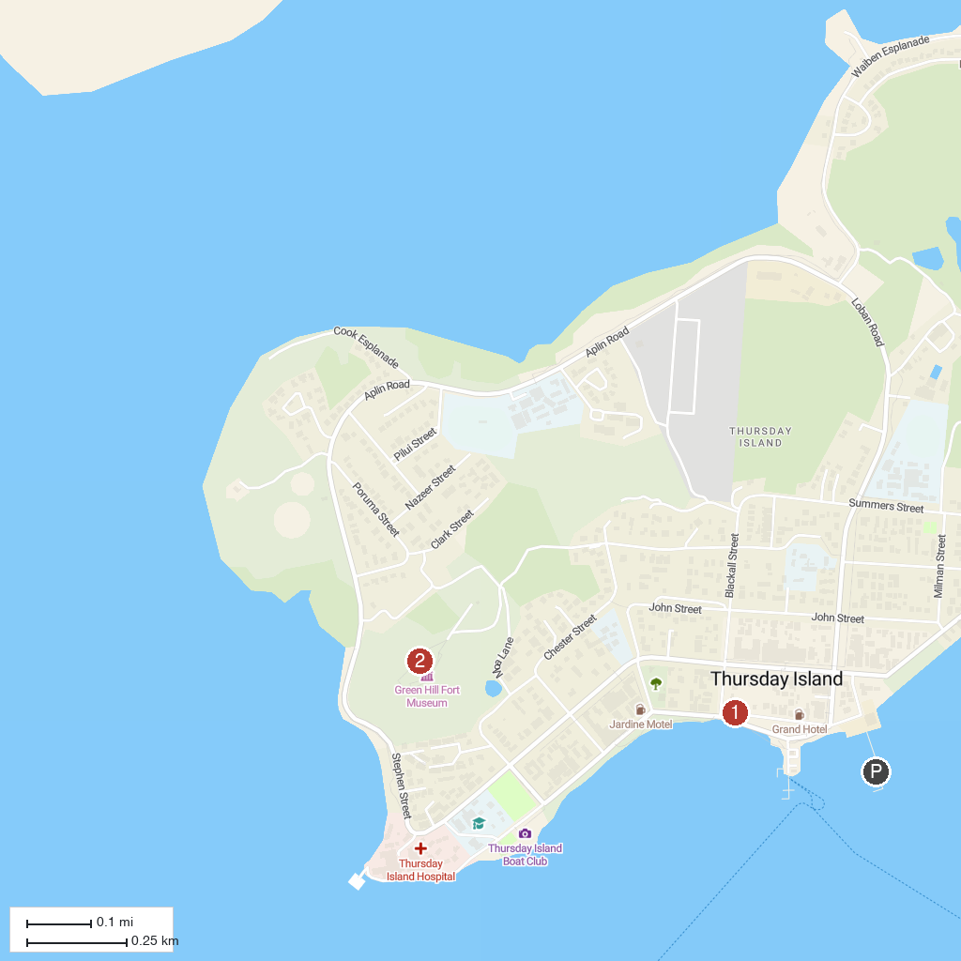
MAP KEY
1. Gab Titui Cultural Centre | 2. Green Hill Fort
P. Cruise port / terminal
Map © MapTiler © OpenStreetMap contributors · cruiseports.org

