Tobago Cays, Saint Vincent and the Grenadines
Five uninhabited emerald islets ringed by the Horseshoe Reef — no roads, no resorts, just some of the Caribbean's clearest water and a beach full of wild sea turtles waiting to meet you.
⚓ Tender only (no pier) · 🕒 Typical call: 5–8 hrs · 💵 USD / Eastern Caribbean Dollar · 🗣️ English · 🐢 Marine park — small ships only
✍️ MY DAY IN PORT (FILL IN)
Ship / Date
In port | arrive ______ · all aboard ______
Booked excursion
Notes / meeting point
GETTING ASHORE
- Docking: Tender — ships anchor outside Horseshoe Reef; no pier exists
- Ships Allowed: Small/luxury ships under ~400 passengers (large mega-ships cannot visit)
- Best For: Snorkeling, swimming with sea turtles, beach BBQ, pure Caribbean escape
- Don't Miss: Turtle sanctuary at Baradal, Horseshoe Reef snorkeling, Petit Bateau summit view
GETTING AROUND
- 🚕 Taxi: $30–$50 USD per person round-trip — Shared water taxis run from nearby Union Island and Mayreau to the Cays. A useful option for independent travelers or ex
TOP THINGS TO DO
- Turtle Sanctuary Swim at Baradal — The shallows off Baradal Cay are one of the Caribbean's most reliable spots to swim freely alongside wild green and hawksbill sea…
- Horseshoe Reef Snorkel — This 4km barrier reef shelters the cays from the Atlantic.
- Petit Bateau Summit Hike — A short, slightly steep trail climbs to the top of Petit Bateau for a 360-degree panorama of the Horseshoe Reef, all five cays…
- Iguana Trail, Baradal Cay — Walk inland through Baradal's dry forest to spot dozens of large, brilliantly colored iguanas basking in the trees.
- Petit Tabac — The Pirates of the Caribbean Island — This narrow sand-spit beyond the Horseshoe Reef is where Captain Jack Sparrow and Elizabeth Swann were marooned in the first…
BEST WALKS
- Baradal Turtle Beach & Iguana Trail: Easy · 30–60 min · flat beach + gentle trail — From the tender landing on Baradal, walk along the beach to the turtle sanctuary buoys, then follow…
- Petit Bateau Beach to Summit: Moderate · 30–45 min · short steep climb — Land on Petit Bateau's leeward beach, then take the dirt path to the island's high point for…
WEATHER · DAYLIGHT · MONEY
Month | High °F | Low °F | Rainy days
May | 81 | 79 | 0
Jul | 82 | 79 | 1
Sep | 83 | 80 | 1
Daylight: May 5:40AM–6:23PM · Jul 5:47AM–6:35PM · Sep 5:54AM–6:06PM
cruiseports.org/tobago-cays · Confirm terminal & all-aboard time with your ship

Tobago Cays, Saint Vincent and the Grenadines — Port Map
Red = walkable sights · Amber = excursions farther out · P = cruise terminal
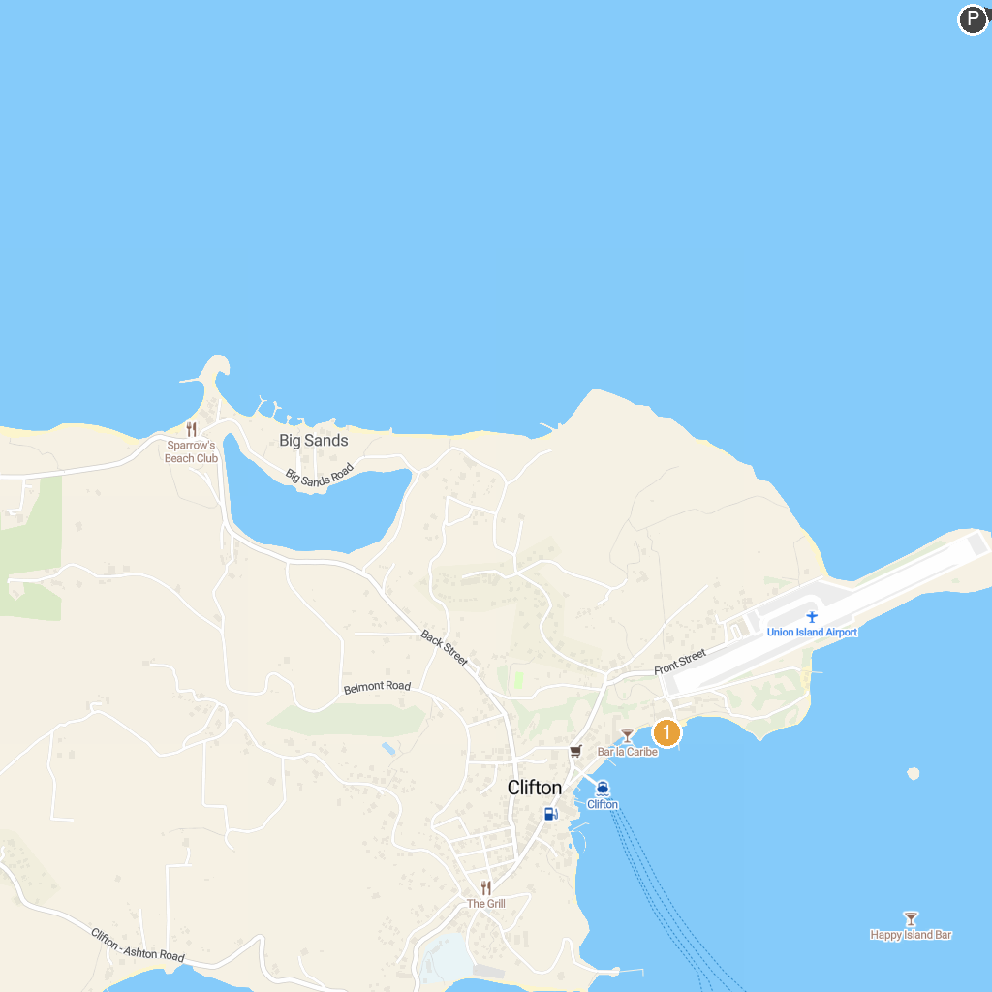
MAP KEY
1. Kiteboarding Cruise - Caribbean | 2. Anse La Roche Bay
P. Cruise port / terminal
Map © MapTiler © OpenStreetMap contributors · cruiseports.org

