Tokyo, Kanto, Japan
Where 1,400-year-old temples share the skyline with neon-lit skyscrapers — Tokyo delivers an extraordinary density of experiences in a single shore day, from Asakusa's incense-filled lanes to the organized chaos of Shibuya Crossing.
⚓ Docked (pier) · 🕒 Typical call: 8-12 hrs · 💴 Currency: Japanese Yen (JPY) · 🗣️ Language: Japanese · 🚇 World-class public transit
✍️ MY DAY IN PORT (FILL IN)
Ship / Date
In port | arrive ______ · all aboard ______
Booked excursion
Notes / meeting point
GETTING ASHORE
- Docking: Tokyo International Cruise Terminal (Odaiba) for large ships; Harumi Pier for smaller vessels; some itineraries dock at Yokohama (Osanbashi or Daikoku Pier)
- Walk to center: Train required — central Tokyo 20-30 min from Odaiba; Yokohama city center walkable from Osanbashi in 10-20 min
- Best For: Culture, food, temples, urban exploration, Yokohama Chinatown, Mount Fuji day trips
- Don't Miss: Senso-ji Temple at dawn, Tsukiji Outer Market breakfast, Shibuya Crossing at rush hour
GETTING AROUND
- 🚕 Taxi: ¥2,500–¥8,500 depending on destination — Taxis are metered, reliable, and widely available. From Harumi Terminal to Tokyo Station runs ~¥2,500–¥3,000; to Shinjuk
- 📱 Rideshare: ✅ Uber, DiDi, GO
- 🚌 Hop-on hop-off: ✅ Skyhop Bus
TOP THINGS TO DO
- Senso-ji & Asakusa District — Tokyo's oldest Buddhist temple (founded 645 AD) anchors the historic Asakusa district.
- Shibuya Crossing & Shibuya Sky — Stand at the world's busiest pedestrian crossing where up to 3,000 people cross simultaneously every signal change — pure…
- Tsukiji Outer Market & Sushi Breakfast — The world-famous Tsukiji inner wholesale market relocated to Toyosu, but the outer market remains a vibrant food street packed…
- Meiji Jingu Shrine & Harajuku — A vast forested Shinto shrine in the heart of the city, dedicated to Emperor Meiji and Empress Shoken.
- Mount Fuji & Hakone Day Trip — Japan's iconic snow-capped volcano (3,776 m) is visible on clear days from Tokyo but fully experienced from Hakone — an area with…
BEST WALKS
- Odaiba Waterfront Stroll (from Tokyo Cruise Terminal): Easy | 3-4 km | 45-60 min — A scenic promenade walk from the cruise terminal past teamLab Borderless (if open), the iconic…
- Asakusa Temple Walk (central Tokyo): Easy | 2 km | 30 min walking + explore time — From Asakusa Station walk the Nakamise-dori shopping lane to Senso-ji Temple, then continue along…
- Yokohama Waterfront Walk (from Osanbashi): Easy | 2-3 km | 30-45 min — From Osanbashi pier, walk the harbor promenade past the Red Brick Warehouse (Aka Renga) with its…
WEATHER · DAYLIGHT · MONEY
Month | High °F | Low °F | Rainy days
May | 74 | 58 | 11
Jul | 85 | 73 | 16
Sep | 80 | 68 | 15
Daylight: May 4:36AM–6:39PM · Jul 4:36AM–6:57PM · Sep 5:23AM–5:48PM
cruiseports.org/tokyo · Confirm terminal & all-aboard time with your ship

Tokyo, Kanto, Japan — Port Map
Red = walkable sights · Amber = excursions farther out · P = cruise terminal
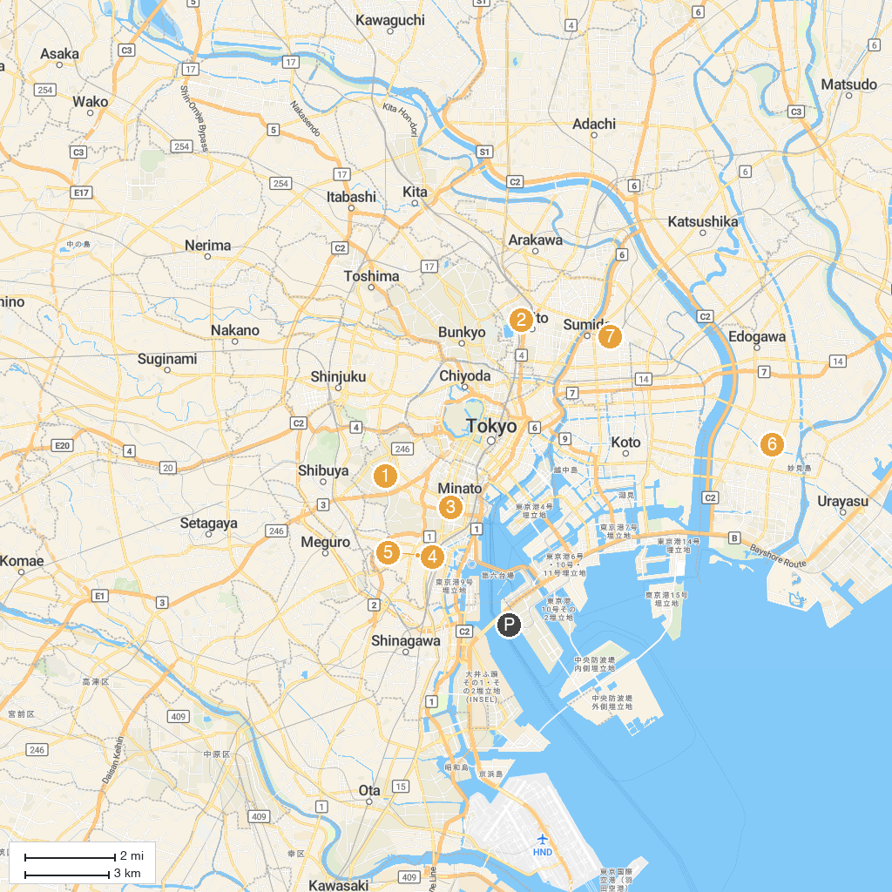
MAP KEY
1. Aoyama Cemetery | 5. Site of the seppuku (ritualistic execution) of Oishi Yoshitaka and the other 16 Akougishi (Akou Roshi) samurai
2. The National Museum of Western Art | 6. Toshima City Agariyashiki Park
3. Shiba Maruyama Kofun (Ancient tomb) | 7. Furukawa Water Park
4. Ruins of Takanawa Ōkido Gate | 8. Tokyo Skytree
P. Cruise port / terminal
Map © MapTiler © OpenStreetMap contributors · cruiseports.org

