Tomonoura, Hiroshima Prefecture, Japan
One of Japan's most unchanged harbor towns, Tomonoura waited for favorable winds in the Edo era — and still feels like time stopped. The circular stone quay, narrow alleys, and hilltop temples inspired Hayao Miyazaki to set Ponyo here.
⚓ Tender (historic harbor, no cruise pier) · 🕒 Typical call: 6–8 hrs · 💴 Japanese Yen (JPY) — carry cash · 🗣️ Japanese (very little English)
✍️ MY DAY IN PORT (FILL IN)
Ship / Date
In port | arrive ______ · all aboard ______
Booked excursion
Notes / meeting point
GETTING ASHORE
- Docking: Tender into Tomonoura Ferry Terminal; larger ships dock at Fukuyama Port (~15 km away)
- Walk to center: Steps from tender dock — entire village is walkable in 15–20 min
- Best For: History, Japanese culture, quiet photography, seafood lunch
- Don't Miss: Fukuzenji Temple view, Joyato lighthouse, Homeishu tasting at Okamoto Brewery
GETTING AROUND
- 🚕 Taxi: ¥4,400–¥5,500 (~$27–$34 USD) one way — Metered taxis (Rose Taxi, Green Taxi, Asahi Taxi) connect Tomonoura to Fukuyama Station in about 15 minutes. Within the
- 📱 Rideshare: ✅ Uber
TOP THINGS TO DO
- Tomonoura Village Walking Tour — Wander the Edo-period townscape: Joyato stone lighthouse, cobblestone alleys, the Ota Residence (preserved merchant complex and…
- Fukuzenji Temple & Best View in Japan — In 1711 a Korean royal envoy declared the view from Fukuzenji's Taichoro Hall 'the most beautiful scenic view East of Korea.' The…
- Sensuijima Island Day Trip — A 5-minute retro ferry ride from the harbor takes you to this small island with a quiet sandy beach (clear water, summer…
- Tai-meshi Seafood Lunch — Tomonoura's signature dish is tai-meshi — whole red sea bream slow-cooked with rice in a clay pot with soy sauce and sake.
- Fukuyama Castle (if docking at Fukuyama Port) — If your shuttle drops you at Fukuyama Station, the castle is literally visible from the platform.
BEST WALKS
- Harbor to Hilltop: Tomonoura Core Loop: 1.5 km · ~45 min · Easy · Free (except optional paid sites) — From the ferry terminal, walk past the Joyato lighthouse to Fukuzenji Temple for the famous Seto…
- Sensuijima Coastal Trail: 1 km loop · 30 min · Easy · Ferry required (~240 JPY) — Take the short harbour ferry to Sensuijima Island and walk the Goshiki-iwa (Five-Colored Rocks)…
cruiseports.org/tomonoura-fukuyama · Confirm terminal & all-aboard time with your ship

Tomonoura, Hiroshima Prefecture, Japan — Port Map
Red = walkable sights · Amber = excursions farther out · P = cruise terminal
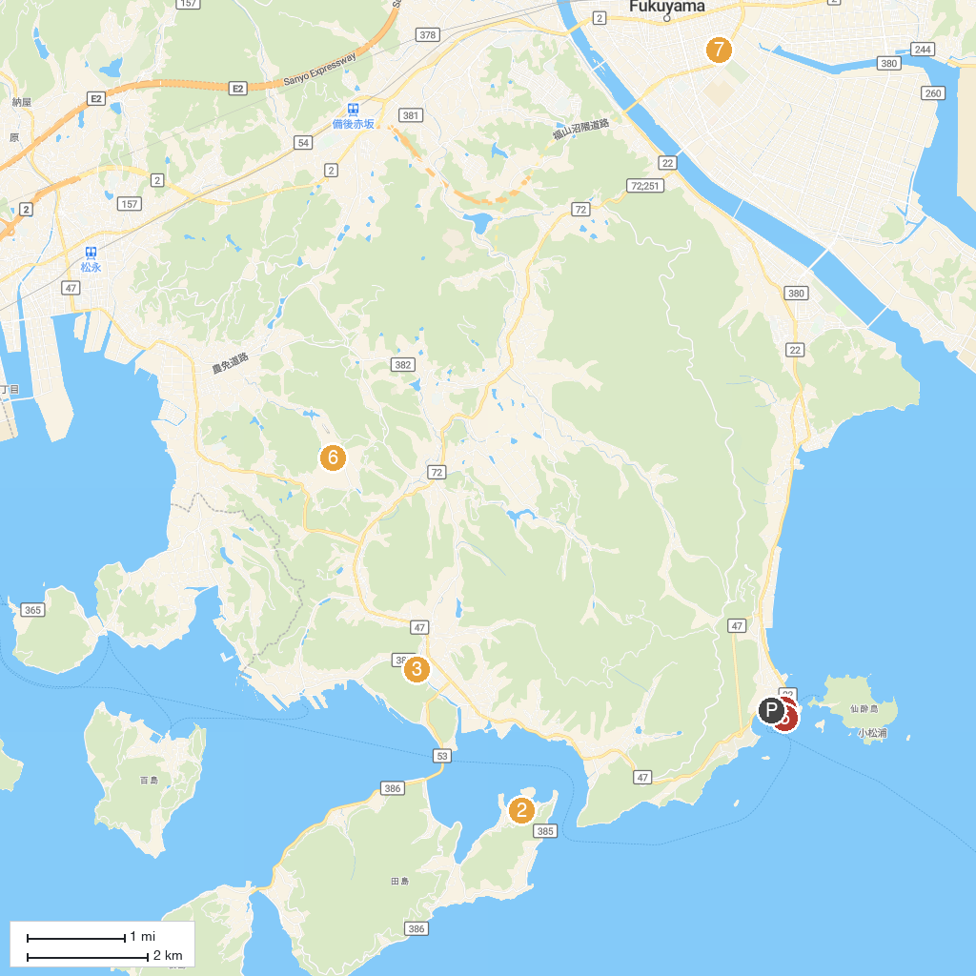
MAP KEY
1. Fukuzenji Temple Taichoroh | 5. Enpuku Temple
2. CRESCENT BEACH | 6. Miroku no Sato
3. 福山市ぬまくま文化館（枝広邸） | 7. Bara Park
4. Tomonoura | 8. Fukuyama Museum Of Literature
P. Cruise port / terminal
Map © MapTiler © OpenStreetMap contributors · cruiseports.org

