Toronto, Ontario, Canada
Canada's cosmopolitan megacity sits on the northwestern shore of Lake Ontario, blending iconic skyline architecture with an extraordinary mosaic of cultures, cuisines, and neighborhoods. From the CN Tower's glass floor to the cobblestones of the Distillery District, a day here rewards every style of explorer.
⚓ Pier (International Marine Passenger Terminal) · 🕒 Typical call: 8-12 hrs · 💵 Canadian Dollar (CAD) · 🗣️ English / French
✍️ MY DAY IN PORT (FILL IN)
Ship / Date
In port | arrive ______ · all aboard ______
Booked excursion
Notes / meeting point
GETTING ASHORE
- Docking: Pier — International Marine Passenger Terminal, 8 Unwin Ave, Port Lands
- Walk to centre: Not walkable (~5 km via industrial roads); taxi/rideshare or ship shuttle
- Best For: City sightseeing, food markets, multicultural dining, architecture
- Don't Miss: CN Tower observation deck, St. Lawrence Market, Toronto Islands ferry
GETTING AROUND
- 🚕 Taxi: CAD 70–80 — Taxis are readily available at the cruise terminal. The ride to downtown Toronto takes about 10–15 minutes depending on
- 📱 Rideshare: ✅ Uber, Lyft
- 🚌 Hop-on hop-off: ✅ City Sightseeing Toronto
TOP THINGS TO DO
- CN Tower Observation Deck — Ride the glass elevator to the observation deck of the 553-metre tower for sweeping views of the city and Lake Ontario.
- Distillery Historic District — The best-preserved collection of Victorian industrial architecture in North America, now a pedestrian village of galleries…
- St. Lawrence Market & Kensington Market — National Geographic's world's best food market has been feeding Torontonians since 1803.
- Toronto Islands Ferry & Skyline Views — A 10-minute ferry from the Jack Layton Ferry Terminal whisks you to a chain of car-free islands.
- Royal Ontario Museum (ROM) — Canada's largest museum of world culture and natural history, housed in a striking building featuring 'The Crystal' — a dramatic…
BEST WALKS
- Waterfront to Distillery District: 2.5 km · Easy · ~45 min — Start at the Harbourfront Centre, walk east along Queens Quay, pass Sugar Beach, and arrive at the…
- Downtown Core: CN Tower to St. Lawrence Market: 2 km · Easy · ~40 min — Begin at the CN Tower and Ripley's Aquarium, walk east past Union Station and the St.
- Kensington Market & Chinatown: 1.5 km loop · Easy · ~1 hr — Explore bohemian Kensington Market's vintage stores and global food stalls, then spill into…
WEATHER · DAYLIGHT · MONEY
Month | High °F | Low °F | Rainy days
May | 67 | 50 | 1
Jul | 81 | 65 | 1
Sep | 73 | 58 | 1
Daylight: May 5:52AM–8:36PM · Jul 5:50AM–8:56PM · Sep 6:57AM–7:27PM
cruiseports.org/toronto · Confirm terminal & all-aboard time with your ship

Toronto, Ontario, Canada — Port Map
Red = walkable sights · Amber = excursions farther out · P = cruise terminal
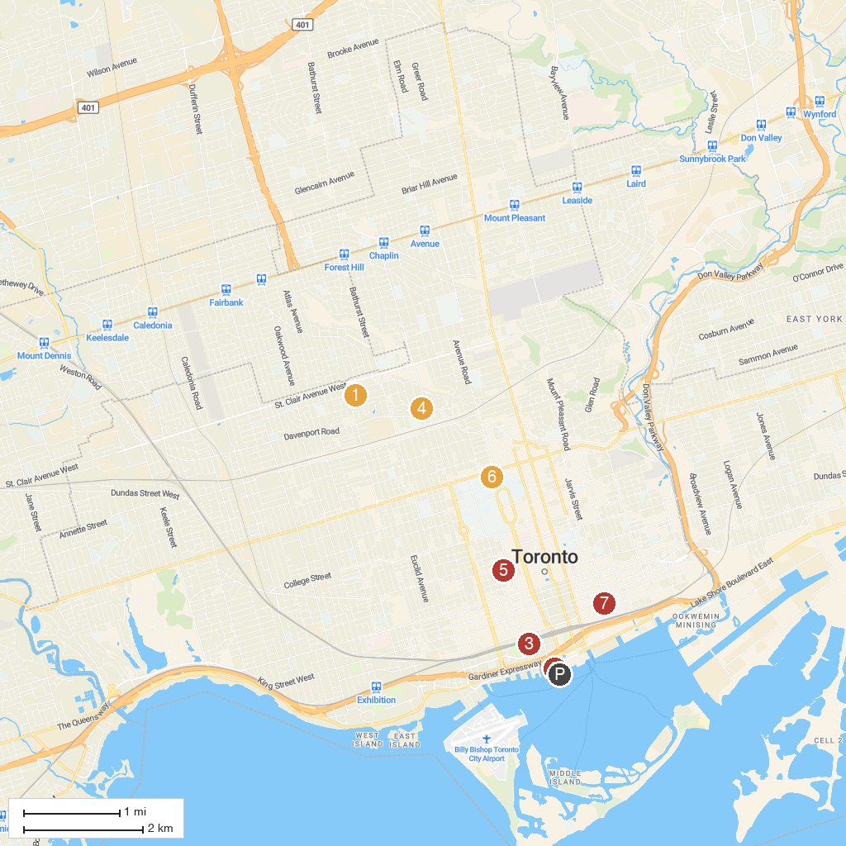
MAP KEY
1. Wychwood Barns Park | 5. Art Gallery of Ontario
2. Harbourfront Centre | 6. Royal Ontario Museum
3. CN Tower | 7. The Village at Black Creek
4. Casa Loma | 8. St. Lawrence Market
P. Cruise port / terminal
Map © MapTiler © OpenStreetMap contributors · cruiseports.org

