Tórshavn, Faroe Islands, Denmark
One of the world's smallest capitals, Tórshavn is a storybook cluster of turf-roofed Viking houses perched on a North Atlantic harbor — where the parliament has met since the 9th century and 80,000 sheep outnumber the people.
⚓ Pier (Skansabryggjan or Molain quay) · 🕒 Typical call: 7-10 hrs · 💵 Danish Krone (DKK) — nearly cashless · 🗣️ Faroese & Danish; English widely spoken · 🌧️ Pack layers & waterproofs
✍️ MY DAY IN PORT (FILL IN)
Ship / Date
In port | arrive ______ · all aboard ______
Booked excursion
Notes / meeting point
GETTING ASHORE
- Docking: Pier-side at Skansabryggjan or Molain quay; tender extremely rare
- Walk to center: 5-10 min from Skansabryggjan; 15-20 min from Molain
- Best For: Viking history, turf-roof architecture, dramatic island day trips
- Don't Miss: Tinganes old town peninsula and Kirkjubøur medieval ruins
GETTING AROUND
- 🚕 Taxi: DKK 75+ flag fall (~+) — Local taxis are available near the port (taxi.fo). Sightseeing charters run ~DKK 550–875/hr. Pre-booking recommended on
- 📱 Rideshare: ❌ not available
TOP THINGS TO DO
- Kirkjubøur: Faroe Islands' Historic Heart — A 20-minute drive south, Kirkjubøur holds the ruins of a 13th-century Gothic cathedral, a still-active medieval church, and the…
- Vestmanna Sea Cliffs Boat Tour — Cruise through sea caves and alongside 480 m basalt cliffs teeming with guillemots, kittiwakes, and puffins on this classic…
- Island Highlights: Fossá Waterfall & Saksun — Drive north on Streymoy to visit Fossá — one of the Faroes' tallest waterfalls — then continue to Saksun, a remote lagoon village…
- Puffin & Birdwatching Boat Around Nólsoy — A 2-hour boat trip circles the island of Nólsoy — home to one of the world's largest puffin colonies — giving close-up views of…
- Tórshavn Old Town Self-Guided Walk — Explore Tinganes, the turf-roofed government peninsula, the Á Reyni residential quarter, Skansin Fort, and the harbor waterfront…
BEST WALKS
- Harbor Loop: Tinganes, Skansin & the Waterfront: 1.5-2 hrs · Easy · Free — Start at Skansabryggjan pier, visit Skansin Fort for harbor views, continue along Vágsbotnur…
- Cathedral, Park & Art Museum: 1-1.5 hrs · Easy · Some paid entry — Walk up from the harbor to Tórshavn Cathedral (1788), continue to Viðarlundin city park for a…
WEATHER · DAYLIGHT · MONEY
Month | High °F | Low °F | Rainy days
May | 49 | 42 | 1
Jul | 55 | 49 | 1
Sep | 54 | 48 | 1
Daylight: May 4:33AM–10:15PM · Jul 4:10AM–10:53PM · Sep 6:53AM–7:49PM
cruiseports.org/torshavn · Confirm terminal & all-aboard time with your ship

Tórshavn, Faroe Islands, Denmark — Port Map
Red = walkable sights · Amber = excursions farther out · P = cruise terminal
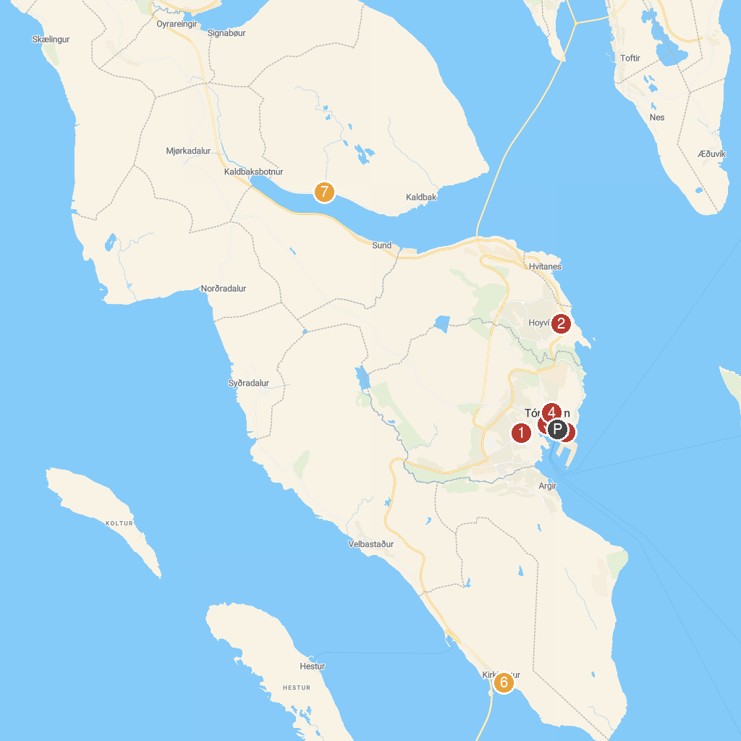
MAP KEY
1. Vesturkirkjan | 5. Skansin
2. Tjóðsavnið (Faroe Islands National Museum) | 6. Kirkjubømúrurin
3. Tórshavn Cathedral | 7. Tyggjara falls
4. Kongaminnið (The King’s Monument)
P. Cruise port / terminal
Map © MapTiler © OpenStreetMap contributors · cruiseports.org

