Torvik, Møre og Romsdal, Norway
A handful of houses, a working pier, and the wild Norwegian coast stretching in every direction — Torvik is as authentic as cruise ports get. The reward for venturing out is Runde Island, home to 500,000 seabirds including 100,000 puffins.
⚓ Pier (direct docking) · 🕒 Typical call: 15 min–7 hrs (varies by line) · 💵 Norwegian Krone (NOK) — cashless OK · 🗣️ Norwegian (English widely spoken) · 🐦 Best May–Aug for puffins
✍️ MY DAY IN PORT (FILL IN)
Ship / Date
In port | arrive ______ · all aboard ______
Booked excursion
Notes / meeting point
GETTING ASHORE
- Docking: Pier at Torvik Kai — no tender
- Walk to center: You're in "Torvik" at the gangway; nearest town (Fosnavåg) is 9 km
- Best For: Puffin watching, coastal bridges, off-the-beaten-path Norway
- Don't Miss: Runde Bird Island (May–Aug) — one of Europe's great seabird spectacles
GETTING AROUND
- 🚕 Taxi: Varies (metered) — Local taxis can be arranged through the cruise line or port staff. Useful for reaching trailheads or nearby towns like Ø
- 📱 Rideshare: ❌ not available
TOP THINGS TO DO
- Runde Bird Island Puffin Tour — Runde is one of Europe's largest seabird colonies, with up to 100,000 Atlantic puffins nesting May–August alongside gannets…
- Herøy Archipelago Bridge Drive — A network of high-arched Atlantic bridges leaps from island to island across open sea.
- Herøy Coastal Museum (Herøy Kystmuseum) — Open-air museum on the historic island of Herøya featuring 18th-century trade buildings, Viking-age exhibits, and restored…
- Mulesanden Beach — One of Norway's most beautiful beaches — a wide expanse of white sand flanked by dramatic Atlantic cliffs on Nerlandsøya island.
BEST WALKS
- Torvik Pier to the Bridge Viewpoint: 0.8 km · 15 min · Easy · Free — Turn right from the pier and walk along the coastal road toward Torvikbrua (the bridge connecting…
cruiseports.org/torvik · Confirm terminal & all-aboard time with your ship

Torvik, Møre og Romsdal, Norway — Port Map
Red = walkable sights · Amber = excursions farther out · P = cruise terminal
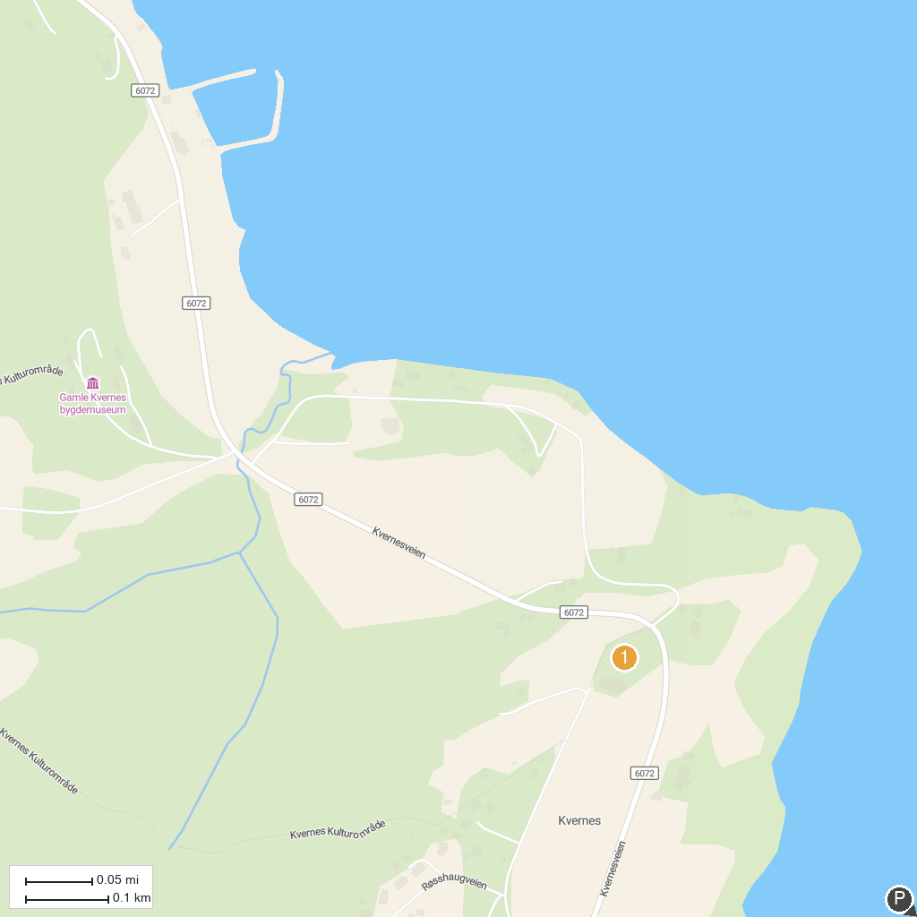
MAP KEY
1. Sundbåten- The harbour ferry | 4. The Atlantic Road
2. Varden | 5. Kvernes Stave Church
3. Folkeparken
P. Cruise port / terminal
Map © MapTiler © OpenStreetMap contributors · cruiseports.org

