Toyama City, Toyama Prefecture, Japan
On the shores of Toyama Bay with the snow-capped Northern Alps as a backdrop, Toyama City blends a feudal castle, world-class glass art, and a mountain route unlike anything else in Asia.
⚓ Pier (Fushiki-Toyama Port) · 🕒 Typical call: 8-10 hrs · 💴 Japanese Yen (JPY) · 🗣️ Japanese
✍️ MY DAY IN PORT (FILL IN)
Ship / Date
In port | arrive ______ · all aboard ______
Booked excursion
Notes / meeting point
GETTING ASHORE
- Docking: Pier at Fushiki-Toyama Port — no tendering
- Port to City Center: ~25-30 min by shuttle bus or taxi
- Best For: Alpine scenery, Japanese culture, architecture
- Don't Miss: Tateyama Kurobe Alpine Route snow walls (spring)
GETTING AROUND
- 🚕 Taxi: ¥10,000–¥12,000 one-way — Taxis are metered; base fare ¥650 plus ~¥458/km. The ~20 km ride to Toyama City center typically runs ¥10,000–¥12,000 (~
- 📱 Rideshare: ✅ Uber, DiDi
TOP THINGS TO DO
- Tateyama Kurobe Alpine Route — Japan's most dramatic mountain crossing uses cable cars, buses, and ropeways to reach 2,450 m.
- Toyama Castle Park — A photogenic reconstruction of the feudal castle sits in a leafy central park, its moat fed by the Jinzu River earning it the…
- Toyama Glass Art Museum — Designed by Kengo Kuma, this striking timber-and-glass building hosts a permanent Dale Chihuly installation alongside world-class…
- Zuiryū-ji Zen Temple, Takaoka — A National Treasure and one of Japan's finest Zen temple complexes, Zuiryū-ji is in nearby Takaoka (30 min from port) — actually…
- Iwase Historic Merchant District — Edo and Meiji-period merchant houses line the streets of this former port district, once the hub of Toyama's medicine trade.
BEST WALKS
- Castle to Glass Museum Loop: 2.5 km · ~45 min · flat — From Toyama Station, walk to Toyama Castle Park (10 min), explore the grounds, then continue to the…
- Fugan Canal Kansui Park Stroll: 1.5 km canal loop · 30 min · flat — A peaceful walk along the Fugan Canal with wide views of the Tateyama mountain range on clear days.
WEATHER · DAYLIGHT · MONEY
Month | High °F | Low °F | Rainy days
May | 75 | 57 | 2
Jul | 87 | 73 | 3
Sep | 81 | 69 | 2
Daylight: May 4:44AM–6:51PM · Jul 4:44AM–7:09PM · Sep 5:33AM–5:58PM
cruiseports.org/toyama-city · Confirm terminal & all-aboard time with your ship

Toyama City, Toyama Prefecture, Japan — Port Map
Red = walkable sights · Amber = excursions farther out · P = cruise terminal
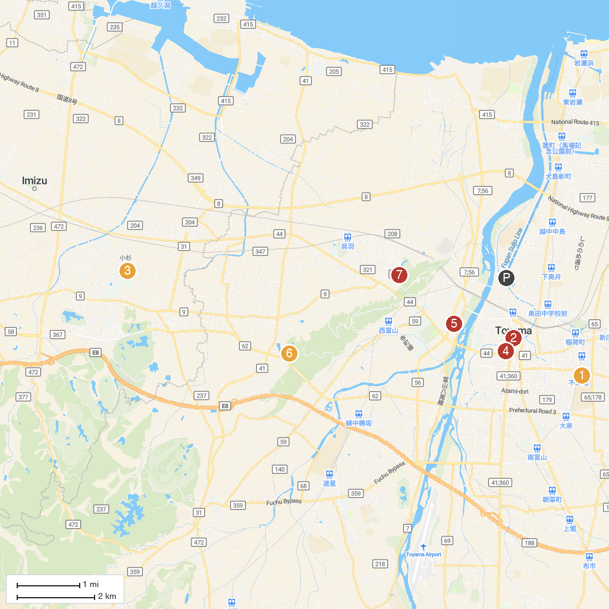
MAP KEY
1. Manten-no-yu Toyama | 5. Toyama Prefecture Suiboku Museum
2. Toyama City Hall observation tower | 6. Toyama Family Park
3. Utanomori Sports Park | 7. Toyama Prefecture Buried Cultural Property Center
4. Toyama City Local History Museum (Toyama Castle) | 8. Hotaruika Museum
P. Cruise port / terminal
Map © MapTiler © OpenStreetMap contributors · cruiseports.org

