Trapani, Sicily, Italy
Shaped like a sickle jutting into the sea, Trapani rewards walkers with Baroque palaces, ancient salt windmills, and couscous so good it'll make you question everything you thought you knew about Italian cooking.
⚓ Pier (no tender) · 🕒 Typical call: 7-10 hrs · 💶 Euro · 🗣️ Italian / Sicilian
✍️ MY DAY IN PORT (FILL IN)
Ship / Date
In port | arrive ______ · all aboard ______
Booked excursion
Notes / meeting point
GETTING ASHORE
- Docking: Pier — ships dock at Molo Garibaldi / Molo Sanità; no tender required
- Walk to center: 5–10 min (≈400 m) from the cruise terminal to the old town
- Best For: Authentic Sicilian culture, day trip to Erice, salt pans & windmills
- Don't Miss: Couscous alla Trapanese — this is the birthplace of Sicilian fish couscous
GETTING AROUND
- 🚕 Taxi: €7–€10 — Taxis are available at the port. A short ride (approx. 4 km) to the city center costs €7–€10; meter starts at ~€3.50. Co
- 📱 Rideshare: ✅ Uber Black
TOP THINGS TO DO
- Erice by Cable Car — Ride the Funivia cable car up 750 m to this perfectly preserved medieval hilltop town.
- Ancient Segesta — One of Sicily's greatest Greek archaeological sites — a near-intact 5th-century BC Doric temple and a hilltop theatre with…
- Trapani Salt Pans & Windmills — The Saline di Trapani e Paceco nature reserve, just south of the city, features ancient salt flats with pink-hued basins and…
- San Vito Lo Capo Beach — Consistently voted one of Italy's best beaches — white sand, shallow turquoise water, and the dramatic backdrop of Monte Monaco.
- Trapani Old Town Walking Tour — Explore the Baroque Corso Vittorio Emanuele, the Cathedral of San Lorenzo, and the Church of the Purgatorio with its famous…
BEST WALKS
- Old Town Highlights: 2 km · 40–50 min · Flat — The classic Trapani stroll from the port along the waterfront promenade to the Torre di Ligny at…
- Seaside Walls & Torre di Ligny: 1.5 km · 25 min · Flat — Walk the Mura di Tramontana seafront promenade north of the old town, with views of the turquoise…
WEATHER · DAYLIGHT · MONEY
Month | High °F | Low °F | Rainy days
May | 74 | 57 | 0
Jul | 88 | 70 | 0
Sep | 84 | 68 | 0
Daylight: May 5:59AM–8:13PM · Jul 5:59AM–8:31PM · Sep 6:51AM–7:17PM
cruiseports.org/trapani · Confirm terminal & all-aboard time with your ship

Trapani, Sicily, Italy — Port Map
Red = walkable sights · Amber = excursions farther out · P = cruise terminal
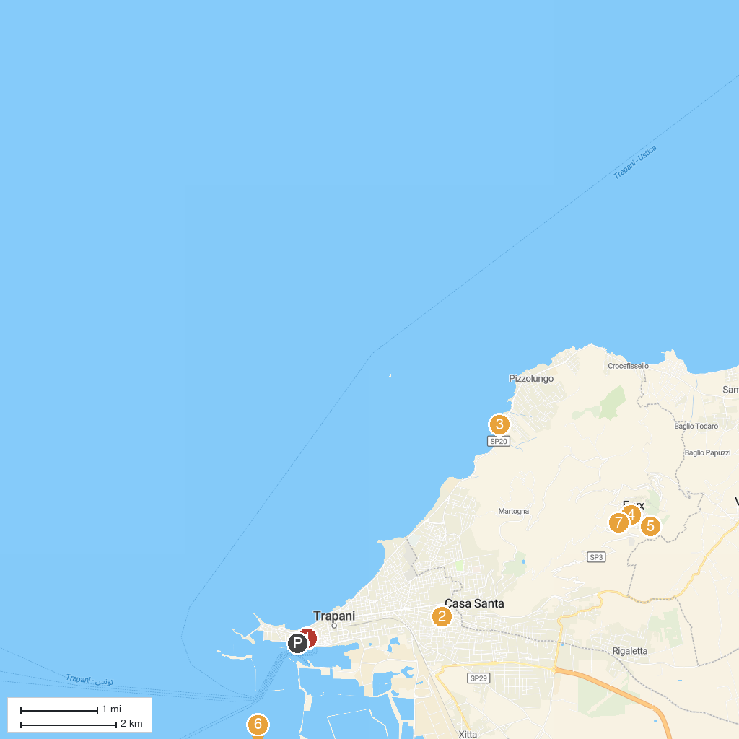
MAP KEY
1. Fontana di Saturno | 5. Torretta Pepoli
2. Basilic of Maria Santissima Annunziata (Madonna of Trapani) | 6. Museo del Sale
3. Stele Virgiliana (Stele di Anchise) | 7. Torre di Re Federico (Campanile della Chiesa Madre)
4. Polo Museale Antonino Cordici | 8. Parco Cerriolo
P. Cruise port / terminal
Map © MapTiler © OpenStreetMap contributors · cruiseports.org

