Trier, Rhineland-Palatinate, Germany
Germany's oldest city wears two millennia lightly — Roman amphitheatres, imperial baths, and the iconic Porta Nigra all within easy walking distance of the Moselle quay. Add a glass of local Riesling at the Hauptmarkt and the afternoon practically plans itself.
⚓ Docked (river quay) · 🕒 Typical call: 8-10 hrs · 💶 Euro (€) · 🗣️ German · 🏛️ UNESCO World Heritage
✍️ MY DAY IN PORT (FILL IN)
Ship / Date
In port | arrive ______ · all aboard ______
Booked excursion
Notes / meeting point
GETTING ASHORE
- Docking: River quay along the Moselle; some ships dock slightly outside the centre
- Walk to centre: 10-15 min on foot to Porta Nigra and Hauptmarkt
- Best For: Roman history, UNESCO monuments, Moselle wine tasting
- Don't Miss: Porta Nigra, Constantine Basilica (Aula Palatina), Roman Bridge
GETTING AROUND
- 🚕 Taxi: ~€10–15 to city center — Regulated taxis are available near the docking area. The short 2–3 km ride to Porta Nigra typically costs €10–15 at mete
- 📱 Rideshare: ✅ Uber
- 🚌 Hop-on hop-off: ✅ City Sightseeing Trier
TOP THINGS TO DO
- Porta Nigra & Roman Monuments Self-Tour — Trier's defining landmark is the Porta Nigra, the best-preserved Roman city gate north of the Alps.
- Constantine Basilica (Aula Palatina) — The largest surviving intact Roman building outside Rome — once the throne room of Emperor Constantine, now a stunning Protestant…
- Karl Marx House Museum — The birthplace of Karl Marx now houses a thoughtful museum exploring his life, ideas, and global influence.
- Hauptmarkt & Moselle Wine Tasting — Trier's central market square is ringed by medieval buildings and café terraces.
- Moselle Valley Vineyard Excursion — The hills above Trier are terraced with steep Riesling vineyards.
BEST WALKS
- Roman Trier Highlights Loop: 2.5 km · ~1.5 hrs · Easy · Flat — Start at the Porta Nigra, walk through the Hauptmarkt to the Cathedral and Liebfrauenkirche…
- Amphitheatre & Karl Marx Walk: 2 km · ~1 hr · Easy — Head south from the centre to Trier's Roman Amphitheatre (holds 20,000), then loop back via…
WEATHER · DAYLIGHT · MONEY
Month | High °F | Low °F | Rainy days
May | 68 | 47 | 1
Jul | 80 | 57 | 1
Sep | 71 | 50 | 1
Daylight: May 5:48AM–9:11PM · Jul 5:42AM–9:35PM · Sep 7:09AM–7:46PM
cruiseports.org/trier · Confirm terminal & all-aboard time with your ship

Trier, Rhineland-Palatinate, Germany — Port Map
Red = walkable sights · Amber = excursions farther out · P = cruise terminal
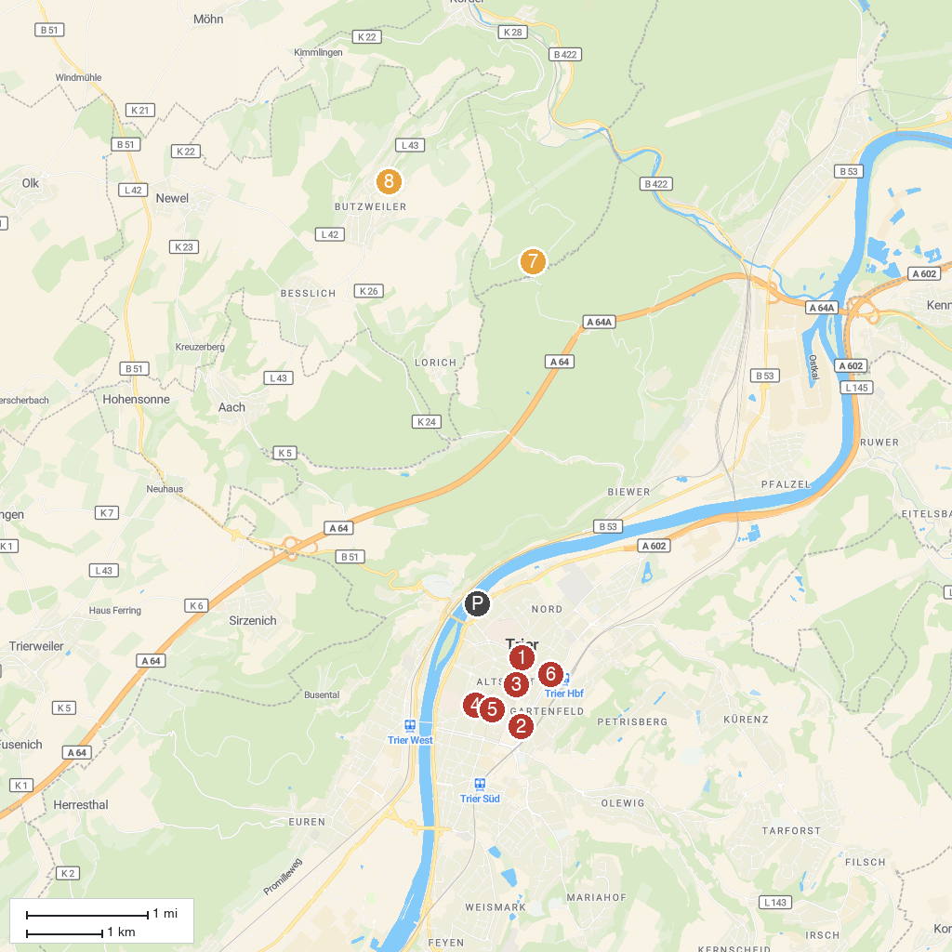
MAP KEY
1. Porta Nigra | 5. Handwerkerbrunnen
2. Rhineland State Museum Trier | 6. Balduinsbrunnen
3. Trier Cathedral | 7. Genovevahöhle
4. Karl Marx House | 8. Römerpfad Premiumwanderweg
P. Cruise port / terminal
Map © MapTiler © OpenStreetMap contributors · cruiseports.org

