Trois-Rivières, Quebec, Canada
Founded in 1634, Trois-Rivières is North America's second-oldest French-speaking city — a compact, walkable gem where a 19th-century stone prison sits beside hip microbreweries and 300 poetry plaques line the streets.
⚓ Pier (docked) · 🕒 Typical call: 7-9 hrs · 💵 Canadian Dollar (CAD) · 🗣️ French (English widely spoken)
✍️ MY DAY IN PORT (FILL IN)
Ship / Date
In port | arrive ______ · all aboard ______
Booked excursion
Notes / meeting point
GETTING ASHORE
- Docking: Cruise Pavilion, Section 3 — direct pier, 5-min walk to historic district
- Walk to centre: 5 min to Old Town; 10 min to Rue des Forges
- Best For: History, French-Canadian culture, craft beer, walking
- Don't Miss: Old Prison tour, Boréalis pulp-mill museum, poutine on Rue des Forges
GETTING AROUND
- 🚕 Taxi: CAD $8–18 — Taxis are available at the port. Typical base fare is around CAD $4.40 plus ~$1.80/km; most in-city trips run under CAD
- 📱 Rideshare: ✅ Uber, Lyft
TOP THINGS TO DO
- Old Prison of Trois-Rivières — Tour a grim stone prison that operated from 1822 to 1986.
- Boréalis — Pulp & Paper Museum — Set in a stunning restored water-filtration plant, this museum celebrates the lumberjacks and mill workers who made…
- Musée POP (Popular Culture Museum) — Fun, interactive museum next to the Old Prison dedicated to Quebec's popular culture — games, traditions, and social history…
- Île Saint-Quentin Beach & Trails — A short taxi ride to a river island with a sandy supervised beach, kayak rentals, walking trails through marshland, and a…
- Sanctuaire Notre-Dame-du-Cap — One of Canada's national pilgrimage shrines: a striking modernist basilica, a 1720 stone chapel, and peaceful grounds beside Lac…
BEST WALKS
- Historic Core Walk: ~2 km · 45 min · Flat — From the pier, walk north to Parc Portuaire for river views, then up to Rue des Ursulines (the…
- Riverfront to Boréalis: ~1.5 km one-way · 30 min · Flat — Follow the riverfront promenade west from the Cruise Pavilion along the Saint-Lawrence to the…
WEATHER · DAYLIGHT · MONEY
Month | High °F | Low °F | Rainy days
May | 65 | 46 | 1
Jul | 78 | 62 | 1
Sep | 69 | 53 | 1
Daylight: May 5:16AM–8:16PM · Jul 5:13AM–8:38PM · Sep 6:28AM–7:00PM
cruiseports.org/trois-rivieres · Confirm terminal & all-aboard time with your ship

Trois-Rivières, Quebec, Canada — Port Map
Red = walkable sights · Amber = excursions farther out · P = cruise terminal
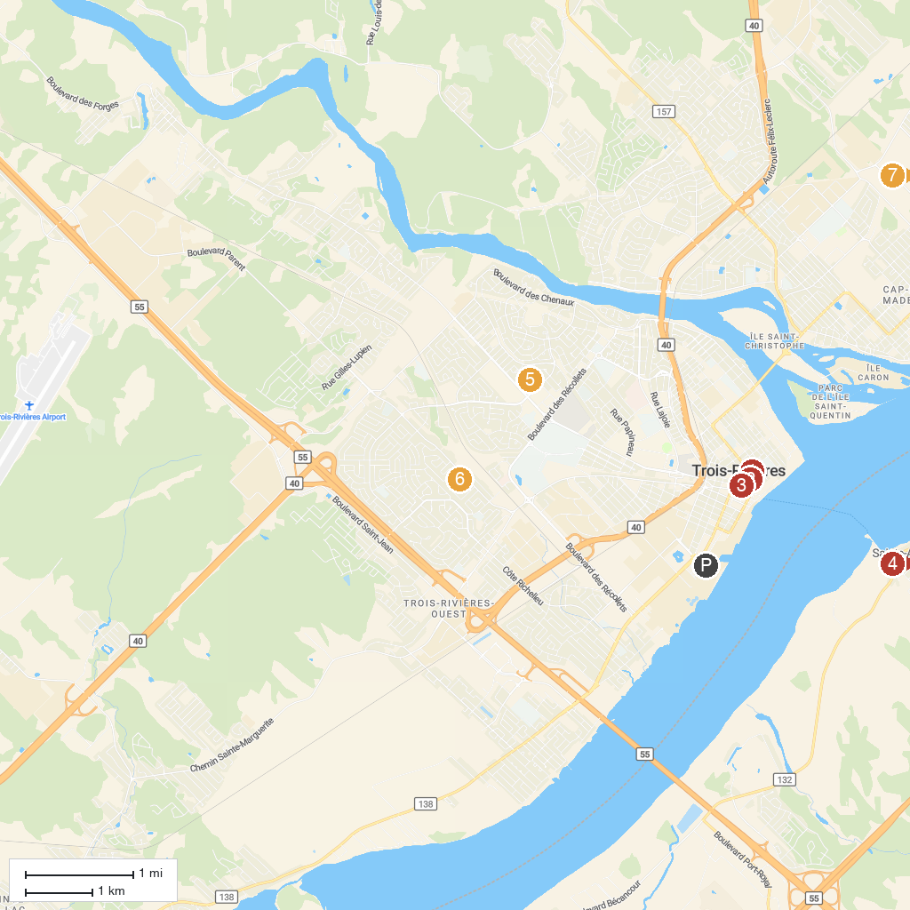
MAP KEY
1. Vieille prison de Trois-Rivières | 5. Savonnerie artisanale de la Maison de Bibi
2. Manoir de Niverville | 6. Parc du Cardinal-Roy
3. centre d'exposition Raymond-Lasnier | 7. Parc de Marseille
4. Moulin seigneurial de Pointe-du-Lac | 8. Roger Guilbault Park
P. Cruise port / terminal
Map © MapTiler © OpenStreetMap contributors · cruiseports.org

