Trollfjord, Lofoten, Norway
One of Norway's most dramatic natural spectacles: a cathedral of sheer rock walls just 100 metres wide, where your ship performs a breathtaking 180° turn at the head of the fjord. You never leave the deck — and you won't want to.
⚓ Scenic transit only — no going ashore · 🕒 Typical transit: 1-2 hrs · 💵 Norwegian Krone (NOK) · 🗣️ Norwegian · 🦅 White-tailed sea eagle habitat
✍️ MY DAY IN PORT (FILL IN)
Ship / Date
In port | arrive ______ · all aboard ______
Booked excursion
Notes / meeting point
GETTING ASHORE
- Docking: No pier or tender — scenic cruising only
- Best For: Dramatic fjord photography and wildlife spotting from deck
- Don't Miss: The captain's 180° turn at the fjord head
- Ship Size: Small/mid-size ships only; mega-ships cannot enter
GETTING AROUND
TOP THINGS TO DO
- RIB Safari into Trollfjord — Departs from Svolvær harbour.
- Sea Eagle Safari — Boat captains carry fish to hand-feed white-tailed sea eagles — Europe's largest bird of prey — right alongside the boat.
- Silent Electric Cruise — Operated by Brim Explorer from Svolvær, these quiet electric vessels glide into the fjord with minimal impact — ideal for…
- Kayaking Inside the Fjord — Some expedition ship programmes offer guided sea kayak tours inside Trollfjord's glassy water.
BEST WALKS
- Deck Circuit — Best Photo Positions: Onboard | 5 min | All abilities — Walk the full circuit of your ship's open decks before entering.
WEATHER · DAYLIGHT · MONEY
Month | High °F | Low °F | Rainy days
May | 48 | 39 | 1
Jul | 63 | 53 | 1
Sep | 54 | 47 | 1
Daylight: Sep 6:16AM–7:31PM
cruiseports.org/trollfjord · Confirm terminal & all-aboard time with your ship

Trollfjord, Lofoten, Norway — Port Map
Red = walkable sights · Amber = excursions farther out · P = cruise terminal
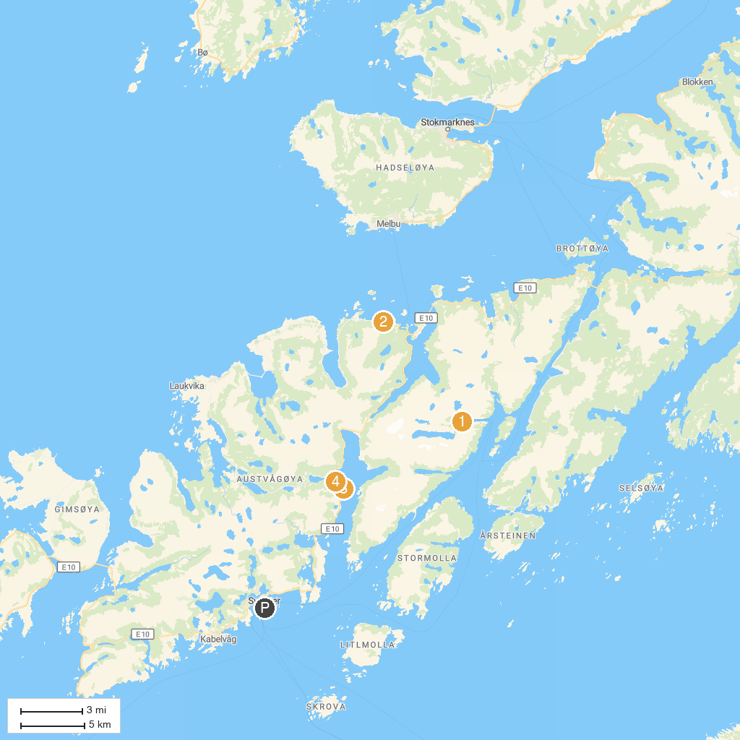
MAP KEY
1. Trollfjord | 3. Austnesfjorden
2. Hessand beach | 4. Vanha puinen laivanhylky
P. Cruise port / terminal
Map © MapTiler © OpenStreetMap contributors · cruiseports.org

