Tulcea, Dobrogea, Romania
Where the Danube fans into a UNESCO wilderness. Tulcea is the river cruise world's back door to one of Europe's last great unspoiled deltas — pelicans, reed channels, and sturgeon soup await just steps from the quay.
⚓ Docked (riverside quay) · 🕒 Typical call: 6–8 hrs · 💵 Romanian Leu (RON) · 🗣️ Romanian (English widely spoken in tourism) · 🐦 Danube Delta UNESCO Site
✍️ MY DAY IN PORT (FILL IN)
Ship / Date
In port | arrive ______ · all aboard ______
Booked excursion
Notes / meeting point
GETTING ASHORE
- Docking: Riverside quay — ships berth directly on the Faleza promenade; no tender
- Walk to center: 0–5 min flat walk to Civic Square and promenade cafés
- Best For: Delta boat tours, birdwatching, fresh fish, Romanian history
- Don't Miss: Small-boat excursion into the Danube Delta channels to spot Great White Pelicans
GETTING AROUND
- 🚕 Taxi: 10–15 RON (~$2–3) — The cruise port sits right next to the city center — a taxi is barely necessary. Metered fares start at 2.50–3.00 RON wi
- 📱 Rideshare: ✅ Uber, Bolt
TOP THINGS TO DO
- Danube Delta Small-Boat Tour — Glide through narrow reed-lined channels into the UNESCO Danube Delta — Europe's second-largest river delta.
- Independence Monument & Aegyssus Ruins — Climb Monument Hill to the 1877 Independence Monument obelisk for panoramic views over the Danube and your ship far below.
- Danube Delta Ecomuseum — One of Europe's finest Delta museums, with a living aquarium of Danube fish including massive sturgeons, interactive exhibits on…
- Promenade Fish Lunch — Dobrogea cuisine is built on freshwater fish.
- Ciuperca Lake Beach — Tulcea has no sea beach, but Ciuperca Lake on the city's western edge offers a freshwater sandy beach with lounge chairs and a…
BEST WALKS
- Promenade to Civic Square: Flat • 10 min • Free — A gentle stroll from the ship along Faleza Tulcea past riverside cafés to Piața Civică, dominated…
- Monument Hill Loop: Moderate • 1–1.5 hrs • Free — From Civic Square, follow the signs uphill to the Independence Monument obelisk and the Aegyssus…
WEATHER · DAYLIGHT · MONEY
Month | High °F | Low °F | Rainy days
May | 73 | 53 | 1
Jul | 86 | 65 | 1
Sep | 77 | 56 | 0
Daylight: May 5:35AM–8:27PM · Jul 5:32AM–8:48PM · Sep 6:43AM–7:15PM
cruiseports.org/tulcea · Confirm terminal & all-aboard time with your ship

Tulcea, Dobrogea, Romania — Port Map
Red = walkable sights · Amber = excursions farther out · P = cruise terminal
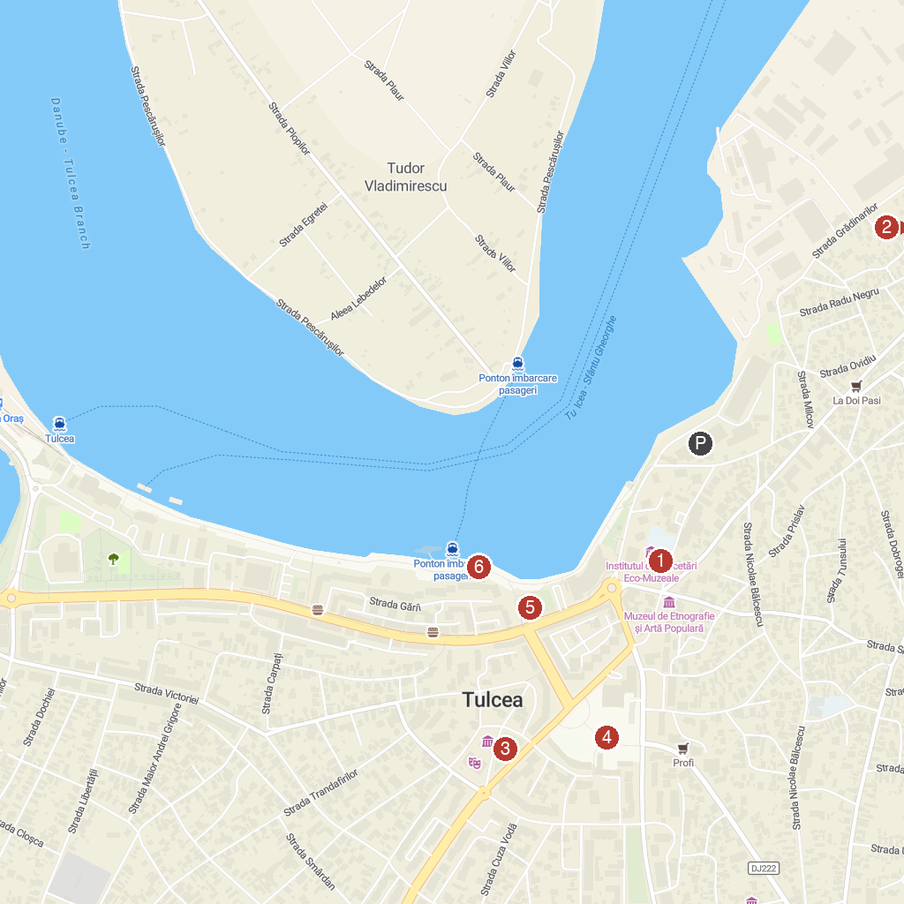
MAP KEY
1. "The Danube Delta" Museum of Ecotourism | 4. Tulcea walking tour
2. Museum of History and Archaeology | 5. Parcul Orășenesc
3. The "Saint Nicholas" Cathedral | 6. Faleza Tulcea
P. Cruise port / terminal
Map © MapTiler © OpenStreetMap contributors · cruiseports.org

