Ullapool, Wester Ross, Scotland
A grid-planned 18th-century fishing village on the shores of Loch Broom, Ullapool punches well above its 1,500-person weight — superb seafood, dramatic Highland peaks, and an easy tender landing right in the village center.
⚓ Tender port (ships anchor in Loch Broom) · 🕒 Typical call: 7-9 hrs · 💷 Currency: British Pound (GBP) · 🗣️ Language: English (Gaelic bilingual signs) · 🌧️ Weather: changeable — always pack a waterproof
✍️ MY DAY IN PORT (FILL IN)
Ship / Date
In port | arrive ______ · all aboard ______
Booked excursion
Notes / meeting point
GETTING ASHORE
- Docking: Tender — 10-15 min ride to harbour pontoon in village centre
- Walk to centre: 1 min from tender pontoon to Shore Street
- Best For: Scenery, seafood, Highland walks, local culture
- Don't Miss: The Seafood Shack on the waterfront
GETTING AROUND
- 🚕 Taxi: £40–£50 round-trip (excursions) — Pre-booking strongly advised due to limited availability on ship days. Ulla Taxis (+44 7795 622627) and Ullapool Taxis (
- 📱 Rideshare: ❌ not available
TOP THINGS TO DO
- Summer Isles Boat Cruise — Board a wildlife boat from Ullapool harbour to explore the uninhabited Summer Isles archipelago — seals, puffins, porpoises, and…
- Corrieshalloch Gorge & Falls of Measach — A spectacular 150-ft slot gorge 12 miles south of town, with a Victorian suspension bridge dangling over the chasm.
- Ullapool Museum — Housed in a Grade-A listed Thomas Telford church, this award-winning museum covers the Loch Broom area's fishing heritage, the…
- Whisky & Highland Culture at The Ceilidh Place — Ullapool's best-known institution: a hotel, pub, restaurant, bookshop, and live music venue rolled into one on West Argyle Street.
- Ullapool Hill (Meall Mor) Walk — A well-marked trail from the edge of the village climbs to a hilltop monument with sweeping panoramas of Loch Broom, the Summer…
BEST WALKS
- Shore Street Harbour Stroll: 30-45 min · Flat · Free — Walk the length of Shore Street from the ferry terminal south to the loch shore, stopping at the…
- Ullapool Hill Summit: 1-1.5 hrs · Moderate ascent · Free — Head to the top of Broom Court to pick up the hill path.
- Ullapool River & Loch Shore Loop: 45-60 min · Flat · Free — A gentle loop from the village along the stony Loch Broom foreshore, around the small peninsula…
cruiseports.org/ullapool · Confirm terminal & all-aboard time with your ship

Ullapool, Wester Ross, Scotland — Port Map
Red = walkable sights · Amber = excursions farther out · P = cruise terminal
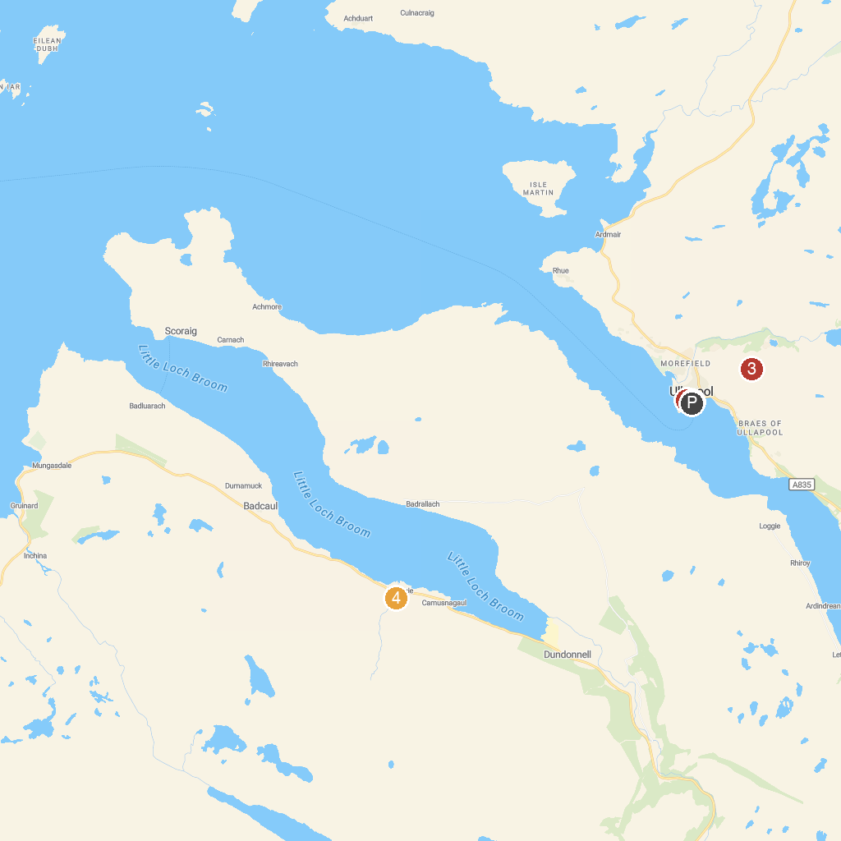
MAP KEY
1. Ullapool Museum | 3. Meall Mhor - Ullapool Hill
2. Shearwater (Summer Queen) Cruises | 4. Ardessie Falls
P. Cruise port / terminal
Map © MapTiler © OpenStreetMap contributors · cruiseports.org

