Ulvik, Vestland, Norway
Norway's orchard village sits at the innermost bend of the Hardangerfjord — a compact, walkable place of fruit farms, cider tastings, mountain trails, and fjord reflections so still they look like mirrors.
⚓ Tender port · 🕒 Typical call: 6-8 hrs · 💵 Norwegian Krone (NOK) — cards everywhere · 🗣️ Norwegian (English widely spoken) · 🍎 Famous for Hardanger cider
✍️ MY DAY IN PORT (FILL IN)
Ship / Date
In port | arrive ______ · all aboard ______
Booked excursion
Notes / meeting point
GETTING ASHORE
- Docking: Tender — ships anchor in the fjord; boats land at a floating pontoon in the village center
- Walk to center: Immediate — the tender pier IS the village center, next to Brakanes Hotel
- Best For: Fjord scenery, cider trail, hiking, Norwegian village life
- Don't Miss: The Hardanger Cider Route — walk uphill to working fruit farms for tastings
GETTING AROUND
- 🚕 Taxi: NOK 150–300 (local) — Taxis are scarce in Ulvik; book in advance through your cruise line or Brakanes Hotel. Base fare ~NOK 50–60 plus ~NOK 15
TOP THINGS TO DO
- Hardanger Cider Route — Walk uphill through orchards past cherry, apple, and plum trees to family-run farms including Ulvik Frukt & Cideri and Syse Gard.
- RIB Fjord Safari — High-speed rigid inflatable boat tours depart near the tender pier and race into the narrow Osafjord and Eidfjord arms, passing…
- Vøringsfossen & Eidfjord Day Trip — A guided coach or taxi excursion to Eidfjord and up to Vøringsfossen — one of Norway's most dramatic waterfalls, dropping 182 m…
- Olav H. Hauge Centre — A short walk from the pier, this interactive museum celebrates Norway's beloved poet Olav H.
- Elvadalen Valley Walk — An easy trail starting near the village center that follows the Tysso River into the lush Elvadalen valley.
BEST WALKS
- Village Loop & Fjord Promenade: 1.5 km · 30 min · Easy · Free — From the tender pontoon, walk along the flat harbor promenade past benches and art installations…
- Cider Route — Fruit Farm Walk: 5–8 km · 2-3 hrs · Moderate (sustained uphill) · Farm tasting fees — From the pier, head uphill on Sidervegen past thousands of apple, cherry, and plum trees.
WEATHER · DAYLIGHT · MONEY
Month | High °F | Low °F | Rainy days
May | 51 | 36 | 0
Jul | 60 | 46 | 1
Sep | 55 | 42 | 1
Daylight: May 4:50AM–10:08PM · Jul 4:31AM–10:43PM · Sep 7:00AM–7:53PM
cruiseports.org/ulvik · Confirm terminal & all-aboard time with your ship

Ulvik, Vestland, Norway — Port Map
Red = walkable sights · Amber = excursions farther out · P = cruise terminal
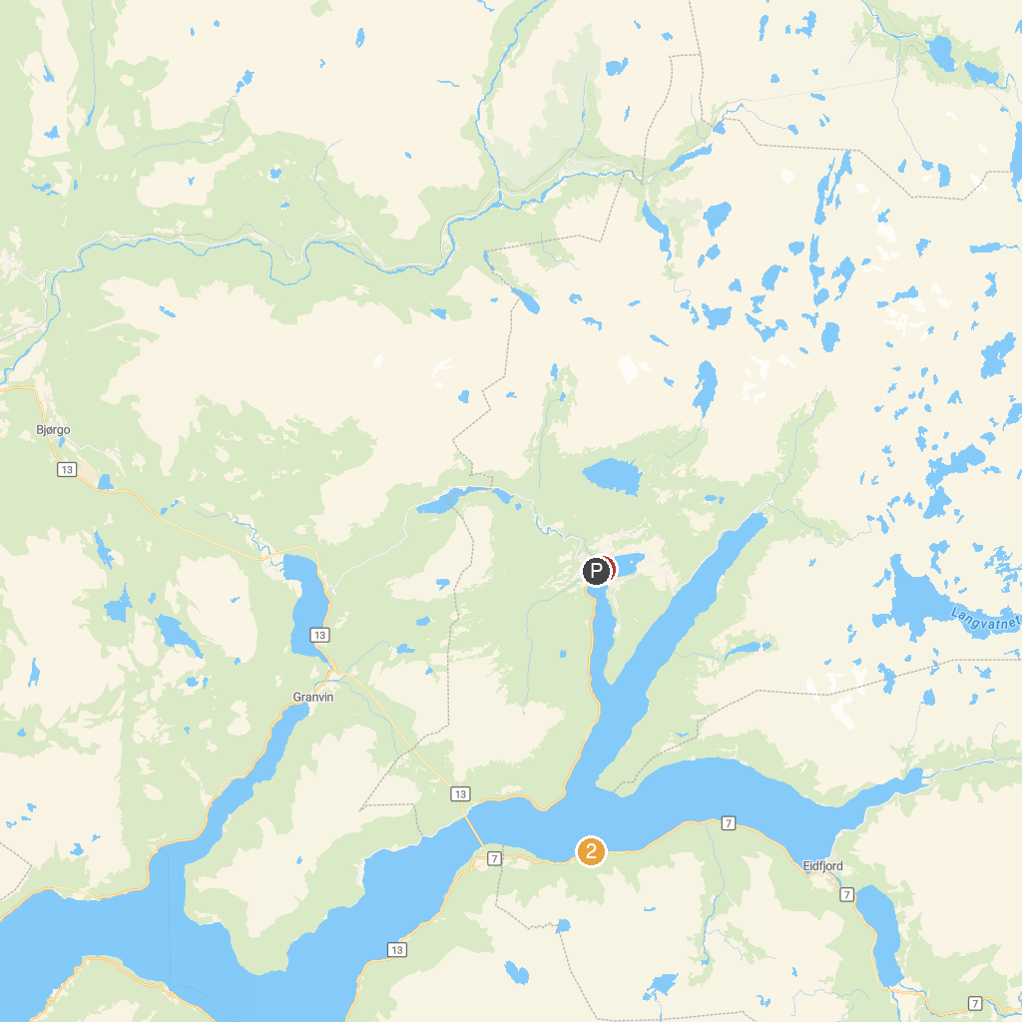
MAP KEY
1. Olav H. Hauge Center | 2. Eidfjorden
P. Cruise port / terminal
Map © MapTiler © OpenStreetMap contributors · cruiseports.org

